Foreign Investment Portal enhancements
  - The Foreign Investment Portal will be updated on 4 July 2026. This release introduces improvements to submission processes, information capture, and system usability. The changes are designed to make it easier for investors and their representatives to complete submissions, manage information, and meet reporting requirements.

Submission changes

Copying investor owner details
Portal users will be able to copy owner details from one investor to a second investor provided they are included in the same submission.
Key features include:
- A new option to add owner details from an existing investor.
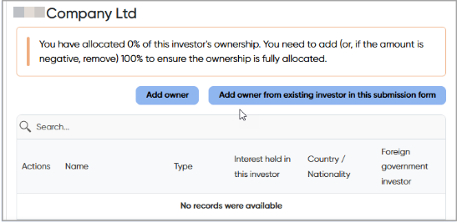
- A list of available owners entered in the current submission form, including name of owner, ownership type, interest held, and country or nationality.
- Users can also select one or more owners to copy into the current investor.
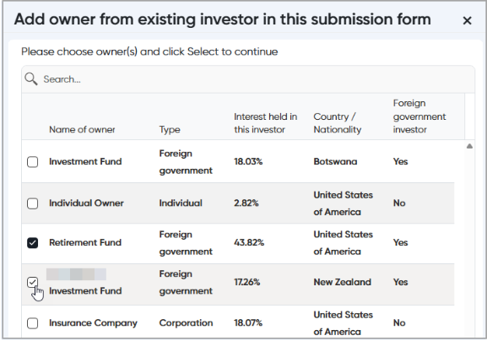
- Once copied, a message will prompt portal users to review and confirm the owner’s information. The copied owner information can then be edited for the new investor.
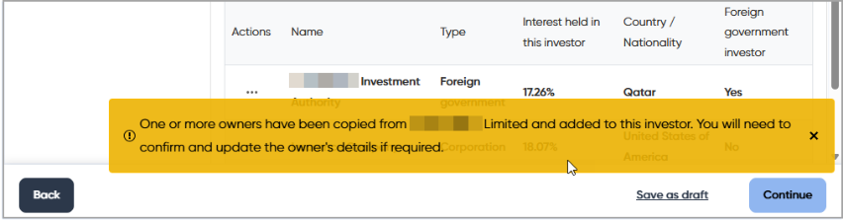
- A cumulative ownership percentage will also be displayed for all owners. A warning will appear where the total does not equal 100 per cent.
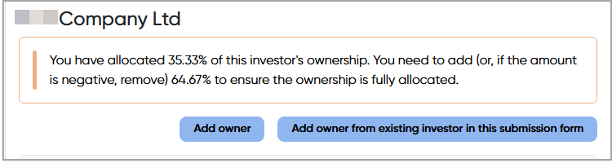

Agreements
Enhancements have been made to how agreements are created and viewed within a submission.

Add a new agreement in a target
Portal users will be able to create agreements directly when adding target details:
- A new option allows an agreement to be created from within the Add Target section of the submission. Agreements that are newly created using this feature are automatically linked to the relevant target.
- Users can still select from existing agreements where appropriate.
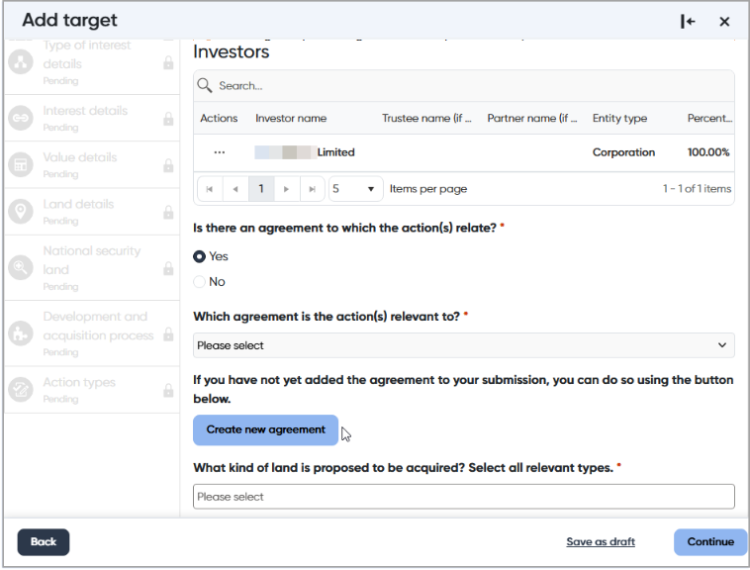

Reason for single agreement
A new mandatory question will be introduced in the Agreements section. Investors/agents must provide an explanation of why the single agreement rule applies to the relevant action(s).
Note: Existing draft submissions that include agreements will need to be updated before they can be submitted.
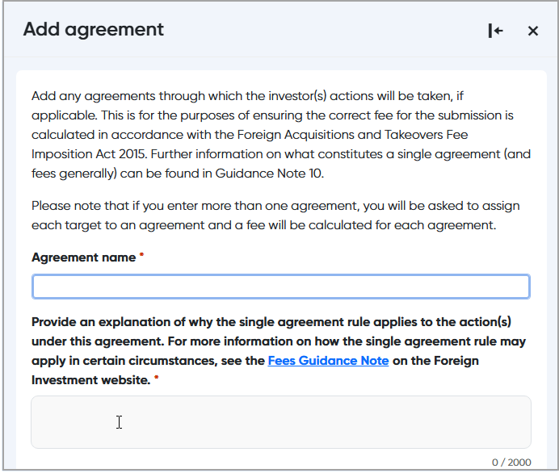

Agreements listed against each target
A new column will display the agreement associated with each target in the target view table. This will allow portal users to see which targets are linked to which agreements.
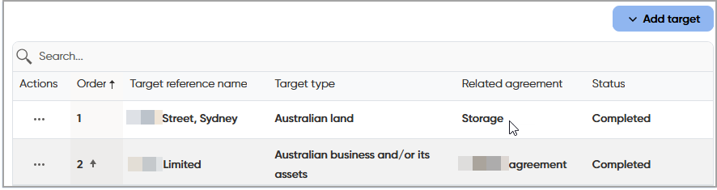

Tax checklist
The updated Tax checklist provides greater clarity around the financing information required at time of submission, based on the specifics of the transaction. Uploading responses to the tax checklist is also now mandatory depending on the answers to certain tax questions.
These changes are intended to ensure information required for the assessment is provided up front, reducing unnecessary delays in processing.

Contextual questions
Updates will be made to the Contextual questions, including renaming sections to clearly describe the purpose of each section.
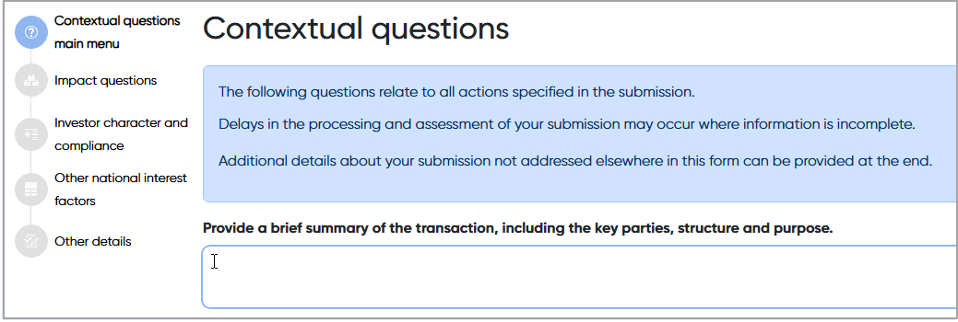
A new optional field will allow investors or agents to provide a brief summary of the transaction, including key parties, structure and purpose. This field is intended to provide additional context and does not replace the structured questions in the form.

Exemption Certificate submissions
A new Submission summary page will be added to the review and declaration step for an Exemption Certificate. This page will display key details, including the exemption certificate types and the reference names provided by the investor/agent.
A summary table will show the country of ownership for the primary investor, including percentage interests by country.
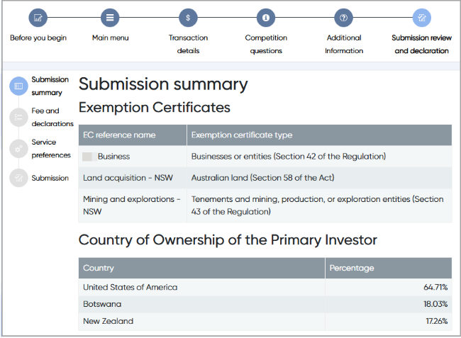

Access to uploaded documents
Portal users will be able to view and download documents originally uploaded as part of a submission, including message attachments. This functionality will also be available for Compliance Reports.
Documents will be available from the Related records view. Users will be able to download documents individually or as a single zip file. To access the documents in the portal:
- On the Submissions page, move to the required submission under Submitted or Finalised section.
- Click on the Action item and select Related Records.
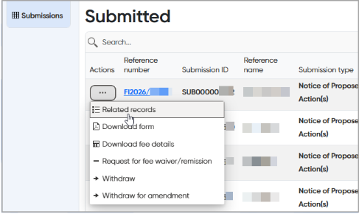
- Scroll to the end of the record.
- Select the document to download or click Download all documents to obtain a zip file of all submitted or attached documents.
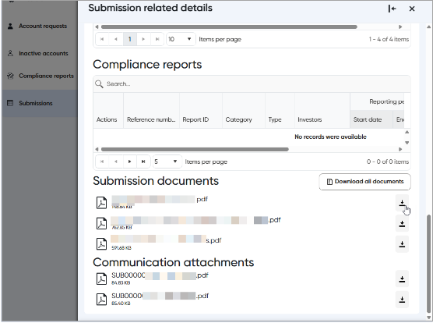

Communications

Improved communications
Updates to the communications features will make it easier to track and manage messages:
- The character limit in message texts will be increased to allow more detailed messages.
- Access to messages for a submission will be automatically removed when a user leaves the account which owns the submission.
- The variation submission acknowledgement message text has been updated to provide more information on when the fee request will be sent to the investor/agent.

Compliance reporting
Several updates will be introduced to improve how compliance reports are managed in the portal.

Draft Compliance report expiry and deletion
Draft compliance reports will be retained for up to 28 calendar days from the last time they are viewed or edited.
If a compliance report includes multiple related records, activity on one record will extend the expiry period for all related records.
A notification will be sent 7 days before expiry to remind users that the draft will be deleted if no action is taken.

Display of reference numbers in draft documents
All referenced (FI) numbers included in compliance reports will be displayed in the footer of draft documents, replacing the current approach where only the first reference number is shown.

Additional questions in Action Taken and Termination event reports
A new question will be introduced for Action taken and Termination event report types.
Portal users will be required to describe the action or termination event being reported. This question will appear in the Conditions section of the reports.
