Ultimate ownership instructions
  - You must complete the ultimate ownership details when creating or adding an investor to a submission in the Foreign Investment Portal.
An ultimate owner has a proportionate beneficial interest of 5 per cent or more in an investor. This is also the case if the aggregated proportionate interests of the owner and its associates add up to more than 5 per cent.

Overview
Providing accurate information in accordance with these instructions will reduce delays during assessment. Further information may be requested during assessment if needed.
- Add the details of each ultimate owner, noting that entities holding less than a 5 per cent proportionate beneficial interest (individually or in aggregate with associates) are not considered ultimate owners.
- Ultimate owners must be identifiable and not include intermediate or interposed entities between ultimate owners and the investor. You should upload a diagram illustrating these structures.
- You must add the details of each ultimate owner when they are associates that in aggregate hold more than a 5 per cent proportionate interest in the investor. This includes foreign government investors from the same country.
- You must also include when an ultimate owner is a publicly listed entity. This includes:
- shareholders that hold 5 per cent or more proportionate interest in the investor.
- any remaining interest must be attributed to the publicly listed entity.
- The total interest held by non-publicly listed entities with less than 5 per cent proportionate beneficial interest, individually or together with associates, is called a ‘widely held’ interest.
- The interest of ultimate owners, the interest from publicly listed entities, and any remaining widely held interest must sum to 100 per cent in the portal.
- Individuals are considered to be from the country of their nationality. If they are dual nationals, then they are considered to be from their country of ordinary residence.
- The ‘Owner (to be provided later)’ option may be selected when certain owner information cannot be accessed at the time of submission.
  - The use of this option is limited to circumstances where information is unavailable at the time of submission such as due to upstream confidentiality requirements.
  - The submitting portal user must facilitate the provision of this information to Treasury during the assessment process.

Ultimate ownership examples
Three examples are included to support you when entering ultimate ownership details into the portal.
Example 1: Publicly listed entities
InvestCo is an entity incorporated in Delaware, United States and is partially owned by a Singaporean incorporated company listed on the Singapore Exchange.
InvestCo’s ownership structure is as follows:
- A Canadian citizen holds a 20 per cent interest in InvestCo.
- A Singaporean citizen holds a 20 per cent interest in Singapore Listed Ltd., which in turn holds an 80 per cent interest in InvestCo.
- Other individuals/entities with each holding less than a 5 per cent interest, holds the remaining 80 per cent interest in Singapore Listed Ltd.
Diagram 1: InvestCo corporate structure
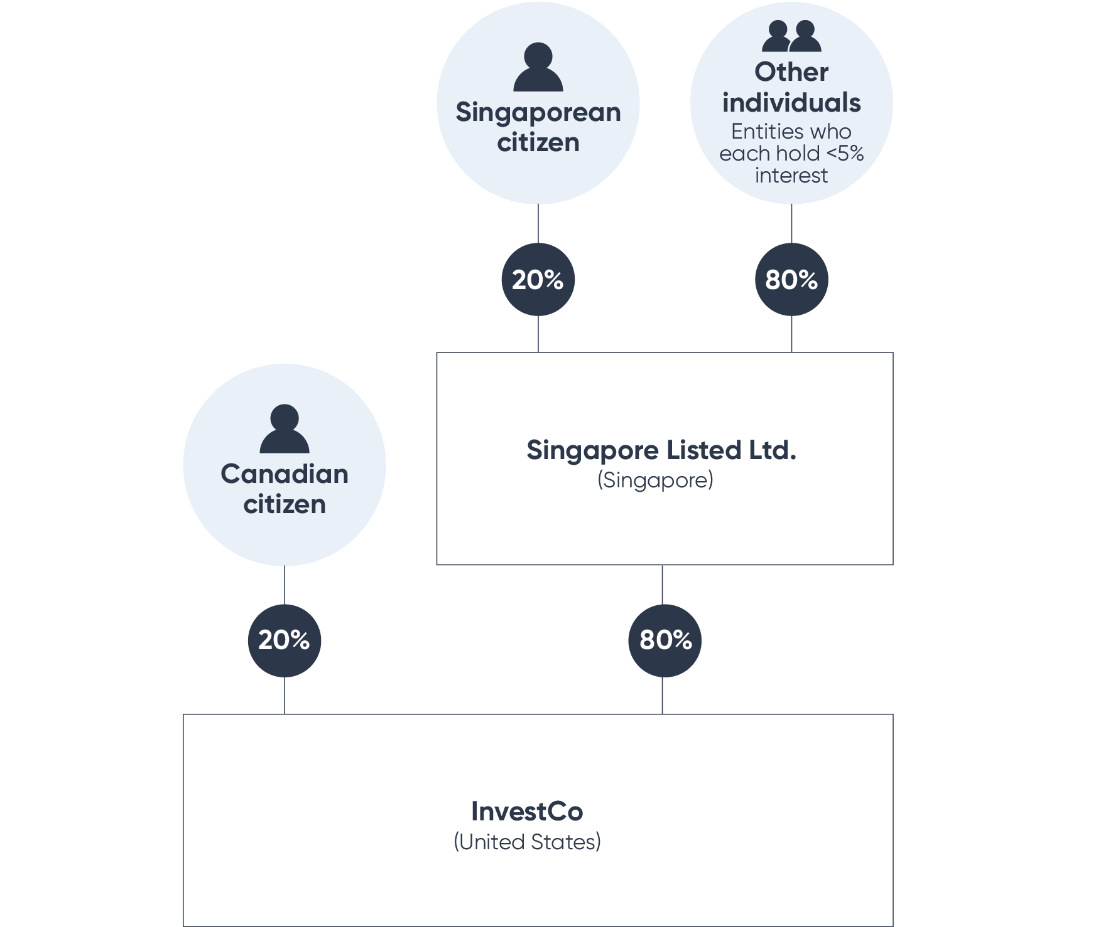
Text description
For this example, the following screenshot shows how the above information should be added in the portal.
The proportionate beneficial interest of the Singaporean Citizen is 16 per cent, because this is equal to Singapore Listed Ltd.’s 80 per cent interest in InvestCo multiplied by the Singapore Citizen’s 20 per cent interest in Singapore Listed Ltd.
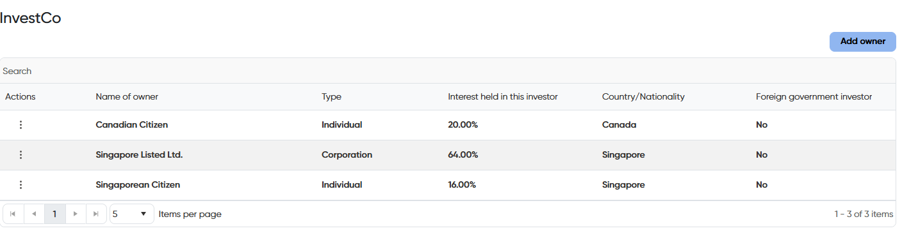
Text description
Example 2: Funds
InvestCo is an entity incorporated in Delaware, United States. It’s owned by the Foreign Infrastructure Fund (FI Fund) which is comprised of multiple ultimate beneficial owners.
InvestCo’s ownership structure is as follows:
- The FI Fund holds a 75 per cent interest in InvestCo.
- The remaining 25 per cent interest is held by other individuals/entities that each hold less than a 5 per cent interest in InvestCo and none of whom are associates of each other or the other parties. This can be considered ‘widely held’ interest as it is not held via a publicly listed entity.
The FI Fund’s holding structure is as follows:
- Singapore Corp Pte. Ltd. (a Singaporean entity) owns all the units in the Singapore Corp Unit Trust. Trustee Ltd., in its capacity as trustee of the Singapore Corp Unit Trust, holds a 30 per cent interest in FI Fund.
- There are multiple Canadian foreign government investors, each with less than 5 per cent interests in Investment Holdings Co. Inc. Investment Holdings Co., Limited holds a 10 per cent interest in FI Fund.
- A French citizen holds a 20 per cent interest in Infrastructure Fund I L.P. and the remaining 80 per cent interest is held by Saudi Arabia Corp LLC (a Saudi Arabian government owned entity).
- Infrastructure Fund I L.P. in turn holds a 35 per cent interest in FI Fund.
- Japan Corp Co., Ltd (a Japanese government owned entity) wholly owns Japan Investment Holdings Co., Ltd which in turn holds a 25 per cent interest in FI Fund.

Diagram 2: FI Fund corporate structure
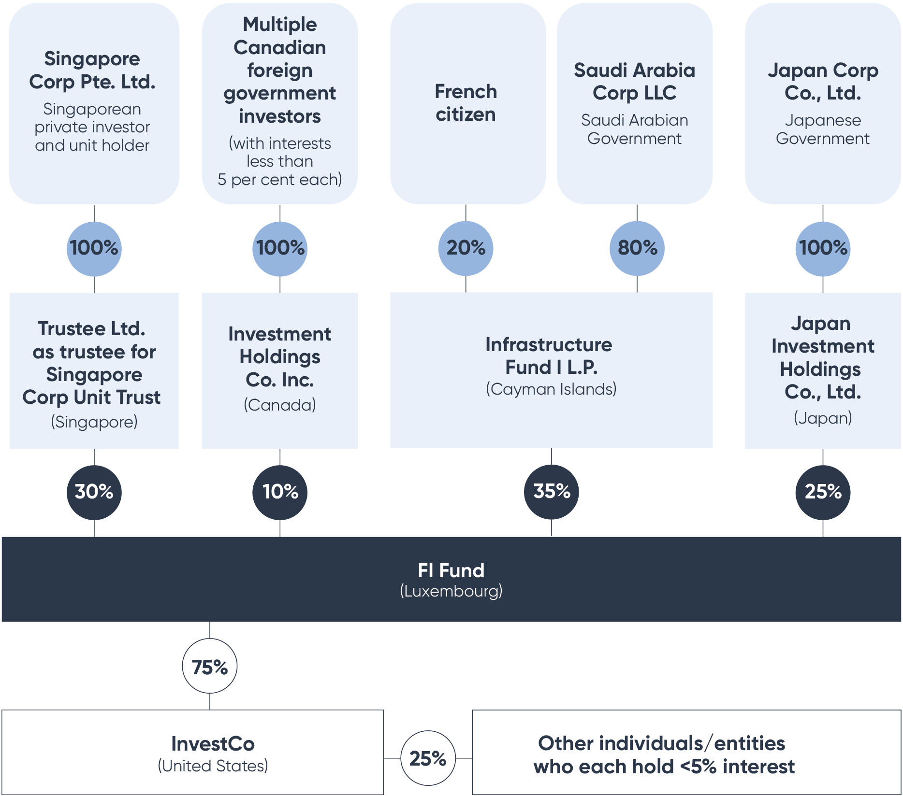Text description
For this example, the following is a screenshot that shows how the above information should be entered in the portal.
The French Citizen holds 20 per cent in Infrastructure Fund I L.P., which holds 35 per cent in FI Fund, which holds 75 per cent in InvestCo. This means the French Citizen’s proportionate beneficial interest in InvestCo is the product of 20 per cent, 35 per cent, and 75 per cent, which is equal to 5.25 per cent. The same calculations are applied to the other owners.
Image 2: Foreign Investment Portal screenshot: Ultimate ownership section with example 2 publicly listed entities
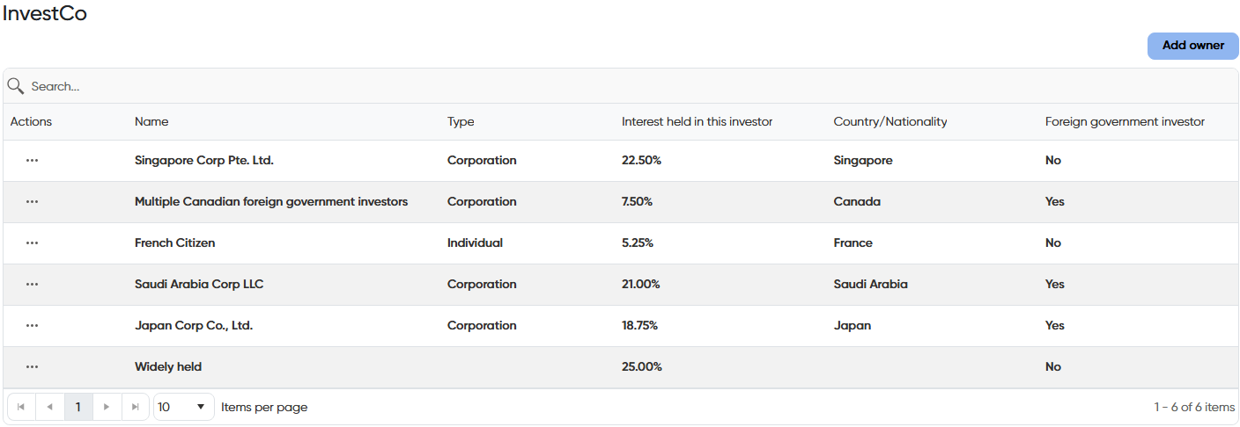
Text description
Example 3: Citizenship, residency and associates
BidCo is an entity incorporated in Australia. BidCo’s ownership structure is as follows:
- A dual Australian/Canadian citizen ordinarily resident in Canada holds 36 per cent.
- An Australian citizen, who is a sibling (and therefore an associate) of the dual Australian/Canadian citizen, holds 4 per cent.
- The remaining 60 per cent interest in BidCo is held by USA LLC, which is an entity incorporated in Delaware, United States.
USA LLC’s holding structure is as follows:
- A dual United States/Irish citizen ordinarily resident in Ireland holds 90 per cent of the interest in USA LLC.
- The remaining 10 per cent interest in USA LLC is held by four Irish citizens, each holding 2.5 per cent individually, and all of whom are immediate family members.
Diagram 3: BidCo corporate structure
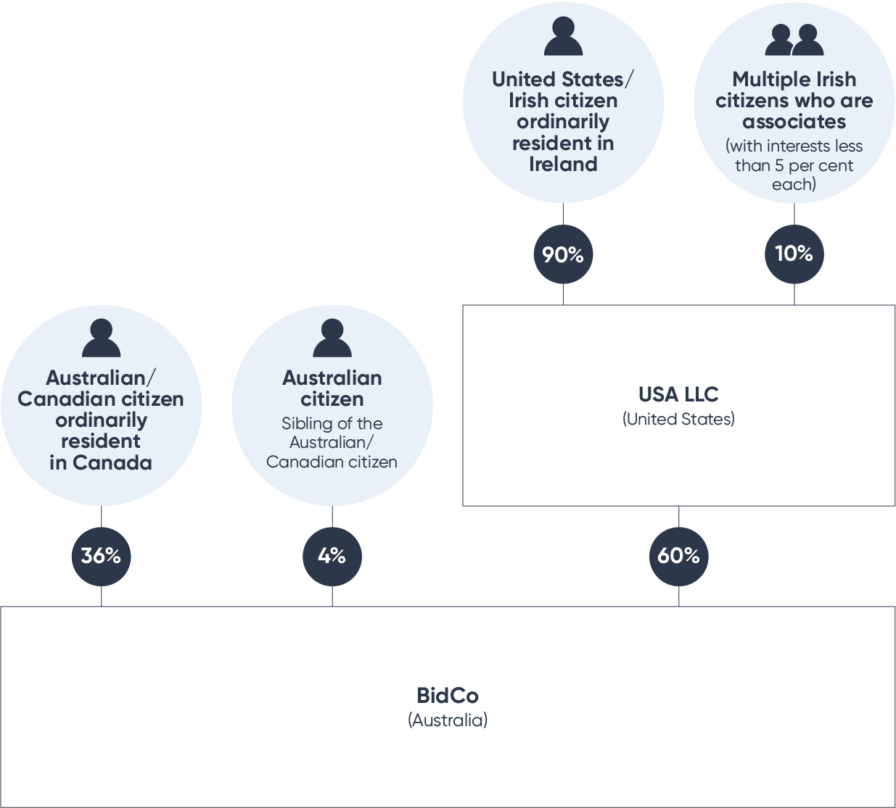
Text description
For this example, the following is a screenshot shows how the above information should be entered in the portal.
Image 3: Foreign Investment Portal screenshot: Ultimate ownership section with example dual citizens and associates
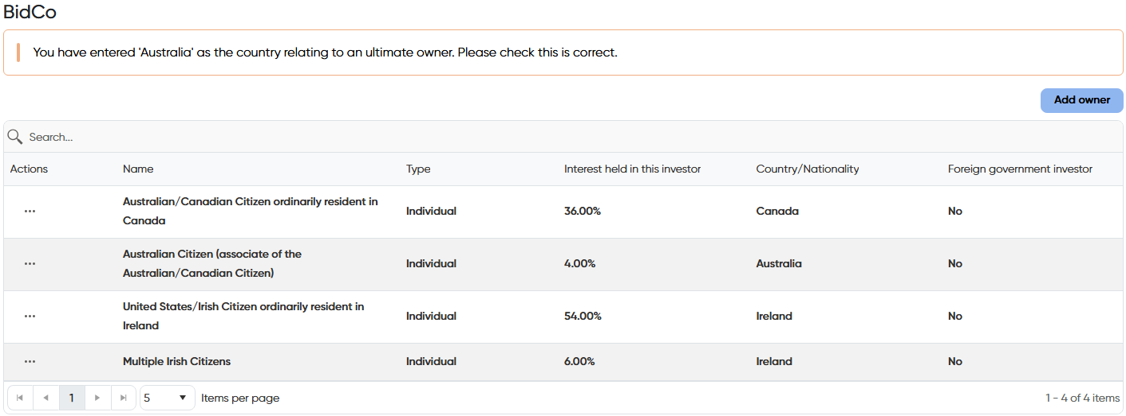
Text description

Text description of diagram 1
Diagram 1 shows how to draw a simple corporate structure to be uploaded into the Foreign Investment Portal. The example is for a publicly listed entity with 3 main interest holders.

Text description of image 1
Screenshot 1 shows an example of how to enter InvestCo’s ultimate ownership into the Foreign Investment Portal. The information includes:
- A Canadian Citizen being an individual that is not a foreign government investor with a 20 per cent interest.
- Singapore Listed Ltd. being a corporation that is not a foreign government investor with a 64 per cent interest.
- A Singaporean Citizen being an individual that is not a foreign government investor with a 16 per cent interest.

Text description of diagram 2
Diagram 2 shows how to draw a complex corporate structure to be uploaded into the Foreign Investment Portal. The example is for a Foreign Investment Infrastructure Fund comprising of multiple ultimate beneficial owners.

Text description of image 2
Image 2 shows an example of how to enter InvestCo’s ultimate ownership into the Foreign Investment Portal. The information includes:
- Singapore Corp Pte. Ltd. being a corporation that is not a foreign government investor with a 22.5 per cent interest.
- Multiple Canadian foreign government investors being a foreign government that is a foreign government investor with a 7.5 per cent interest.
- A French Citizen being an individual that is not a foreign government investor with a 5.25 per cent interest.
- Saudi Arabia Corp LLC being a corporation that is a foreign government investor with a 21 per cent interest.
- Japan Corp Co., Ltd. being a corporation that is a foreign government investor with an 18.75 per cent interest.
- Widely held interest of 25 per cent.

Text description of diagram 3
Diagram 3 shows how to draw a complex corporate structure to be uploaded into the Foreign Investment Portal. The example is for a company whose ownership traces to multiple dual citizens, some of whom hold less than 5 per cent individually but more than 5 per cent when including the interests of their associates.

Text description of image 3
Image 3 shows an example of how to enter BidCo’s ultimate ownership into the Foreign Investment Portal. The information includes:
- A dual Canadian and Australian Citizen who is ordinarily resident in Canada being an individual that is not a foreign government investor with a 36 per cent interest, denominated as originating from Canada.
- An Australian Citizen being an individual that is not a foreign government investor with a 4 per cent interest, denominated as originating from Australia.
- A dual United States and Irish Citizen who is ordinarily resident in Ireland being an individual that is not a foreign government investor with a 54 per cent interest, denominated as originating from Ireland.
- Multiple Irish Citizens being an individual that is not a foreign government investor with a 6 per cent interest, denominated as originating from Ireland.

As defined in section 4 of the Foreign Acquisitions and Takeovers Act 1975.
As defined in section 17 of the Foreign Acquisitions and Takeovers Regulation 2015.

