Foreign Investment Portal enhancements
  - On 21 March 2026, the Foreign Investment Portal will be upgraded to improve functionality, enhance the clarity of instructions and update key areas such as ultimate ownership, dynamic declarations, submission displays and fee information. This fact sheet outlines the changes you will see in the Portal.

Ultimate Ownership
Ultimate ownership requirements in the Foreign Investment Portal have been updated, and the Ultimate ownership instructions have been revised. The new instructions are available on the Foreign Investment website.
For all investors listed in the Portal, at least one ultimate owner must now be recorded. Investor information is required in both submissions and compliance reports.
Investors and agents must provide ownership information that totals 100 percent. To support the provision of accurate and complete information, three ownership options are available:
- Owner (known) – when the name, type and country of the owner is known at time of submission.
- Owner (to be provided later) – used only when the holding percentage is known but the owner details have not yet been confirmed or cannot be made available to the investor.
- Widely held – used for the holding percentage from one or several parties whose interests are less than 5 per cent. Only one ownership record can be set as Widely held, and additional details are required.
Investor and ownership details from earlier submissions or reports will be available when using the same account. This information can be edited or replaced as needed.
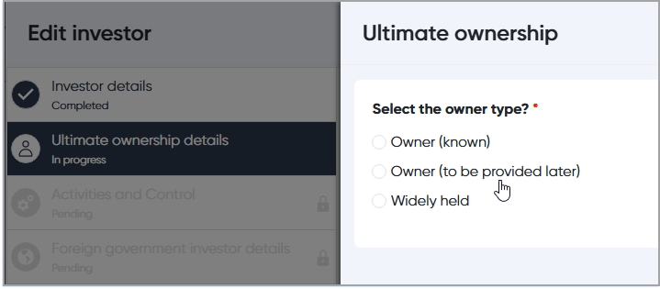
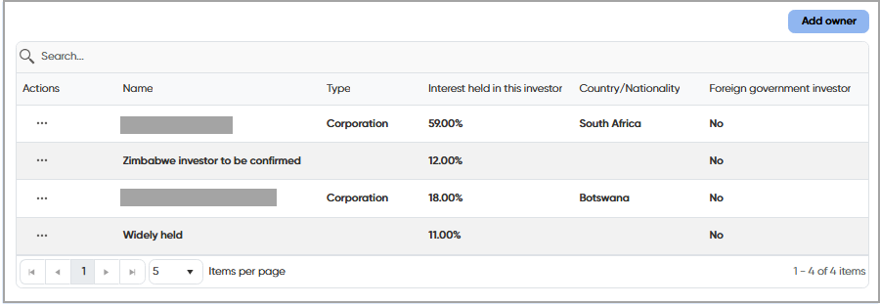

Owner (to be provided later)
You may select the Owner (to be provided later) option when certain owner information is genuinely unavailable at the time of submission, for example due to upstream confidentiality requirements. When you select this option, you will need to confirm that you are following the Ultimate Ownership instructions and that you will provide the missing information during the assessment process. You must also include the ownership percentage and any preliminary details you can provide. Please note that delays in supplying this information may affect assessment processing times.
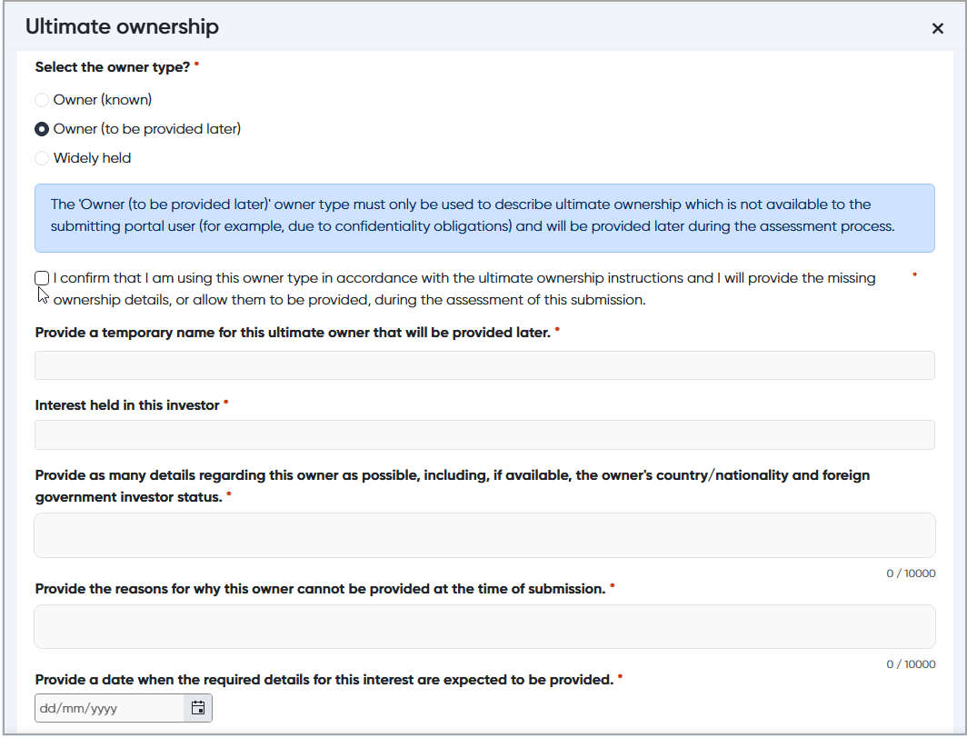

Targets
The targets will now be listed in the order in which they were entered into the Portal. You can reorder the list using the arrows in the target list. Please remember to use the Save button to save any order changes that you have made.
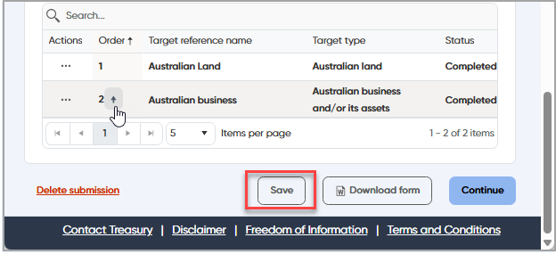

Submission summary
A new Submission summary section has been added to the Review and fee step. The Submission summary displays the Targets by Investor and Country of Ownership and the Consideration Value by Country of Ownership (All Targets) in a table format. This will allow investors and agents to clearly see a breakdown of the information provided before the submission is made.
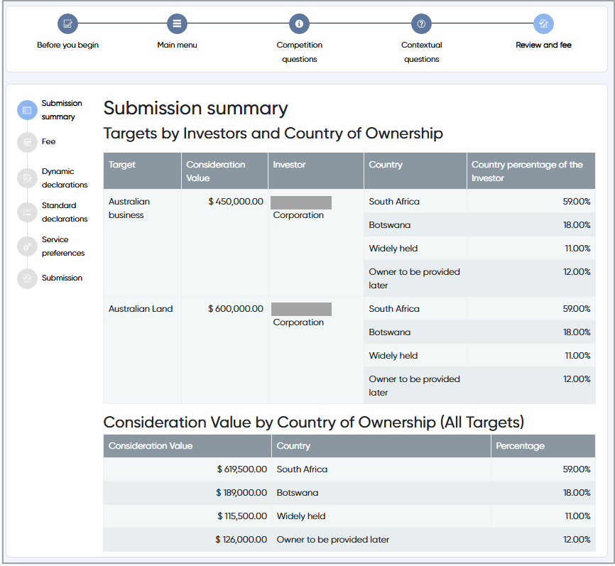

Contextual Questions

Additional tax questions
The tax questionnaire in the Contextual questions has been updated. Additional guidance will now display in the Portal to explain that processing of a proposal may be delayed if the tax questionnaire is not completed at the time of submission. This guidance only appears if the submission meets the thresholds that require the questionnaire to be answered.
The updated checklist is available on the Foreign Investment website and replaces both the previous tax checklist and the tax questions fact sheet.

Other details
A new optional field has been added at the end of the Contextual questions to allow investors and agents to explain any reasons for not complying with the requirements of the submission form, such as unexpected Portal errors.

Fee breakdown
As part of the submission process, investors and agents can now view a breakdown of how the fee has been calculated. The fee breakdown will be visible on screen and can also be downloaded as a PDF using the Download fee details button. Please note that the calculated fee remains subject to manual review.
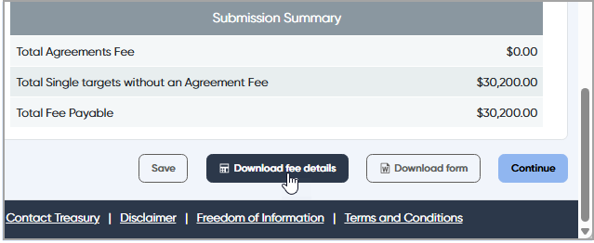

Dynamic Declarations
Some dynamic declarations have been updated to better reflect the structure and language used in the proposal descriptions of no-objection notifications and exemption certificates.
The declarations also group together references to actions of the same type, and minor typographical errors in the land and tenements declarations have been corrected.
The procedural fairness process will continue to be used, and you will still have the opportunity to review proposal descriptions if necessary.

Time zone and date information
Dates and times relating to statutory deadlines in the Foreign Investment Portal now display in Canberra time, regardless of the time zone you are located in. Additional information has been added to clarify which times are shown in Australian Eastern Standard time or Australian Eastern Daylight Saving Time.

Portal display
Submitted and Finalised submissions are now shown in two separate tables on the Foreign Investment Portal. This change is intended to assist investors and agents locate their records more easily.

Agreement information
Additional information has been added regarding agreements and how they are used to apply the single fee agreement rules. The Portal now provides the following guidance:
Add any agreements that apply to the investor(s) actions, if applicable. For this section, agreement has the same meaning as in “single agreement” in the Foreign Acquisitions and Takeovers Fees Imposition Regulations 2020.
If multiple actions form part of one transaction, then the single agreement rule may affect the fee calculation. To ensure this rule is applied, you must add the agreement here and then link the relevant targets to the agreement by selecting “Yes” to the “Is there an agreement to which the action(s) relate?” question in the Target details section.
Please note that the calculated fee may still be subject to manual review.
For more information on the single agreement rule, see the Fees Guidance Note on the Foreign Investment website.

Opportunity to Comment
The opportunity to comment communication messages now provide clearer instructions on how to submit comments during the procedural fairness process.
If you are providing comments on proposal descriptions or conditions, you must send your response to Treasury in two formats: a marked-up PDF version and a clean Word document version.

Extension requests
When requesting an extension to the decision period, if an extension request has already been requested, a warning message will display that an existing request has already been made. Any pending extension requests will be available in the ‘Related records’ for the submission, available from the actions menu.

Submission and Case numbers
The Submission (SUB) and Case (FI) identification numbers will now appear in a wider range of communication messages and emails relating to submissions. This change is intended to make it easier for you to track and reference your submissions.

Submission and Compliance report documents
Updates have been made to the draft and submitted PDF versions of both the Submission and Compliance report documents. These documents will now display the date they were generated by the Portal and the user who generated them. This information will only appear for submissions and reports generated after 21 March 2026.

