

Quarterly Report on Foreign Investment
  - 1 April to 30 June 2025

© Commonwealth of Australia 2026
ISSN 2653-7206
This publication is available for your use under a Creative Commons Attribution 4.0 Australia licence, with the exception of the Commonwealth Coat of Arms, the Treasury logo, photographs, images, signatures and where otherwise stated. The full licence terms are available from https://creativecommons.org/licenses/by/4.0/legalcode.en.

Use of Treasury material under a Creative Commons Attribution 4.0 Australia licence requires you to attribute the work (but not in any way that suggests that the Treasury endorses you or your use of the work).
Treasury material used ‘as supplied’
Provided you have not modified or transformed Treasury material in any way including, for example, by changing the Treasury text; calculating percentage changes; graphing or charting data; or deriving new statistics from published Treasury statistics – then Treasury prefers the following attribution:
Source: The Australian Government the Treasury.
Derivative material
If you have modified or transformed Treasury material, or derived new material from those of the Treasury in any way, then Treasury prefers the following attribution:
Based on The Australian Government the Treasury data.
Use of the Coat of Arms
The terms under which the Coat of Arms can be used are set out on the Department of the Prime Minister and Cabinet website (see https://www.pmc.gov.au/honours-and-symbols/commonwealth-coat-arms).
Other uses
Enquiries regarding this licence and any other use of this document are welcome at:
Manager
Media Unit
The Treasury
Langton Crescent
Parkes ACT 2600
Email: media@treasury.gov.au
In the spirit of reconciliation, the Treasury acknowledges the Traditional Custodians of country throughout Australia and their connections to land, sea and community. We pay our respect to their Elders past and present and extend that respect to all Aboriginal and Torres Strait Islander peoples.

Contents
Key Foreign Investment Framework data 1
Foreign investment reporting 1 April to 30 June 2025 2
Introduction 2
About this report 2
Headline statistics 3
Investment proposals 5
Investment proposals by number and value 5
Approved investment proposals by investment source and industry sector 6
Consideration of investment proposals 8
Median processing times 8
National Security 9
Compliance with foreign investment legislation 10
Condition mandated reports 10
Foreign investment audit program 10
Referrals and assessment of potential non-compliance 11
Matters under investigation 11
Methodology and glossary 12
Overview 12
General caveats 12
Glossary 13

Key Foreign Investment Framework data
Commercial foreign investment in Australia
Key data for the period 1 April – 30 June 2025
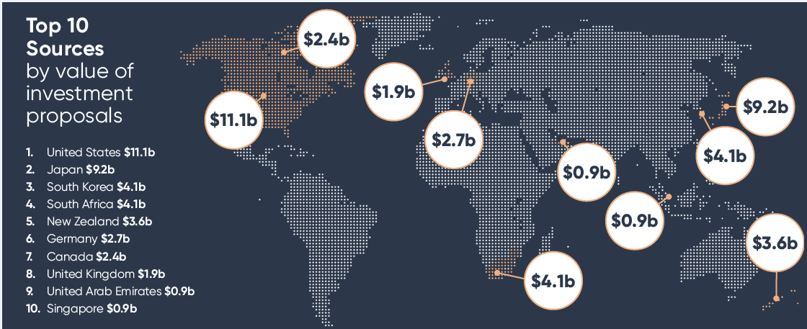
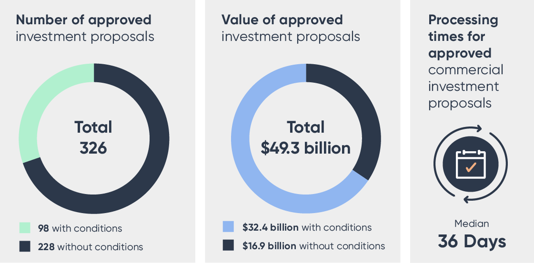
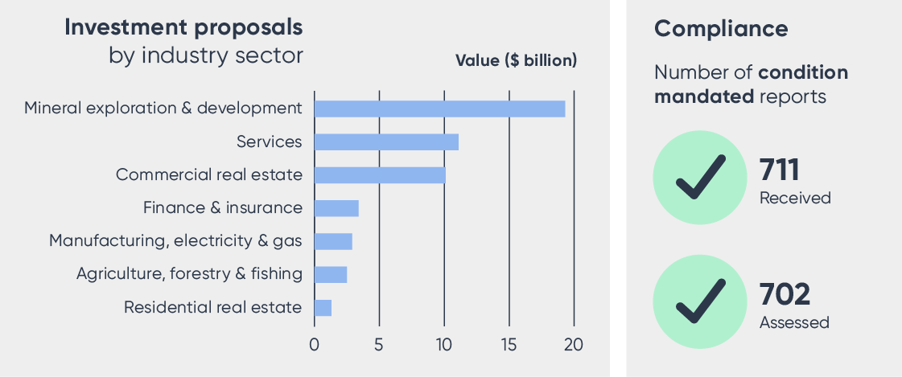

Foreign investment reporting 1 April to 30 June 2025

Introduction
The Treasury is Australia’s foreign investment policy advisor and regulator. It administers the Foreign Investment Framework, which is set by the Foreign Acquisitions and Takeovers Act 1975 and the Foreign Acquisitions and Takeovers Fees Impositions Act 2015, along with their associated regulations.
The Treasury assesses commercial investment proposals, is responsible for promoting compliance, and advises the Australian Government on all aspects of foreign investment policy. Under the Foreign Investment Framework, the Australian Taxation Office (ATO) is responsible for residential real estate investment proposals. Under the Foreign Acquisitions and Takeovers Act 1975, proposed foreign investments are assessed using the national interest test or the national security test.
The Treasurer is the decision maker under Australia’s Foreign Investment Framework. However, decision-making delegations exist to enable Treasury portfolio ministers, Treasury and ATO officials to make decisions on foreign investment proposals on behalf of the Treasurer.
The Foreign Investment Review Board (FIRB) is a non-statutory body which advises the Treasurer on the policy and administration of the Foreign Investment Framework.
More information about Australia’s foreign investment regulatory system is available at https://foreigninvestment.gov.au. You can also find further information on Australia’s foreign investment policy at https://foreigninvestment.gov.au/investing-in-australia/foreign-investment-framework.

About this report
This is the fourth quarterly report for the 2024–25 financial year covering the regulation of foreign investment in Australia.
This quarterly report sets out key performance data concerning the operation of Australia’s foreign investment regulatory framework from 1 April 2025 to 30 June 2025.

Headline statistics – 1 April to 30 June 2025

Commercial investment proposals
The number of commercial investment proposals approved was 326 with a total value of $49.3 billion.
The United States was the largest source for approved commercial investment proposals by value ($11.1 billion), followed by Japan ($9.2 billion), South Korea ($4.1 billion), South Africa ($4.1 billion) and New Zealand ($3.6 billion).
Mineral exploration & development was the largest target sector for proposed investment with a total value of $19.3 billion, followed by Services ($11.1 billion) and Commercial real estate ($10.1 billion).

Residential real estate investment proposals
The number of residential real estate investment proposals approved was 917 with a total value of $1.3 billion.
China was the largest source for approved residential real estate investment proposals by value ($0.3 billion), followed by Taiwan ($0.2 billion), Vietnam ($0.1 billion) and India ($0.1 billion).

Median processing times
From 1 January 2025, Treasury adopted a new performance target of deciding 50 per cent of investment proposals within the 30-day statutory decision period.
Treasury’s median processing time for approved commercial investment proposals was 36 days, with 46 per cent of proposals decided in 30 days or less.
The ATO’s median processing time for approved residential real estate proposals was 4 days.

National security
In January 2021, Australia’s Foreign Investment Framework’s national security powers were strengthened to cover more types of transactions subject to mandatory notification and create a scheme for voluntary notification by investors for actions of any value which may pose national security concerns.
Of the 326 commercial foreign investment proposals approved in this quarter, 33 related to national security actions that would not have been captured prior to January 2021. Of these 33 national security actions, 26 were mandatory notifications and 7 were voluntary notifications.

Compliance with foreign investment legislation
Maintaining strong compliance with Australia’s foreign investment legislation is a priority for the Government. The Government expects all foreign investors to be aware of, understand and comply with their obligations under Australian law, including Australia’s foreign investment laws. The Foreign Investment Compliance Framework Policy Statement helps foreign investors understand and meet their compliance obligations.
The compliance program aims to achieve a balance between providing assurance, detecting and addressing non-compliance.
Treasury promotes compliance through a range of activities which include educating foreign investors about their obligations under the foreign investment laws and any conditions attached to their investments. Treasury also undertakes various compliance assurance activities and enforcement actions, including penalties as appropriate. In doing so, Treasury may use legislative powers to compel information and documents, enter premises (either by consent or by court issued warrant) and exercise monitoring powers.
Treasury is focused on carrying out these compliance and enforcement activities in a way that promotes the integrity of the Foreign Investment Framework and is proportionate to the risks of harm to Australia’s national interest and national security.

Investment proposals

Investment proposals by number and value

Table 1: Number of investment proposals
 | Commercial |  |  |  |  | Residential real estate
 | Current quarter | Previous quarter | 2024-25 | 2023-24 | 2022-23 | Current quarter | Previous quarter | 2024-25 | 2023-24 | 2022-23
Approved with conditions | 98 | 83 | 443 | 476 | 547 | 628 | 647 | 2,692 | 4,042 | 4,768
Approved without conditions | 228 | 223 | 919 | 755 | 767 | 289 | 267 | 1,230 | 1,539 | 1,808
Total | 326 | 306 | 1,362 | 1,231 | 1,314 | 917 | 914 | 3,922 | 5,581 | 6,576
Withdrawn | 39 | 23 | 131 | 246 | 149 | 35 | 19 | 94 | 139 | 74
Prohibition orders | 0 | 0 | 0 | 1 | 1 | 0 | 0 | 0 | 0 | 0
Disposal orders | 0 | 0 | 0 | 5 | 0 | 0 | 0 | 0 | 0 | 0
Note: Tables on residential real estate exclude variations and applications processed where the outcome was exempt. Variations from previously published statistics are due to the reconciliation processes.

Table 2: Value of investment proposals ($ billion)
 | Commercial |  |  |  |  | Residential real estate
 | Current quarter | Previous quarter | 2024-25 | 2023-24 | 2022-23 | Current quarter | Previous quarter | 2024-25 | 2023-24 | 2022-23
Approved with conditions | 32.4 | 86.8 | 198.2 | 133.8 | 132.6 | 0.9 | 0.9 | 3.5 | 4.8 | 6.1
Approved without conditions | 16.9 | 14.6 | 53.3 | 53.3 | 40.5 | 0.3 | 0.3 | 1.4 | 1.8 | 1.8
Total | 49.3 | 101.5 | 251.5 | 187.0 | 173.1 | 1.3 | 1.2 | 4.9 | 6.6 | 7.9
Note: Anomalous values or values that could identify specific transactions have been removed. The ATO assessed some commercial applications received before December 2022.
Variations from previously published statistics are due to the reconciliation processes.
Proposals include Exemption Certificates, which grant investors approval to make acquisitions over a defined period. These may have a specified financial limit or no financial cap. The majority of Exemption Certificates are given for a duration longer than one year. As a result, the associated acquisitions take place over a number of years and not necessarily within the same reporting period as when the Exemption Certificate was given.

Approved investment proposals by investment source and industry sector

Table 3: Top 10 sources of investment by value of approved commercial investment proposals*
 | Number |  |  |  |  | Value ($ billion)
 | Current quarter | Previous quarter | 2024-25 | 2023-24 | 2022-23 | Current quarter | Previous quarter | 2024-25 | 2023-24 | 2022-23
United States | 120 | 118 | 523 | 504 | 604 | 11.1 | 74.1 | 122.3 | 65.7 | 34.7
Japan | 37 | 40 | 155 | 114 | 138 | 9.2 | 3.7 | 15.0 | 20.0 | 14.0
Republic of Korea (South Korea) | 21 | 23 | 103 | 107 | 77 | 4.1 | 2.4 | 7.4 | 1.0 | 6.6
South Africa | 11 | 6 | 35 | 20 | 30 | 4.1 | 0.1 | 4.5 | 0.5 | 1.3
New Zealand | 12 | 4 | 38 | 54 | 43 | 3.6 | 0.0 | 3.7 | 0.7 | 2.5
Germany | 20 | 19 | 97 | 87 | 84 | 2.7 | 0.6 | 4.4 | 6.4 | 2.0
Canada | 71 | 57 | 297 | 316 | 342 | 2.4 | 2.6 | 12.5 | 6.3 | 14.4
United Kingdom | 46 | 40 | 203 | 176 | 187 | 1.9 | 2.2 | 5.9 | 2.9 | 6.6
United Arab Emirates | 23 | 39 | 161 | 158 | 129 | 0.9 | 0.8 | 3.8 | 4.9 | 2.9
Singapore | 37 | 58 | 274 | 265 | 237 | 0.9 | 1.8 | 11.2 | 9.4 | 14.4
Note: Proposals involving more than one source are counted against each source.
* This table is sorted by the value of approved proposals in the current quarter.

Table 4: Top 10 sources of investment by value of approved residential real estate proposals*
 | Number |  |  |  |  | Value ($ billion)
 | Current quarter | Previous quarter | 2024-25 | 2023-24 | 2022-23 | Current quarter | Previous quarter | 2024-25 | 2023-24 | 2022-23
China | 292 | 329 | 1,355 | 1,998 | 2,601 | 0.3 | 0.3 | 1.4 | 2.6 | 3.4
Taiwan | 123 | 92 | 463 | 395 | 330 | 0.2 | 0.1 | 0.5 | 0.4 | 0.3
Vietnam | 94 | 76 | 383 | 363 | 423 | 0.1 | 0.1 | 0.3 | 0.4 | 0.4
India | 146 | 111 | 509 | 550 | 451 | 0.1 | 0.0 | 0.2 | 0.4 | 0.2
Indonesia | 51 | 53 | 234 | 194 | 190 | 0.0 | 0.0 | 0.2 | 0.2 | 0.2
Hong Kong (SAR) | 54 | 52 | 284 | 409 | 650 | 0.0 | 0.0 | 0.3 | 0.4 | 0.6
Nepal | 70 | 105 | 286 | 321 | 281 | 0.0 | 0.0 | 0.1 | 0.3 | 0.2
Singapore | 51 | 57 | 254 | 268 | 316 | 0.0 | 0.0 | 0.2 | 0.2 | 0.3
Malaysia | 43 | 42 | 201 | 145 | 215 | 0.0 | 0.0 | 0.1 | 0.1 | 0.2
United Kingdom | 36 | 65 | 192 | 197 | 226 | 0.0 | 0.0 | 0.1 | 0.2 | 0.2
Note: *This table is sorted by the value of approved proposals in the current quarter.
Variations from previously published statistics are due to the reconciliation processes.

Table 5: Number and value of approved investment proposals by industry sector*
 | Number |  |  |  |  | Value ($ billion)
 | Current quarter | Previous quarter | 2024-25 | 2023-24 | 2022-23 |  | Current quarter | Previous quarter | 2024-25 | 2023-24 | 2022-23
Mineral exploration & development | 49 | 41 | 169 | 130 | 126 |  | 19.3 | 4.5 | 31.5 | 54.9 | 13.2
Services | 80 | 94 | 372 | 341 | 389 |  | 11.1 | 81.9 | 112.6 | 54.9 | 43.9
Commercial real estate | 106 | 88 | 480 | 464 | 423 |  | 10.1 | 10.0 | 54.0 | 35.8 | 50.1
Finance & insurance | 17 | 21 | 76 | 82 | 80 |  | 3.4 | 1.7 | 33.5 | 21.6 | 32.6
Manufacturing, electricity & gas | 44 | 32 | 161 | 137 | 169 |  | 2.9 | 2.1 | 13.0 | 14.5 | 24.8
Agriculture, forestry & fishing | 46 | 39 | 185 | 134 | 204 |  | 2.5 | 1.1 | 7.1 | 5.3 | 8.5
Residential real estate | 917 | 914 | 3,922 | 5,581 | 6,576 |  | 1.3 | 1.2 | 4.9 | 6.6 | 7.9
Note: * This table is sorted by the value of approved proposals in the current quarter.
Variations from previously published statistics are due to the reconciliation processes.

Consideration of investment proposals

Median processing times

Table 6: Median processing times for approved commercial investment proposals
Current quarter | Previous quarter | 2024-25 | 2023-24 | 2022-23
36 days | 38 days | 33 days | 41 days | 41 days

Chart 1: Approved investment proposal processing times (by number of days)

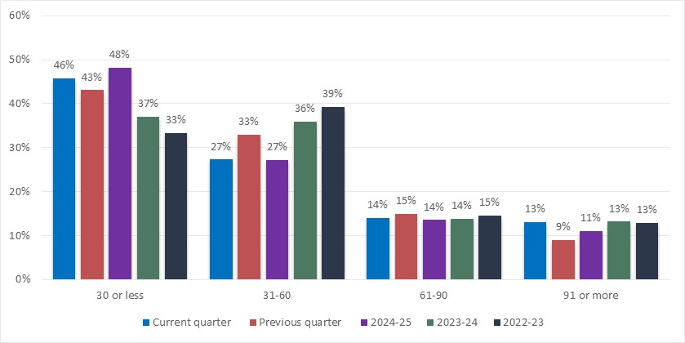

Table 7: Median processing times for residential real estate investment proposals
Current quarter | Previous quarter | 2024-25 | 2023-24 | 2022-23
4 days | 4 days | 4 days | 6 days | 7 days

National Security

Table 8: Number of approved national security investment proposals
 |  | Current quarter | Previous quarter | 2024-25 | 2023-24 | 2022-23
Mandatory | Approved with conditions | 3 | 0 | 8 | 11 | 15
Mandatory | Approved without conditions | 23 | 14 | 77 | 42 | 69
Mandatory | Total | 26 | 14 | 85 | 53 | 84
Voluntary | Approved with conditions | 3 | 1 | 5 | 1 | 4
 | Approved without conditions | 4 | 1 | 19 | 24 | 27
 | Total | 7 | 2 | 24 | 25 | 31
Note: Proposals involving multiple actions that include both mandatory and voluntary notifications are counted against each national security category.

Table 9: Value of approved national security investment proposals ($ billion)
 | Current quarter | Previous quarter | 2024-25 | 2023-24 | 2022-23
Approved with conditions | 0.1 | 0.1 | 0.5 | 0.3 | 1.0
Approved without conditions | 1.9 | 0.2 | 4.3 | 2.4 | 4.7
Total | 2.0 | 0.3 | 4.7 | 2.7 | 5.7

Compliance with foreign investment legislation

Condition mandated reports

Table 10: Number of condition mandated reports
 | Current quarter | Previous quarter | 2024-25 | 2023-24 | 2022-23
Condition mandated reports received | 711 | 685 | 2,788 | 2,785 | 2,577
Condition mandated reports assessed * | 702 | 565 | 2,681 | 3,188 | 3,027
Note: * Condition mandated reports assessed may include reports carried over from the previous financial years. Variations from previously published statistics are due to the reconciliation processes.

Foreign investment audit program

Table 11: Number of regulator audits
 | In progress | Completed
 | At current quarter end | Current quarter | Previous quarter | 2024-25 | 2023-24 | 2022-23
Regulator audits | 4 | 0 | 1 | 5 | 7 | 6

Table 12a: Number of independent audits in progress
 | At current quarter end
Proposals under review | 3
Reports in progress by investor | 24
Reports under review by Treasury | 4

Table 12b: Number of independent audits completed
 | Current quarter | Previous quarter | 2024-25 | 2023-24 | 2022-23
Proposals approved | 27 | 6 | 91 | 76 | 76
Reports completed | 32 | 21 | 96 | 67 | 78

Referrals and assessment of potential non-compliance

Table 13: Number of matters sourced via non-compliance referrals and assessments by information source
 | Current quarter | Previous quarter | 2024-25 | 2023-24 | 2022-23
Self-reported potential non-compliance with conditions (voluntary disclosures outside mandatory reporting) | 1 | 5 | 11 | 11 | 25
Failure to notify related referrals/reports from the public* | 12 | 17 | 64 | 33 | 43
Failure to notify related referrals/reports identified from other source** | 4 | 20 | 39 | 57 | 46
Total | 17 | 42 | 114 | 101 | 114
Note: * Including retrospective notifications received from investors.
** Referrals from other sources can include internal referrals from other areas of the Treasury or Government, as well as Treasury-initiated referrals as a result of media monitoring and market scanning for non-compliance.

Table 14: Number of infringement notices issued
 | Current quarter | Previous quarter | 2024-25 | 2023-24 | 2022-23
Infringement notices issued | 0 | 0 | 1 | 19 | 1

Matters under investigation

Table 15: Number of investigation matters
 | In progress | Completed
 | At current quarter end* | Current quarter | Previous quarter | 2024-25 | 2023-24 | 2022-23
Investigations | 15 | 1 | 3 | 7 | 4 | 2
Note: * Investigations on hand at the end of the current quarter may include investigations carried over from the previous quarter.

Methodology and glossary

Overview
- The statistics contained in this quarterly report reflect investor intentions (not actual purchases) to acquire Australian assets that are subject to the Foreign Acquisitions and Takeovers Act 1975.
- The statistics may include some transactions that do not actually proceed. For example, approvals in a given quarter which are not actually implemented in that quarter or at all. As a result, there can be differences between these statistics on proposed investment and actual investment flows.
- Any data that may enable the identification of a particular person or organisation has been suppressed to preserve confidentiality.
- Variations from previously published statistics are due to the reconciliation processes and system changes for the launch of a new online portal in May 2025 which marked completion of the Foreign Investment Digital Transformation (FIDT) program.

General caveats
- Data capture, systems and reporting methodologies may change over time.
- Data presented from earlier publications may have been revised since last published. Variations from previously published statistics are due to the reconciliation processes.
- Totals presented throughout the report may not add up due to rounding.
- Proposals include Exemption Certificates, which grant investors approval to make acquisitions over a defined period. These may have a specified financial limit or no financial cap. The majority of Exemption Certificates are given for a duration longer than one year. As a result, the associated acquisitions take place over a number of years and not necessarily within the same reporting period as when the Exemption Certificate was given.

Glossary
Term | Description
Compliance | The Treasury has concluded that there is sufficient appropriate evidence provided by the investor, and/or obtained from the third parties, to demonstrate the investors’ compliance with their foreign investment obligations.
Condition mandated reports | Reports from investors submitted in accordance with conditions imposed on their investment proposals, including their compliance with conditions.
Independent audits | Audit reports prepared by independent assurance practitioners on the investors’ compliance with conditions imposed on their investments. The independent assurance practitioners are engaged by the investors and approved by the Treasury.
Non-compliance | The Treasury has concluded that there is sufficient evidence to demonstrate that an investor has not complied with their foreign investment obligations.
Prohibition | Under section 67 of the Foreign Acquisitions and Takeovers Act 1975, the Treasurer may make an order which prohibits a proposed significant action, notifiable national security action or reviewable national security action if the Treasurer is satisfied that taking the action would be contrary to the national interest or national security (as applicable).
Regulator audits | Risk-based, Treasury-initiated compliance assurance activity undertaken to test investors’ compliance with conditions imposed on their investments.
Withdrawn | Withdrawn investment proposals are proposals withdrawn by the investor. Proposals may be withdrawn for a variety of reasons, including: the investor choosing not to proceed with or deferring a purchase; the investor being unsuccessful in a competitive tender process before the proposal was finalised; the proposed investment ‘target’ being withdrawn from the market; changes to investor consortium compositions; concerns identified by the Treasurer; or where the proposal was incorrectly lodged.

See Australia’s foreign investment framework for further information, https://foreigninvestment.gov.au/investing-in-australia/foreign-investment-framework.
See Guidance Note 8 on National Security for further information, https://foreigninvestment.gov.au/guidance/types-investments/national-security
See our approach to compliance, https://foreigninvestment.gov.au/sites/firb.gov.au/files/2021-01/FIRB_compliance_framework.pdf

