Foreign Investment Portal enhancements
  - On 17 January 2026, the Foreign Investment Portal will be upgraded to improve functionality and incorporate changes required under the mandatory ACCC merger control regime.

Communication improvements
We have enhanced the communication features in the Foreign Investment Portal to make messages visible and accessible to all portal users linked to the same account or sub-account. These changes reduce the risk of missing important information and support improved collaboration.

Changes to the communications landing page
You can now see all communication messages within your account or sub-account, not just those sent directly to or by you.
- Account messages and Account sent messages now show communications sent by all users within the relevant account or sub‑account.
- Messages sent directly to you remain visible in My inbox, and messages you send remain visible in My sent messages.
- This improvement ensures greater transparency and reduces the risk of missing critical updates or requests.
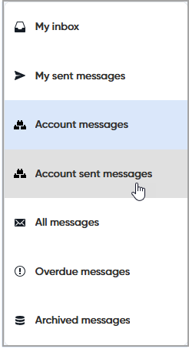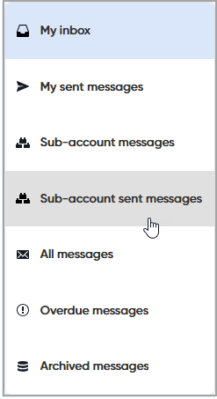
Existing tools such as the Search function and sorting by column headings (e.g., date, sender, subject) remain available to help you locate messages quickly.

Related messages
We have introduced a feature to improve visibility of communication chains between Treasury and portal users:
- View the full message chain: Related messages are now grouped together so you can see the entire conversation in context.
- Full timestamps: Both the date and time now appear for all messages, so you can see exactly when a message was sent or received.
- Access in My inbox: Click the arrow on the left side of a message to expand and view all related messages.
- View within an open message: When you open a message, all related messages will display below the message text, allowing you to follow the entire discussion without navigating away.
These enhancements make it easier to track communications regarding a submission or report and reduces the risk of missing important information.
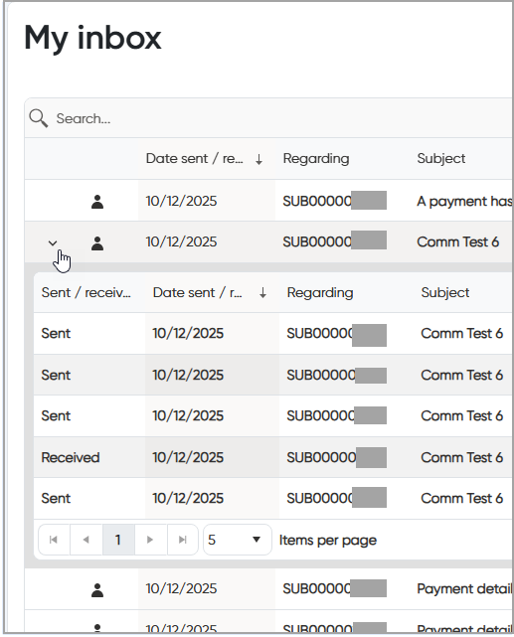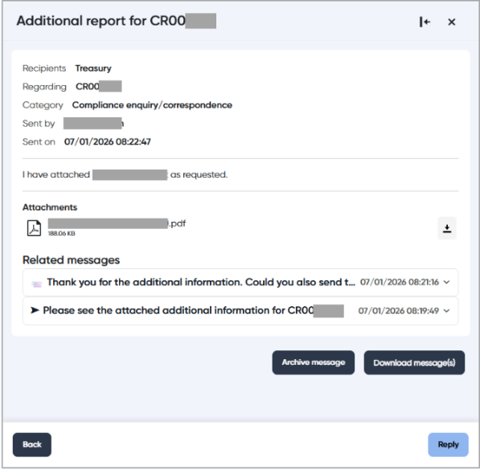

Submission form changes

ACCC merger control regime
Competition-related questions in the submission form have been updated to reflect the mandatory ACCC merger control requirements, effective from 1 January 2026, and their interaction with the foreign investment framework.
A detailed guide has been prepared to assist you in understanding these changes.
Please refer to the document Commencement of new merger control regime and interaction with the foreign investment framework available on our website for full details.
Important note: Draft submissions created before 17 January 2026 may need to be updated to include responses to the new competition questions.

Warning on Notifiable Actions – section 47
When a Notifiable Action (section 47) is selected on its own, the portal will display a warning message indicating that another action may need to be selected before you proceed. This prompts you to review the submission and add additional actions as required.

Compliance report changes
Compliance reports have been updated to improve the reporting and make it more efficient.

Single and multiple FI number compliance reports
- You can now submit multiple different compliance reports for the same FI number.
- You can also submit the same compliance report type across different FI numbers. This is intended to be used if investors are within the same corporate group and must submit similar reports for multiple FI numbers.

Prefilling investor details and conditions
To make compliance reporting faster and reduce manual data entry, some investor details and condition details will be pre-filled as you complete the compliance report. Details will only be pre-filled if the related submission is finalised with a decision in the Foreign Investment Portal.
Pre-filled data is only available when you are linked to the same account as the original submission and the FI number matches our records.

Report a suspected breach
If you have information about a suspected breach of Australia’s foreign investment laws, you can report it by submitting a Compliance Report. Privacy will be maintained where appropriate under law.
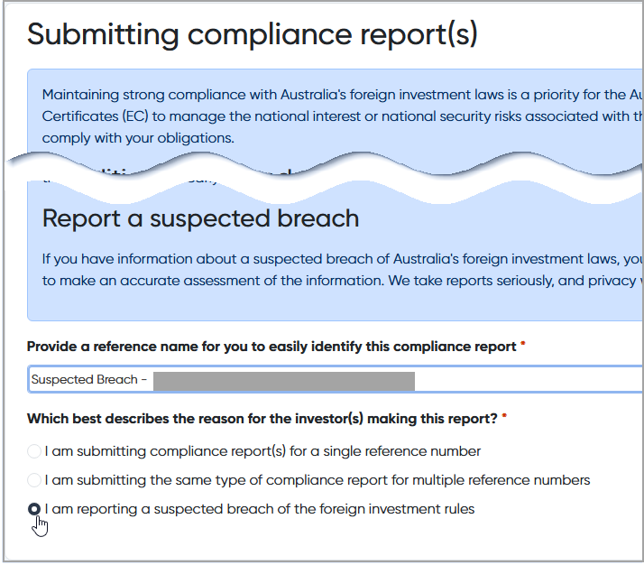

Independent audit reports and officer reports
For reports related to submissions lodged in the new Foreign Investment Portal, the independent audit reports and officer reports have been improved to display:
- All conditions from your Notice of No Objection (NON).
- The ability to select which conditions pertain to the report.
This feature reduces workload by leveraging condition information already held in the system. Conditions will only display if:
- You are linked to the same account as the original submission; and
- The FI number matches our records.

