Ultimate ownership instructions

|  |
| --- |
| You must complete the ultimate ownership details when creating or adding an investor to a submission in the Foreign Investment Portal.  An **ultimate owner** has a proportionate beneficial interest of 5 per cent or more in an investor. This is also the case if the aggregated proportionate interests of the investor’s associates add up to more than 5 per cent. |

## Overview

Providing accurate information in accordance with this guide will help reduce delays during submission assessment. Further information may be requested during assessment if needed.

* Add the details of each ultimate owner noting that entities holding less than a 5 per cent proportional beneficial interest are not considered ultimate owners.
* Ultimate owners must be identifiable and not include intermediate or interposed entities between ultimate owners and the investor. You should upload a diagram illustrating these structures.
* You must add the details of each ultimate owner when they:
* are **foreign government investors**[1] from one country that in aggregate hold more than a 5 per cent proportionate interest in the investor.
* are **associates**[2] that in aggregate hold more than a 5 per cent proportionate interest in the investor.
* You must also include when an ultimate owner is a publicly listed entity, this includes:
* shareholders that hold 5 per cent or more proportionate interest in the investor.
* any remaining interest must be added as the publicly listed entity**.**

## Ultimate ownership examples

Two examples are included to support you when entering ultimate ownership details into the portal.

|  |
| --- |
| Example 1: Publicly listed entities  InvestCo is an entity incorporated in Delaware, United States and is partially owned by a Singaporean incorporated company listed on the Singapore Exchange.  InvestCo’s ownership structure is as follows:   * A Canadian citizen holds a 20 per cent interest in InvestCo. * A Singaporean citizen holds a 20 per cent interest in Singapore Listed Ltd., which in turn holds an 80 per cent interest in InvestCo. * Other individuals/entities with each holding less than a 5 per cent interest, holds the remaining 80 per cent interest in Singapore Listed Ltd. |

Diagram 1: InvestCo corporate structure

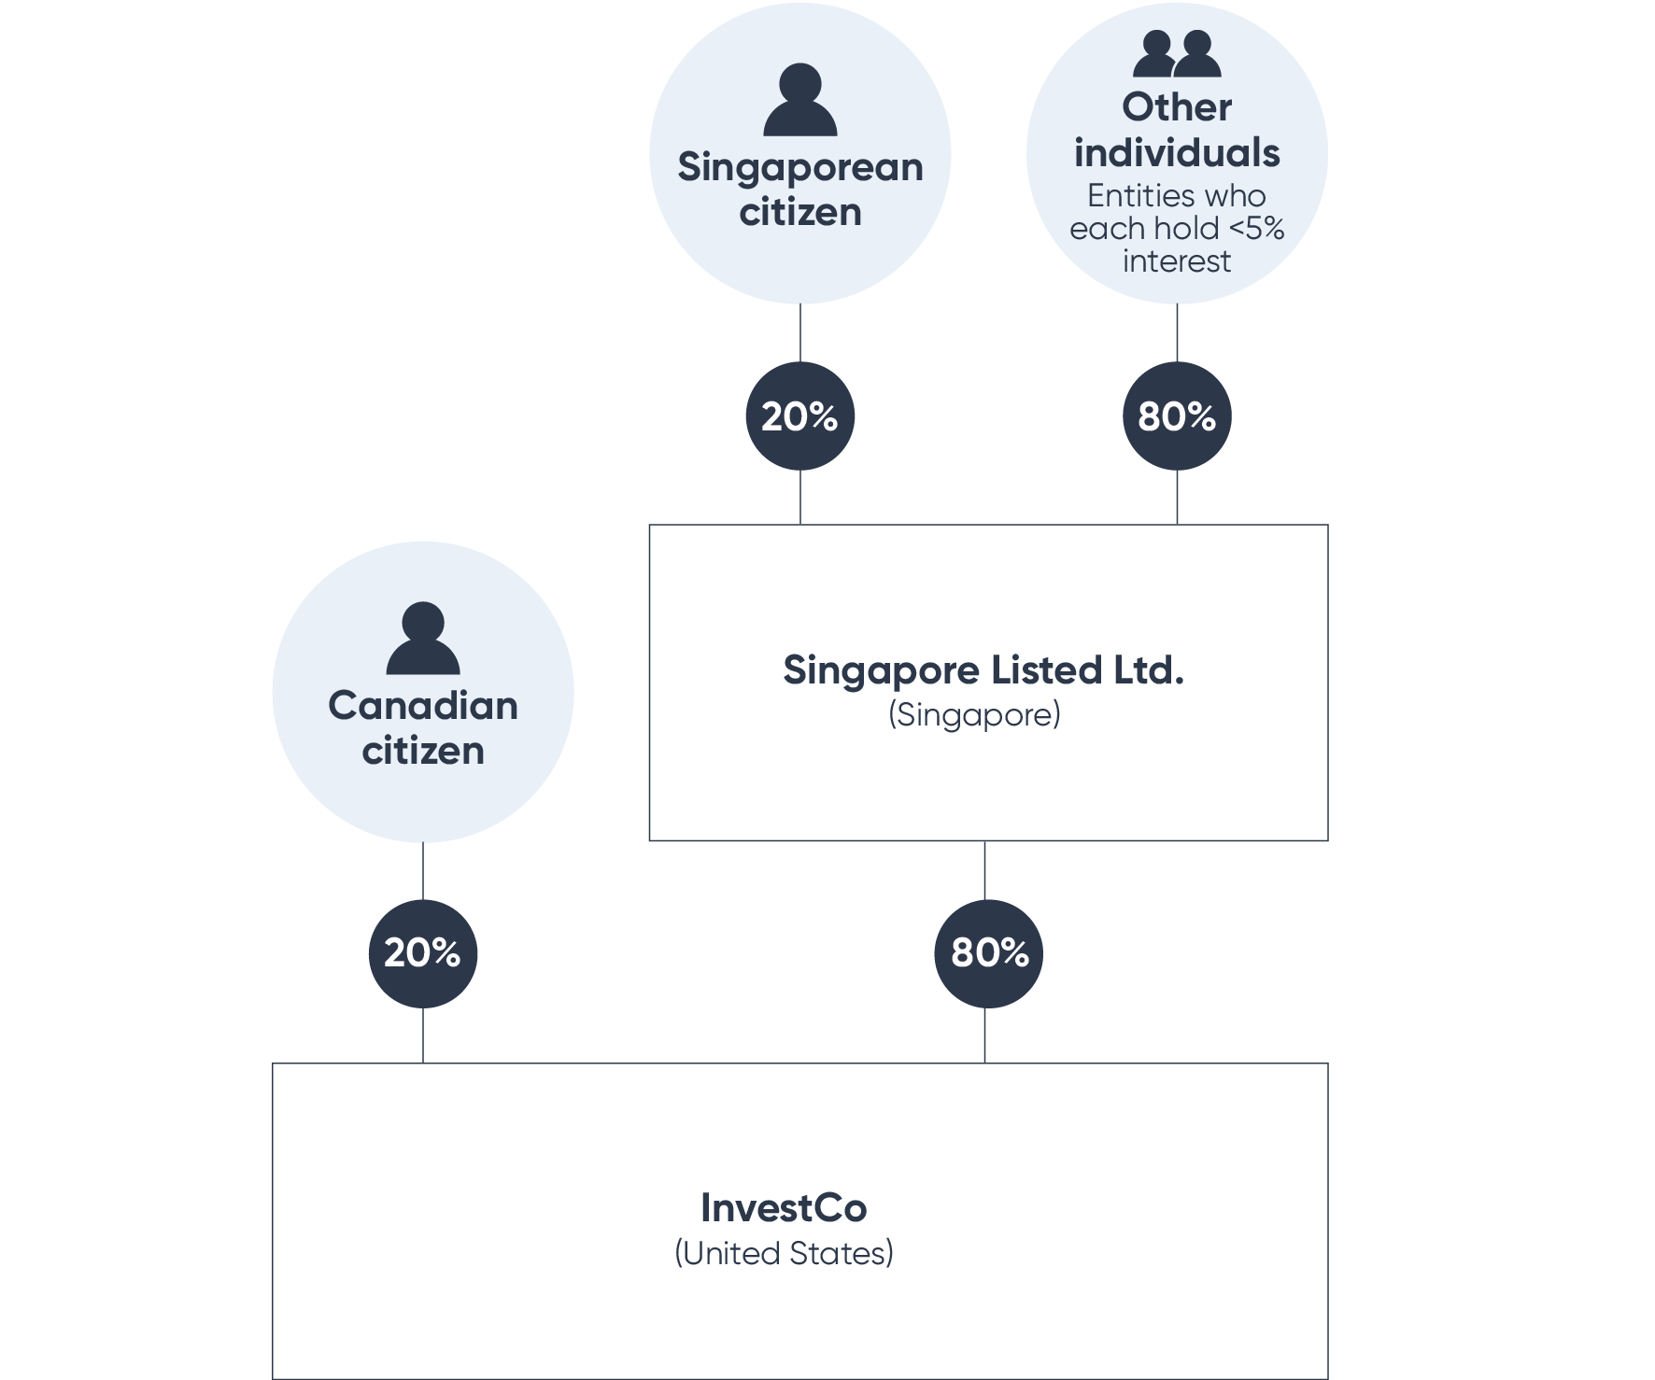

Text description

For this example, the following screenshot shows how the above information should be added in the portal.

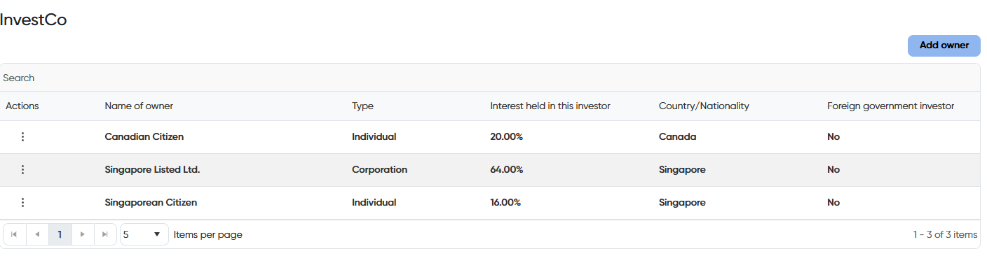

Text description

|  |
| --- |
| Example 2: Funds  InvestCo is an entity incorporated in Delaware, United States. It’s owned by the Foreign Infrastructure Fund (FI Fund) which is comprised of multiple ultimate beneficial owners.  InvestCo’s ownership structure is as follows:   * The FI Fund holds a 75 per cent interest in InvestCo. * The remaining 25 per cent interest is held by other individuals/entities that each hold less than a 5 per cent interest in InvestCo.   The FI Fund’s holding structure is as follows:   * Singapore Corp Pte. Ltd. (a Singaporean entity) owns all the units in the Singapore Corp Unit Trust. Trustee Ltd., in its capacity as trustee of the Singapore Corp Unit Trust, holds a 30 per cent interest in FI Fund. * There are multiple Canadian foreign government investors, each with less than 5 per cent interests in Investment Holdings Co. Inc. Investment Holdings Co., Limited holds a 10 per cent interest in FI Fund. * A French citizen holds a 20 per cent interest in Infrastructure Fund I L.P. and the remaining 80 per cent interest is held by Saudi Arabia Corp LLC (a Saudi Arabian government owned entity). * Infrastructure Fund I L.P. in turn holds a 35 per cent interest in FI Fund. * Japan Corp Co., Ltd (a Japanese government owned entity) wholly owns Japan Investment Holdings Co., Ltd which in turn holds a 25 per cent interest in FI Fund. |

Diagram 2: FI Fund corporate structure

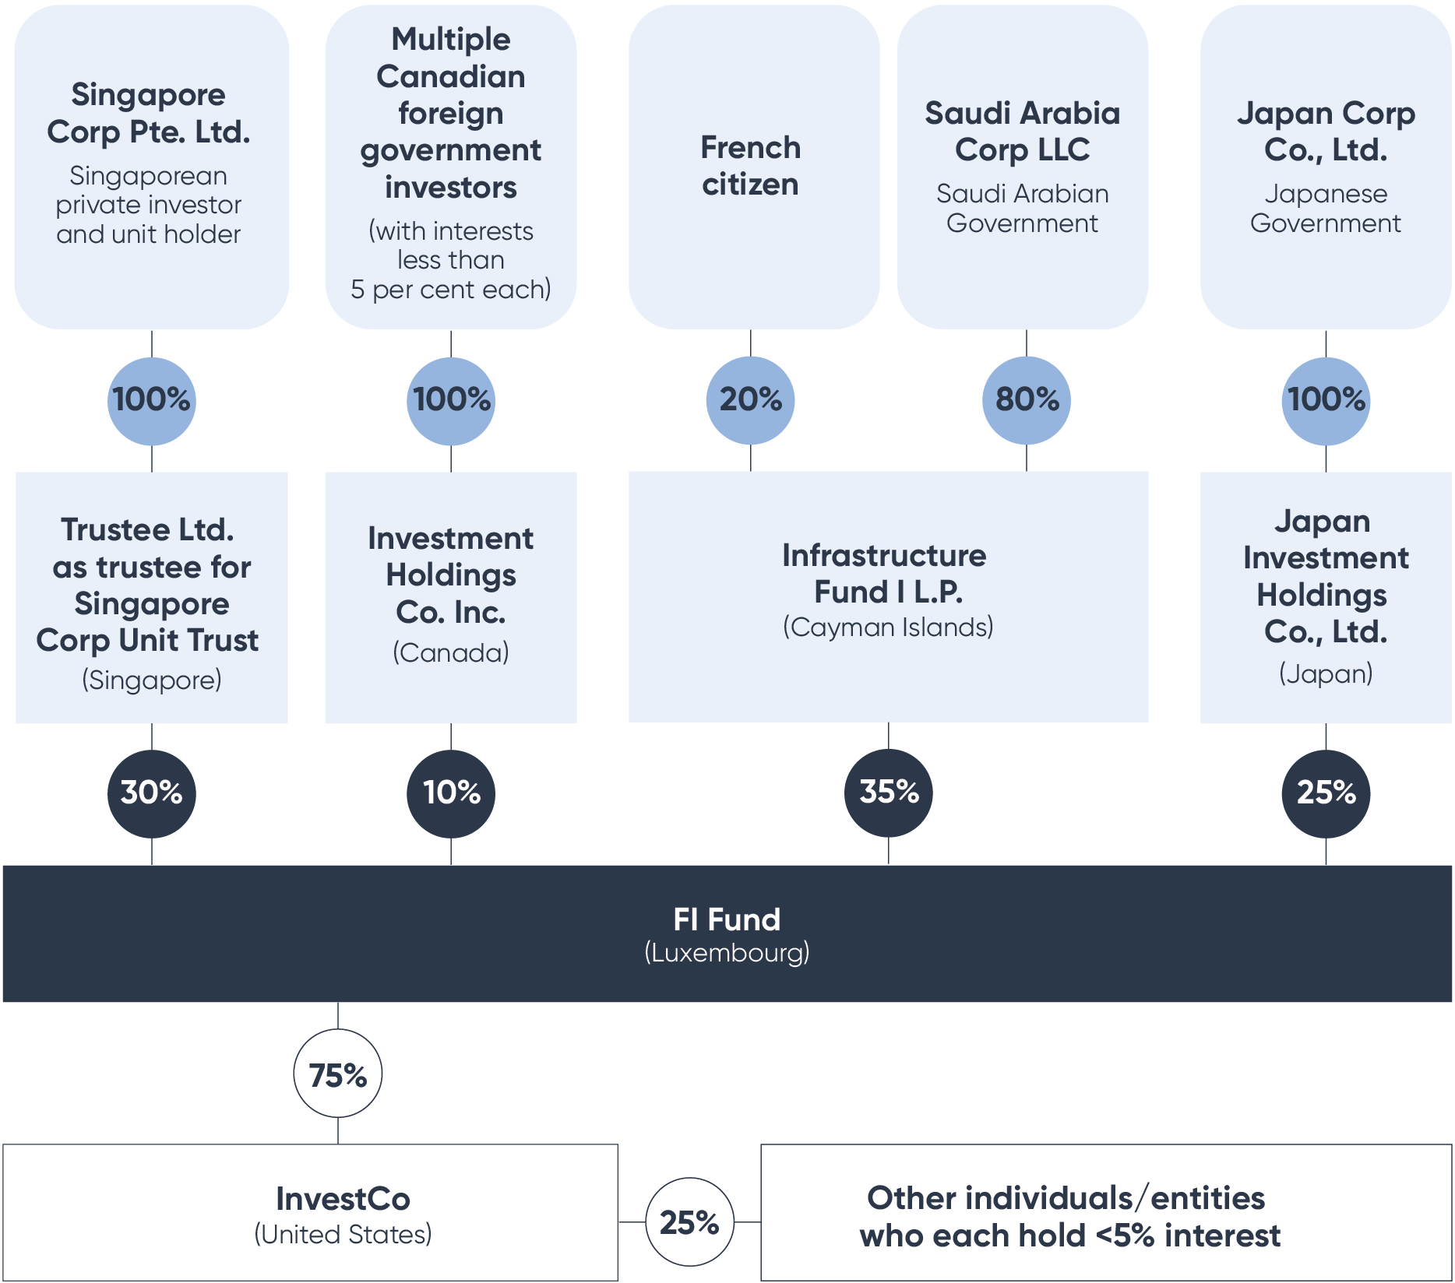Text description

For this example, the following is a screenshot shows how the above information should be entered in the portal.

Image 2: Foreign Investment Portal screenshot: Ultimate ownership section with example 2 publicly listed entities

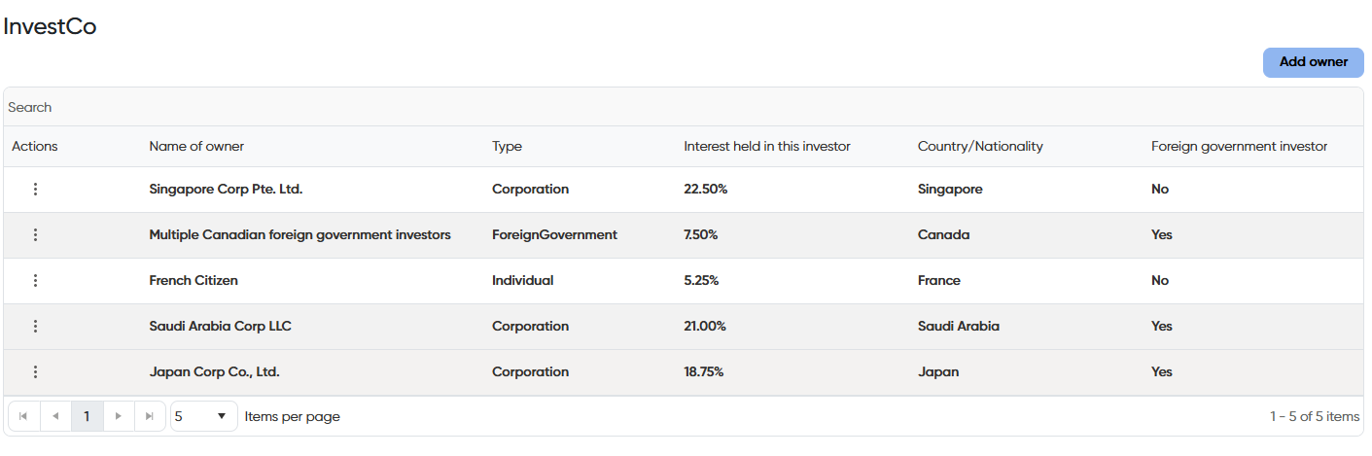

Text description

## Text description of diagram 1

Diagram 1 shows how to draw a simple corporate structure to be uploaded into the Foreign Investment Portal. The example is for a publicly listed entity with 3 main interest holders.

## Text description of image 1

Screenshot 1 shows an example of how to enter InvestCo’s ultimate ownership into the Foreign Investment Portal. The information includes:

* A Canadian Citizen being an individual that is not a foreign government investor with a 20.00 per cent interest.
* Singapore Listed Ltd being a corporation that is not a foreign government investor with a 64 per cent interest.
* A Singaporean Citizen being an individual that is not a foreign government investor with a 16 per cent interest.

## Text description of diagram 2

Diagram 2 shows how to draw a complex corporate structure to be uploaded into the Foreign Investment Portal. The example is for a Foreign Investment Infrastructure Fund comprising of multiple ultimate beneficial owners.

## Text description of screenshot 2

Screenshot 2 shows an example of how to enter InvestCo’s ultimate ownership into the Foreign Investment Portal. The information includes:

* Singapore Corp Pte. Ltd. being a corporation that is not a foreign government investor with a 22.5 per cent interest.
* Multiple Canadian foreign government investors being a foreign government that is a foreign government investor with a 7.5 per cent interest.
* A French Citizen being an individual that is not a foreign government investor with a 5.25 per cent interest.
* Saudi Arabia Corp LLC being a corporation that is a foreign government investor with a 21 per cent interest.
* Japan Corp Co., Ltd being a corporation that is a foreign government investor with an 18.75 per cent interest.

1. As defined in section 17 of the *Foreign Acquisitions and Takeovers Regulation 2015*.
2. As defined in section 4 of the *Foreign Acquisitions and Takeovers Act 1975*.