Portal registration fact sheet

|  |
| --- |
| This fact sheet explains how to register to use the Foreign Investment Portal to manage your obligations relating to foreign investment submissions.   * A **portal user** is an individual user that logs into the Foreign Investment Portal. * A **main account** generally belongs to the organisation the portal user is representing. This is usually an investor or an investor’s agent. |

## Overview

The Foreign Investment Portal is secure and user friendly. It prompts the collection of consistent and structured information upfront.

Portal users can use the Foreign Investment Portal to:

* make submissions
* track the status of submissions
* view historical submissions (from those submitted in the new portal)
* communicate with Treasury
* pay fees and apply for waivers
* submit compliance reports
* request an extension to the decision period end date
* review decisions.

## Access set up

You’ll need to set up your user profile to access the Foreign Investment Portal.

The diagram below shows you how to do this. You only need to do this once.

Diagram 1: Steps to set up access to the Foreign Investment Portal

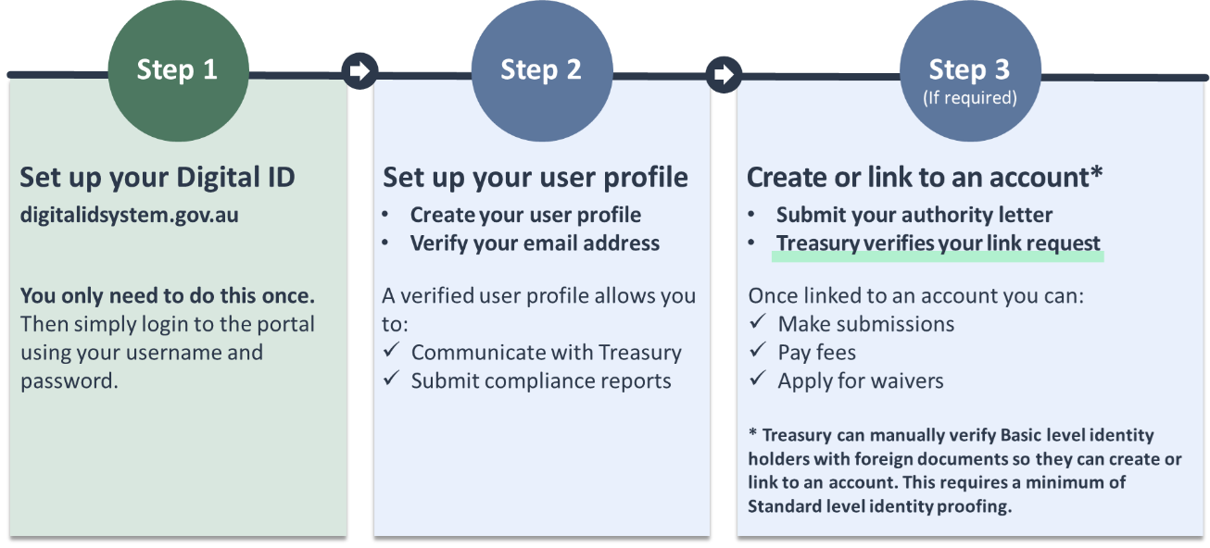Text description

## Digital ID

The Foreign Investment Portal welcome page prompts you to continue with your Digital ID. You’ll need your own Digital ID from an accredited provider to access the portal.

There are different identity proofing levels, and your level will impact what you can do in the portal.

|  |  |  |
| --- | --- | --- |
| **Identity proofing level** | **Identification requirements** | **What you can do** |
| Basic (IP1) | Only requires an email address or a phone number | Submit compliance reports and communicate with Treasury |
| Standard (IP2) | Typically requires 2 Australian ID documents | * Link to a main account * Make foreign investment submissions * Submit compliance reports * Communicate with Treasury |

|  |
| --- |
| Identity proofing level tip:   * If portal users can only achieve Basic identity proofing through their Digital ID provider, Treasury can do a manual verification to give them full access to the portal. |

## User profile

You must create a user profile when you first enter the portal.

Your email address must be verified for your portal access to be connected.

You can enter a different email address for portal communications.

|  |
| --- |
| User profile setup tip:   * You must use your personal credentials (including personal email) during the initial Digital ID setup. You can enter your work email address when setting up your user profile in the Foreign Investment Portal. |

## Main account

### Account linking

To have full access to the portal you must be linked to a main account:

* If you are an individual investor, you’ll need to set up your own main account.
* If you’re employed by an organisation (whether an investor or an agent), you’ll need to link to that organisation’s main account.

Once you are linked to a main account, you’ll be able to make submissions, pay fees and apply for waivers.

|  |
| --- |
| Account tip:   * There are many ways for an organisation to manage their accounts. For account linking options for a variety of organisational requirements, see the [Account linking and authorisation fact sheet](https://foreigninvestment.gov.au/getting-started/where-to-submit/new-portal#account-linking-fact-sheet). |

## Text description of diagram 1

Diagram 1 shows the set up process for the Foreign Investment Portal with 3 steps: set up your Digital ID, set up your portal user profile (Foreign Investment Portal), and create or link to an account (Foreign Investment Portal).

### Step 1: Set up your Digital ID

You only need to do this once.

For information about Digital ID, visit [digitalidsystem.gov.au](https://www.digitalidsystem.gov.au).

After you have set up your Digital ID, simply login to the portal using your username and password.

### Step 2: Set up your portal user profile for the Foreign Investment Portal

To set up your portal user profile you must:

1. Create your user profile
2. Verify your email address.

A verified user profile allows you to communicate with Treasury and submit compliance reports.

### Step 3: Create or link to an account

This step requires a minimum of Standard level identity proofing.

Treasury can perform a manual verification process to give Basic level identity proofing holders the ability to create or link to an account.

To create or link to a main account you must submit an authority letter. Treasury will then verify your link request.

Once you are linked to a main account you can make submissions, pay fees and apply for waivers.