Account linking and authorisation fact sheet

|  |
| --- |
| This fact sheet explains how to create or link to an account to have full access to the Foreign Investment Portal.   * A **portal user** is an individual user that logs into the Foreign Investment Portal. * The **main account** generally belongs to the organisation the portal user is representing. This is usually an investor or an investor’s agent. * **Sub-account(s)** can be set up within the main account to manage ethical walls and confidentiality of information. |

## Overview

The Foreign Investment Portal incorporates secure authorisation and account linking processes.

To make submissions, pay fees and apply for waivers in the Foreign Investment Portal, portal users need to create or link to a main account within the portal.

## Access set up

To become a portal user, you need to set up a user profile in the Foreign Investment Portal.

This process is outlined in the [Portal registration fact sheet](https://foreigninvestment.gov.au/getting-started/where-to-submit/new-portal#portal-registration-fact-sheet).

## Authorisation

Only authorised individuals should have access to an organisation’s main account. This helps safeguard personal and protected information.

Portal users must demonstrate their authorisation to act on behalf of a particular organisation.

### Authority letter

To set up the main account or link to it, you must provide an authority letter to prove you work for the organisation that owns the account.

This letter must be on your company’s letterhead and uploaded when creating the account or submitting an account linking request. For suggested wording, use our [Authority letter template](https://foreigninvestment.gov.au/getting-started/where-to-submit/new-portal#authority-letter-example).

Treasury will verify all linking requests to the main account to further reduce risk of unlawful access to personal or protected information.

Main account links will automatically expire after 2 years. If yours is due to expire, you can renew this authorisation through the portal. This process helps ensure that only the right people have access to the main account and any sub-accounts.

|  |
| --- |
| Example: portal user linking to their employer’s account  A lawyer wants to link to their law firm’s account, or an employee of an investor wants to link to their employer’s account.  To link to their employer’s account, the portal user will log into the portal using their own Digital ID, set up their user profile, verify their identity, and provide their authority letter. |

## Account linking and delinking

To have full access to the portal your user profile must be linked to your organisation’s main account:

* If you’re a direct investor, you’ll need to set up your own main account.
* If you’re employed by an organisation (whether an investor or an agent), you’ll need to link to that organisation’s main account.

Agents acting on behalf of investors do not need to create an investor account. You can add investor details during the submission process.

### Main account linking

There are 2 ways to link to a main account:

1. If there is no existing main account, you’ll need to create one by following the steps outlined in the Portal registration fact sheet.
2. For an existing main account, you can link your user profile using the account’s unique Treasury-issued ID number.

|  |
| --- |
| Main account linking tips:   * If you receive a portal message that your account creation request was denied, it is likely that somebody else within your organisation has already set up the main account. * You can find the Treasury-issued ID number in the portal under the ‘account details’ section. From the top right-hand corner of the screen, select the account name. |

### Main account delinking

You can submit a request to delink yourself or another portal user from a main account.

This safeguards personal and protected information if someone leaves an organisation, no longer needs access to the account, or your representation changes.

|  |
| --- |
| Example: investor delinking an authorised representative from their account  An investor wants to delink a portal user from their account.  A portal user makes a submission on behalf of an investor. After making the submission the investor delinks that portal user from the account, which removes their account access. |

### Sub-account linking

Treasury does not have any oversight or intervention in the creation and management of sub-accounts.

Once you have proven you are authorised to link to your organisation’s main account, you c

an create or be added to sub-accounts.

To set up a sub-account:

* Under ***Account***, select the link to create ***New Sub-Account***.
* Input the sub-account details and add other portal users from your main account.
* Select the ***Confirm*** button.

Once you have added a sub-account, you can click on the **Account name** in the top-right corner to open the account selector. This will allow you to select the account you would like to work from. If other users have granted you access to their sub-accounts, you will see them listed in the account selector too.

Image 1: Foreign Investment Portal screenshot: Account selector

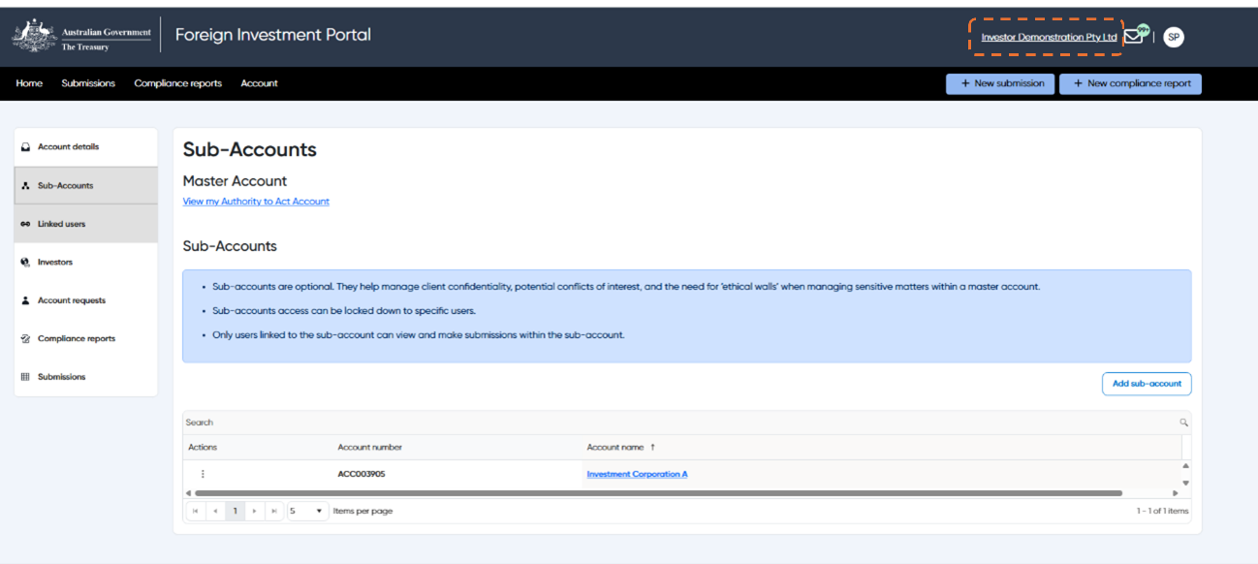

Text description

|  |
| --- |
| Sub-account tips:   * When setting up a sub-account, you don’t need to provide an authority letter as this information will be pre-filled with the information provided when linking to the main account. * Only portal users who are linked to the main account will be available to add to your sub-account. * You can set up multiple sub-accounts and be linked to multiple sub-accounts. * A sub-account will only be visible to portal users linked to it. Once you are linked to a sub-account you can add/remove others as needed. * If you select an account that you are not currently working on, you will receive a notification to confirm your action. |

## Account linking scenarios

Your organisation can only have one main account. If required, you can set up sub-accounts within the main account.

We’ve developed some scenarios to support organisations through this process.

|  |
| --- |
| Scenario 1: Individual investor main account creation  Alfie is an investor and wants to set up a main account.  Alfie must first login as an individual portal user before submitting a request to create the account. |

Diagram 1: Scenario 1 account creation

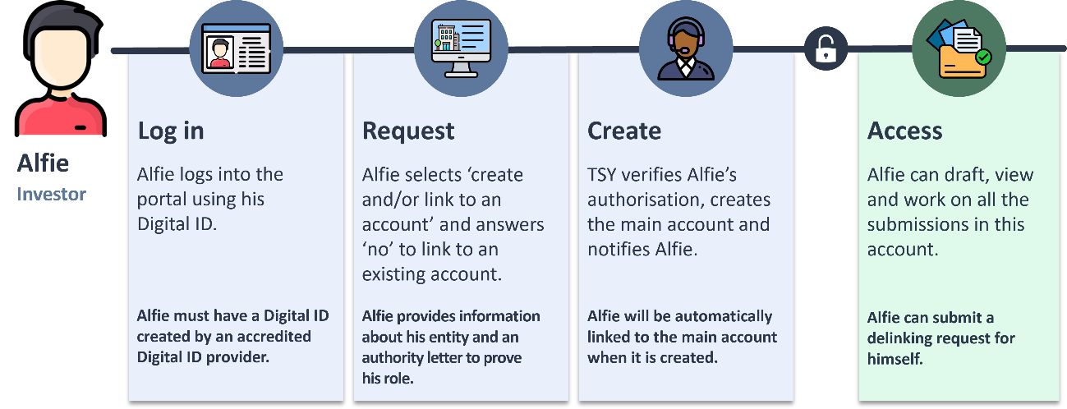

Text description

|  |
| --- |
| **Scenario 2: Investor main account creation**  Tammy is a Palo employee and wants to set up a main account on behalf of Palo.  Tammy must first login as an individual portal user before submitting a request to create the account. |

Diagram 2: Scenario 2 account creation

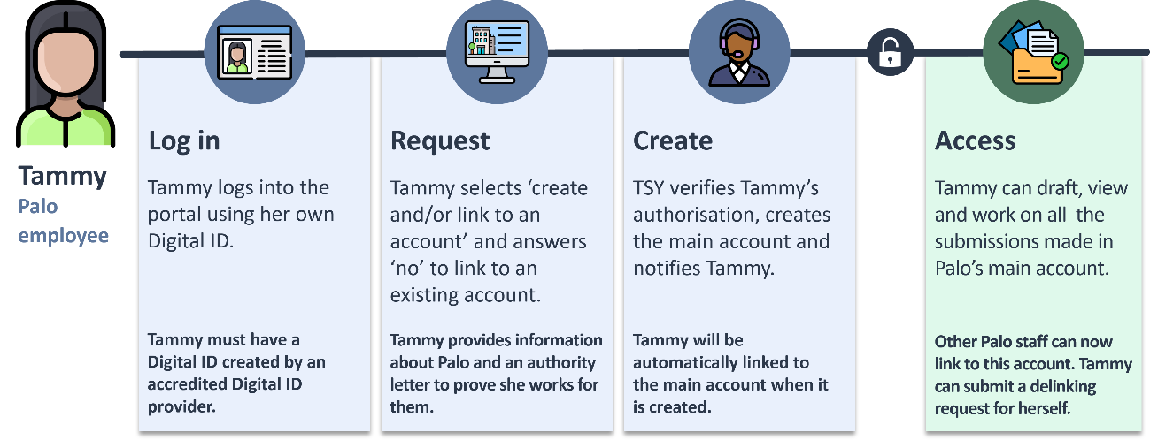

Text description

|  |
| --- |
| **Scenario 3: Agent main account creation**  Jenny is a Genco employee and wants to set up a main account on behalf of Genco.  Jenny must first login as an individual portal user before submitting a request to create the account for Genco.  Jenny does not need to set up an account on behalf of the investor that Genco is representing. |

Diagram 3: Scenario 3 account creation

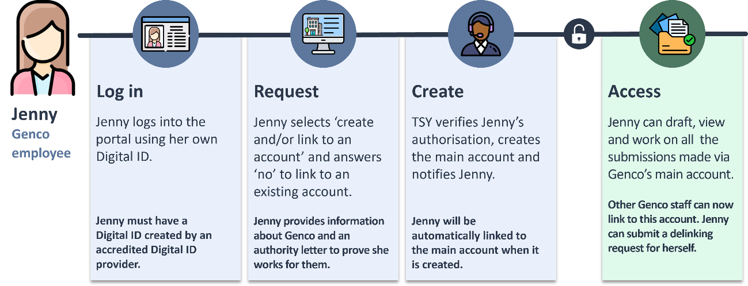

Text description

|  |
| --- |
| **Scenario 4: Linking to an existing main account**  John is a Genco employee and wants to link to Genco’s main account.  John must first login as an individual portal user before submitting a request to link to the main account for Genco. |

Diagram 4: Scenario 4 main account linking

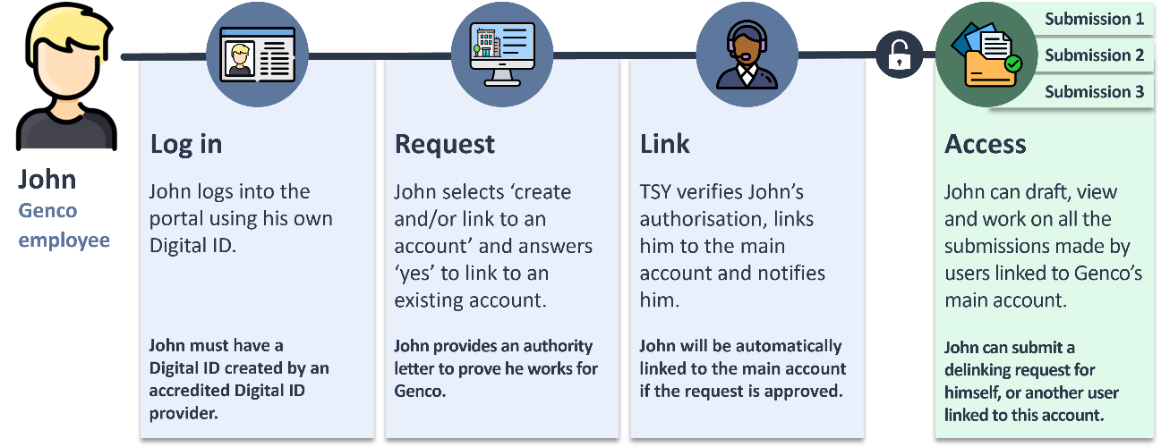

Text description

|  |
| --- |
| **Scenario 5: Sub-account creation**  Jim is a Genco employee but works in a separate practice area to Jenny and John.  There is an ethical wall between Jim’s practice area, *Genco (Investments)* and the rest of Genco.  Jim does not want portal users outside of *Genco (Investments)* to view submissions his practice area makes.  To maintain an ethical wall, Jim can create a sub-account for his practice area, *Genco (Investments).* |

Diagram 5: Scenario 5 sub-account creation

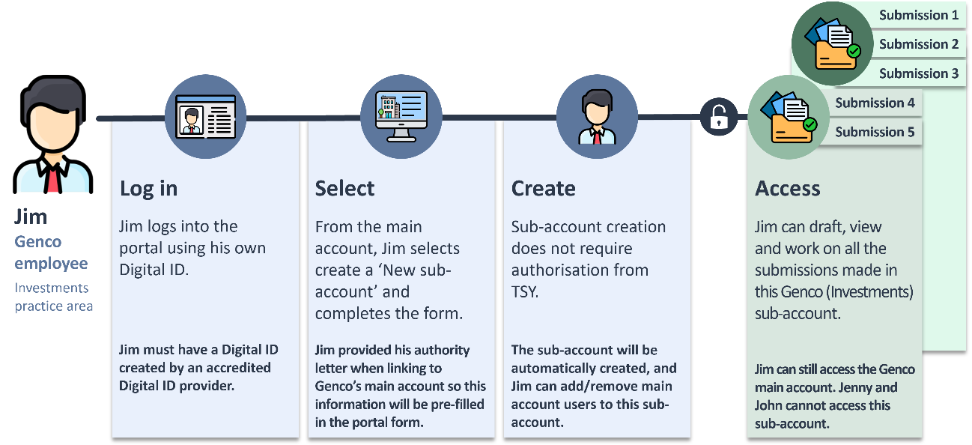

Text description

|  |
| --- |
| **Scenario 6: Main account delinking process**  Mabel left Genco to begin working at Leupin.  She wants to work on submissions Leupin is managing.  Portal users can only be linked to one main account at a time, so she must delink from Genco’s main account (prior to leaving) and submit a request to link to Leupin’s main account. |

Diagram 6: Scenario 6 account delinking

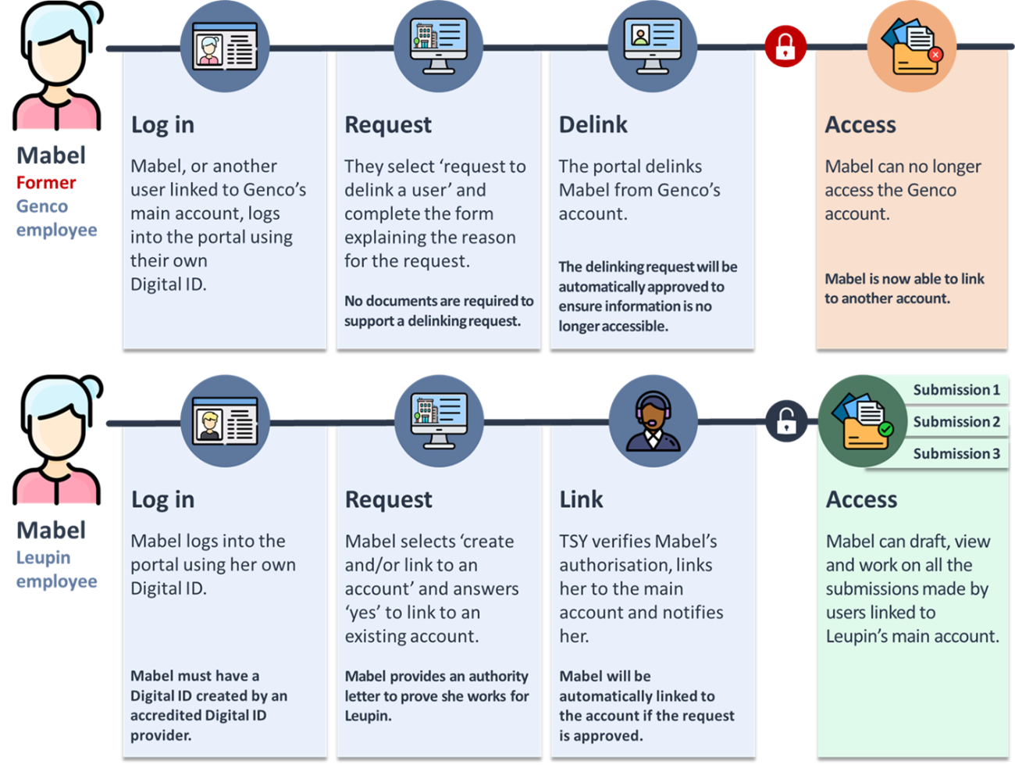

Text description

## Text description of image 1

Screenshot 1 shows how to select an account in the Foreign Investment Portal. Once linked to a sub-account or multiple sub-accounts, portal users can select which account to work from by using the account selector. They can select the main account or a sub-account.

## Text description of diagram 1

Diagram 1 shows the process for how an individual investor can create a main account in the Foreign Investment Portal with 3 steps: log in, request and create.

**Step 1: Log in**

Log into the portal using your Digital ID.

**Step 2: Request**

Select create and/or link to an account and answer no to link to an existing account. During this step the investor must prove their authority.

**Step 3: Create**

Treasury verifies the authorisation, creates the main account and notifies the investor.

Once all the steps are completed, the investor can now draft, view and work on all submissions in this account. The investor can also submit a delinking request for this account.

## Text description of diagram 2

Diagram 2 shows the process for how an employee of an investor can create a main account in the Foreign Investment Portal with 3 steps: log in, request and create.

**Step 1: Log in**

Log into the portal using your Digital ID.

**Step 2: Request**

Select create and/or link to an account and answer no to link to an existing account. During this step the employee must prove their authority.

**Step 3: Create**

Treasury verifies the authorisation, creates the main account and notifies the employee.

Once all the steps are completed, the employee can now draft, view and work on all submissions in this account. The employee can also submit a delinking request for this account.

## Text description of diagram 3

Diagram 3 shows the process for how an agent can create a main account in the Foreign Investment Portal with 3 steps: log in, request and create.

**Step 1: Log in**

Log into the portal using your Digital ID.

**Step 2: Request**

Select create and/or link to an account and answer no to link to an existing account. During this step the agent must prove their authority.

**Step 3: Create**

Treasury verifies the authorisation, creates the main account and notifies the agent.

Once all the steps are completed, the agent can now draft, view and work on all submissions in this account. The agent can also submit a delinking request for this account.

## Text description of diagram 4

Diagram 4 shows the process for how an employee of an investor or an agent, can link to a main account in the Foreign Investment Portal with 3 steps: log in, request and create.

**Step 1: Log in**

Log into the portal using your Digital ID.

**Step 2: Request**

Select create and/or link to an account and answer yes to link to an existing account. During this step the employee must prove their authority.

**Step 3: Link**

Treasury verifies the authorisation, links the employee to the main account and notifies them.

Once all the steps are completed, the employee can now draft, view and work on all submissions in this account. The employee can also submit a delinking request for themselves or another user for this account.

## Text description of diagram 5

Diagram 5 shows the process for setting up a sub-account within a main account to maintain ethical walls in the Foreign Investment Portal with 3 steps: log in, select and create.

**Step 1: Log in**

Log into the portal using your Digital ID.

**Step 2: Select**

Select create new sub-account and enter the sub-account details. As the authority letter was provided when setting up the main account this information will be pre-filled in the portal form.

**Step 3: Create**

Treasury does not approve the creation of sub-accounts so the account will automatically appear once all the steps are completed. The employee can now draft, view and work on all submissions in this sub-account. They can also add/remove users from the main account to this sub-account.

## Text description of diagram 6

Diagram 6 shows the process for how a portal user can delink from an account in the Foreign Investment Portal with 3 steps: log in, request and delink.

**Step 1: Log in**

Log into the portal using your Digital ID.

**Step 2: Request**

Select the request to delink a user button in-system, select the portal user and provide a reason why. No documents are required to support this.

**Step 3: Delink**

The portal delinks the user from the account.

Once all the steps are completed, the portal user can request to create or link to another account.