Compliance reporting fact sheet

|  |
| --- |
| This fact sheet explains how you can use the Foreign Investment Portal to manage your obligations relating to foreign investment compliance reporting. |

## Overview

Compliance reporting forms are user-friendly and provide guidance at the point it’s needed. The forms prompt the collection of accurate information upfront and capture additional information vital for compliance assessment purposes.

Use the Foreign Investment Portal to manage your compliance reporting obligations. You can use the portal to:

* provide periodic or ad hoc reports on compliance with conditions of your no objection notification (NON) or exemption certificate (EC)
* provide notifications in accordance with legislative requirements
* request approval on matters related to your NON or EC conditions
* communicate with Treasury.

## Submit a compliance report, notification or approval request

You’ll need to send compliance reports, notifications, or requests to Treasury through the Foreign Investment Portal. The graphic below shows you how to do this.

Diagram 1: Steps to submit a compliance report

[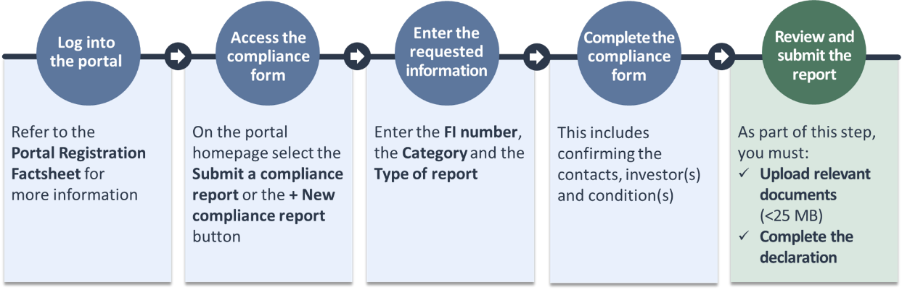](https://foreigninvestment.gov.au/getting-started/where-to-submit/new-portal#portal-registration-fact-sheet)

Text description

|  |
| --- |
| Compliance reporting tips:   * Submitted reports will be saved in the *compliance reports page* of your portal account. * If you are submitting your annual compliance report, you must declare your compliance status for each submission. Have your NON or EC available to assist you. |

## Communicate with Treasury

To communicate with Treasury about compliance obligations, use the ***View correspondence*** link or the envelope icon at the top right of the page.

|  |
| --- |
| Communications tips:   * If you have new messages in your portal inbox, a green circle with the number of unread messages will appear next to the envelope icon. |

If you experience any difficulty using the portal or the compliance form, please contact foreign investment enquiries:

|  |  |
| --- | --- |
| Receiver with solid fill | +61 2 6263 3795 Monday to Friday from 10 am to midday and 2 pm to 5 pm (AEST) except ACT public holidays. |
|  | Our phone line operating hours may change. If you can’t reach us by phone, email [foreigninvestmentenquiries@treasury.gov.au](mailto:foreigninvestmentenquiries@treasury.gov.au). |

## Text description of diagram 1

Diagram 1 shows the process for submitting a compliance report in the Foreign Investment Portal with 5 steps: log into the portal, access the compliance form, enter the requested information, complete the compliance form and review and submit the report.

### Step 1: Log into the portal

Refer to the Portal registration factsheet for more information.

### Step 2: Access the compliance form

On the portal homepage select the **Submit a compliance report** or the **+ New compliance report** button.

### Step 3: Enter the requested information

Enter the **FI number**, the **Category** and the **Type of report**.

### Step 4: Complete the compliance form

This includes confirming the contacts, investor(s) and condition(s).

### Step 5: Review and submit the report

As part of this step, you must upload relevant documents (less than 25 megabytes) and complete the declaration.