Account linking and authorisation fact sheet

|  |
| --- |
| This fact sheet explains how to create or link to an account to have full access to the Foreign Investment Portal.   * A **portal user** is an individual user that logs into the Foreign Investment Portal. * An **account** generally belongs to the organisation the portal user is representing. This is usually an investor or an investor’s agent. |

## Overview

The Foreign Investment Portal incorporates secure authorisation and account linking processes.

To make submissions, pay fees and apply for waivers in the Foreign Investment Portal, portal users need to create or link to an account within the portal.

## Access set up

To become a portal user, you need to set up a user profile in the Foreign Investment Portal.

This process is outlined in the [Portal registration fact sheet](https://foreigninvestment.gov.au/getting-started/where-to-submit/new-portal#portal-registration-fact-sheet).

## Authorisation

Only authorised individuals should have access to an account. This helps safeguard personal and protected information.

Portal users must demonstrate their authorisation to act on behalf of a particular organisation.

### Authority letter

To set up or link to an account, you must provide an authority letter to prove you work for the organisation that owns the account.

This letter must be on your company’s letterhead and uploaded when creating your account or submitting an account linking request. For suggested wording, use our [Authority letter template](https://foreigninvestment.gov.au/getting-started/where-to-submit/new-portal#authority-letter-example).

Treasury will verify all account linking requests to further reduce risk of unlawful access to personal or protected information.

Account links will automatically expire after 2 years. If yours is due to expire, you can renew this authorisation through the portal. This process helps ensure that only the right people have access to the account.

|  |
| --- |
| Example: portal user linking to their employer’s account  A lawyer wants to link to their law firm’s account, or an employee of an investor wants to link to their employer’s account.  To link to their employer’s account, the portal user will log into the portal using their own Digital ID, set up their user profile, verify their identity, and provide their authority letter. |

## Account linking and delinking

To have full access to the portal your user profile must be linked to an account:

* If you’re a direct investor, you’ll need to set up your own account.
* If you’re employed by an organisation (whether an investor or an agent), you’ll need to link to that organisation’s account.

Agents acting on behalf of investors do not need to create an investor account. You can add investor details during the submission process.

### Account linking

There are 2 ways to link to an account:

1. If there is no existing account, you’ll need to create one by following the steps outlined in the Portal registration fact sheet.
2. For an existing account, you can link your user profile using the account’s unique Treasury-issued ID number.

|  |
| --- |
| Account linking tips:   * If you receive a portal message that your account creation request was denied, it is likely that somebody else within your organisation has already set up an account. * You can find the Treasury-issued ID number in the portal under the ‘account details’ section. From the top right-hand corner of the screen, select the account name. |

### Account delinking

You can submit a request to delink yourself or another portal user from an account.

This safeguards personal and protected information if someone leaves an organisation, no longer needs access to the account, or your representation changes.

|  |
| --- |
| Example: investor delinking an authorised representative from their account  An investor wants to delink a portal user from their account.  A portal user makes a submission on behalf of an investor. After making the submission the investor delinks that portal user from the account, which removes their account access. |

## Account linking scenarios

Your user profile can only link to one account at a time, even if your organisation has multiple accounts.

We’ve developed some scenarios to support organisations when setting up accounts.

|  |
| --- |
| Scenario 1: Individual investor account creation  Alfie is an investor and wants to set up an account.  Alfie must first login as an individual portal user before submitting a request to create an account. |

Diagram 1: Scenario 1 account creation

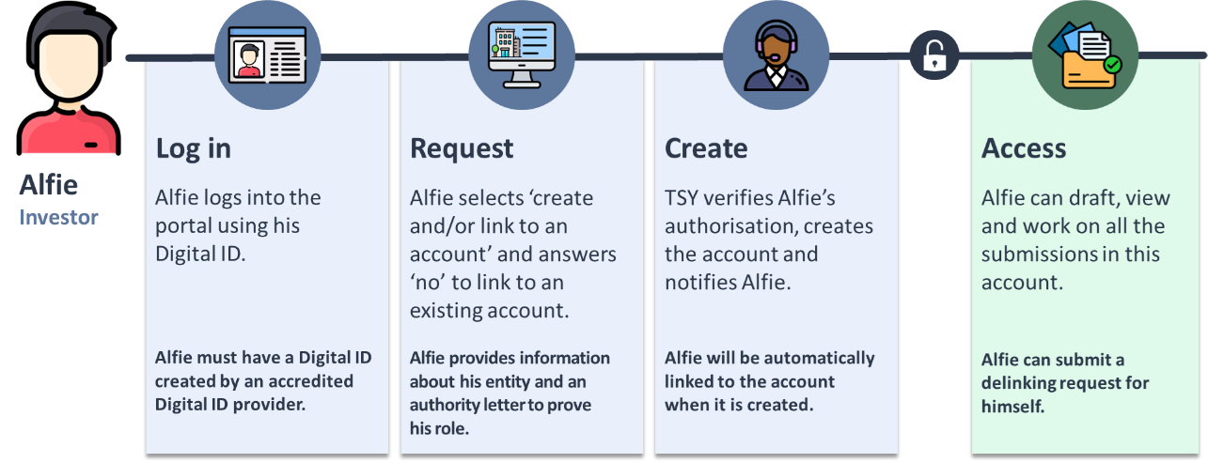Text description

|  |
| --- |
| Scenario 2: Investor account creation  Tammy is a Palo employee and wants to set up an account on behalf of Palo.  Tammy must first login as an individual portal user before submitting a request to create an account. |

Diagram 2: Scenario 2 account creation

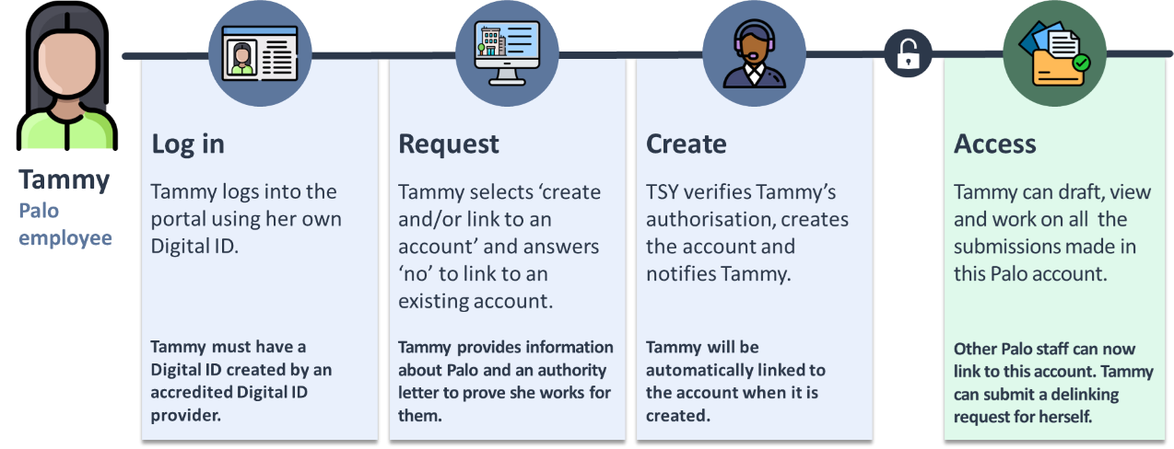Text description

|  |
| --- |
| Scenario 3: Agent portal account creation  Jenny is a Genco employee and wants to set up an account on behalf of Genco.  Jenny must first login as an individual portal user before submitting a request to create an account for Genco.  Jenny does not need to set up an account on behalf of the investor that Genco is representing. |

Diagram 3: Scenario 3 account creation

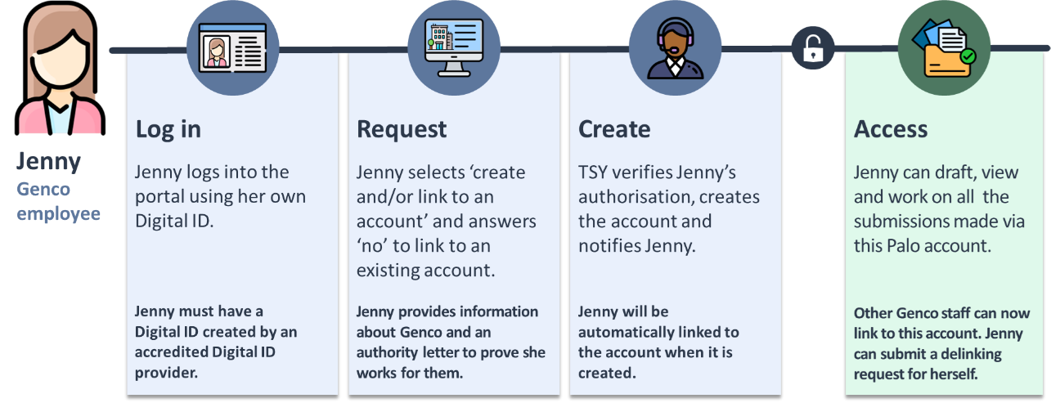Text description

|  |
| --- |
| Scenario 4: Linking to an existing account  John is a Genco employee and wants to link to Genco’s existing account.  John must first login as an individual portal user before submitting a request to link to the account for Genco. |

Diagram 4: Scenario 4 account linking

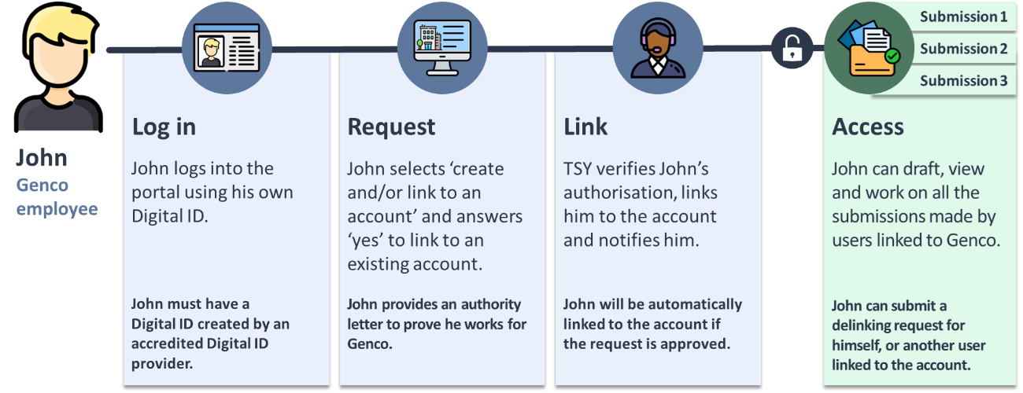Text description

|  |
| --- |
| Scenario 5: Account creation to maintain ethical walls  Jim is a Genco employee but works in a separate practice area to Jenny and John.  There is an ethical wall between Jim’s practice area, *Genco (Investments)* and the rest of Genco.  Jim does not want portal users outside of *Genco (Investments)* to view submissions his practice area makes.  To maintain an ethical wall, Jim can create an account for his practice area, *Genco (Investments).* |

Diagram 5: Scenario 5 account creation

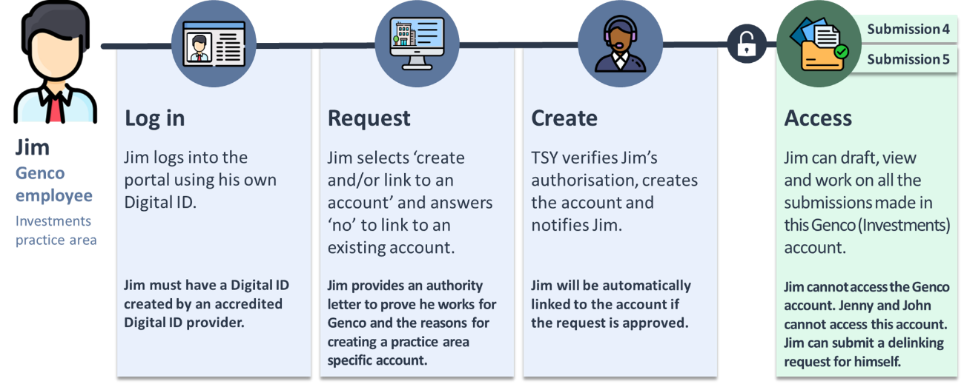Text description

|  |
| --- |
| Scenario 6: Management wanting to oversee multiple accounts  Marigold is a managing partner at Genco. She requires oversight of all Genco submissions.  Her intention is to be linked to these accounts, but this is not possible.  Instead, she maintains oversight by getting Jenny and Jim to download drafts of their submissions for her review before they submit them in the portal. |

Diagram 6: Scenario 6 overseeing accounts

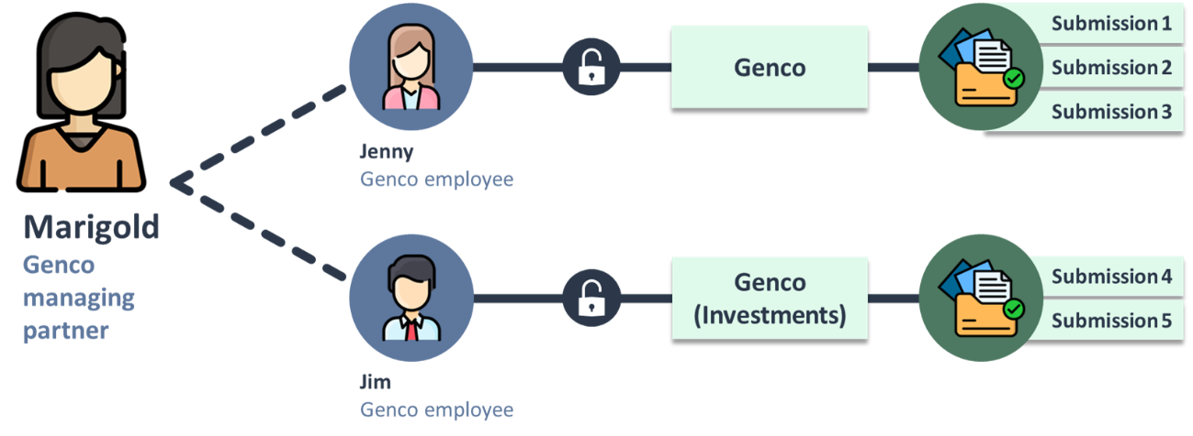Text description

|  |
| --- |
| Scenario 7: Managing inability to link to multiple accounts  Jerome is an in-house lawyer at Palo who is required to provide input into all their submissions.  Tammy and Brenda work for Palo but there is an ethical wall that prevents them from viewing each other's submissions.  Tammy and Brenda draft their submissions and hand them onto Jerome.  Jerome creates an account for *Palo (Law)*, provides input into all submissions and submits them in the portal. |

Diagram 7: Scenario 7 managing multiple accounts

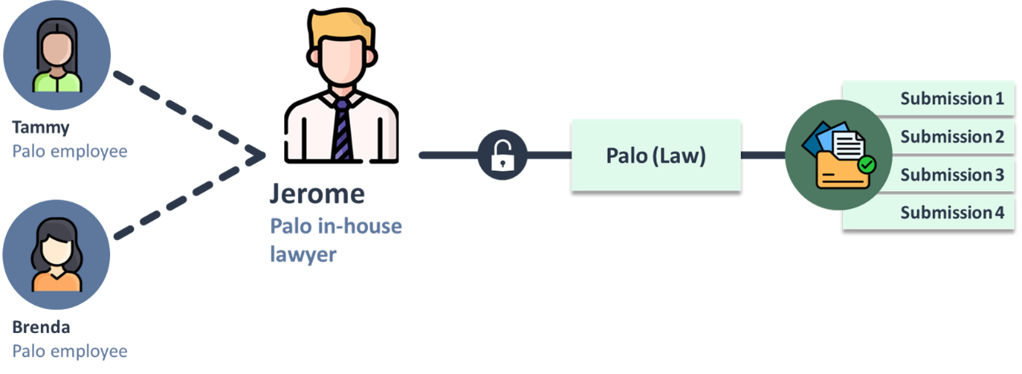

Text description

|  |
| --- |
| Scenario 8: Account delinking process  Mabel left Genco to begin working at Leupin.  She wants to work on submissions Leupin is managing.  Portal users can only be linked to one account at a time, so she must delink from Genco (prior to leaving) and submit a request to link to Leupin. |

Diagram 8: Scenario 8 account delinking

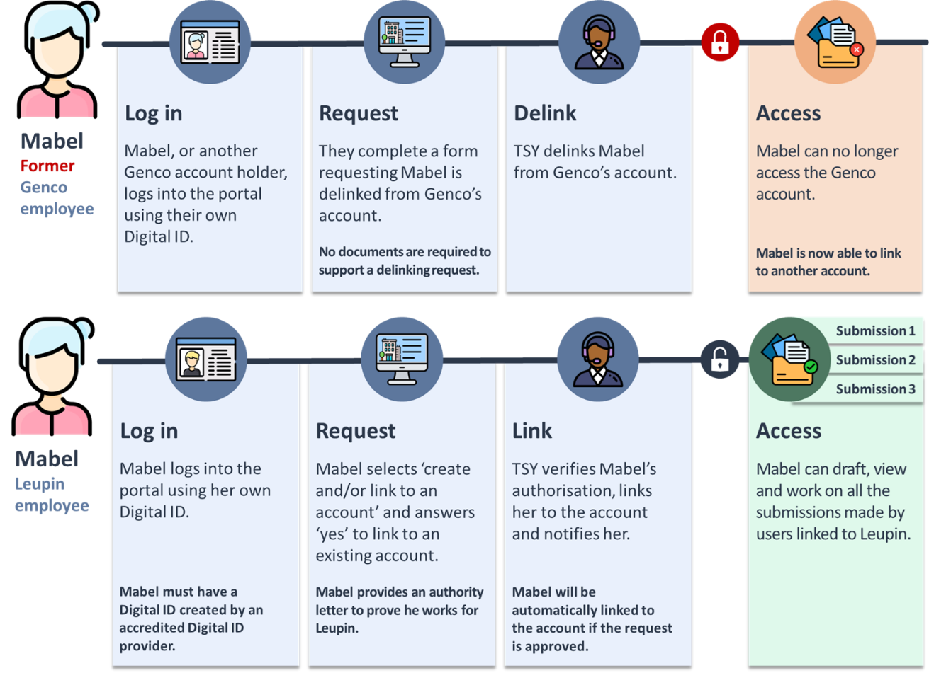

Text description

## Text description of diagram 1

Diagram 1 shows the process for how an individual investor can create an account in the Foreign Investment Portal with 3 steps: log in, request and create.

**Step 1: Log in**

Log into the portal using your Digital ID.

**Step 2: Request**

Select create and/or link to an account and answer no to link to an existing account. During this step the investor must prove their authority.

**Step 3: Create**

Treasury verifies the authorisation, creates the account and notifies the investor.

Once all the steps are completed, the investor can now draft, view and work on all submissions in this account. The investor can also submit a delinking request for this account.

## Text description of diagram 2

Diagram 2 shows the process for how an employee of an investor can create an account in the Foreign Investment Portal with 3 steps: log in, request and create.

**Step 1: Log in**

Log into the portal using your Digital ID.

**Step 2: Request**

Select create and/or link to an account and answer no to link to an existing account. During this step the employee must prove their authority.

**Step 3: Create**

Treasury verifies the authorisation, creates the account and notifies the employee.

Once all the steps are completed, the employee can now draft, view and work on all submissions in this account. The employee can also submit a delinking request for this account.

## Text description of diagram 3

Diagram 3 shows the process for how an agent can create an account in the Foreign Investment Portal with 3 steps: log in, request and create.

**Step 1: Log in**

Log into the portal using your Digital ID.

**Step 2: Request**

Select create and/or link to an account and answer no to link to an existing account. During this step the agent must prove their authority.

**Step 3: Create**

Treasury verifies the authorisation, creates the account and notifies the agent.

Once all the steps are completed, the agent can now draft, view and work on all submissions in this account. The agent can also submit a delinking request for this account.

## Text description of diagram 4

Diagram 4 shows the process for how an employee of an investor or an agent, can link to an account in the Foreign Investment Portal with 3 steps: log in, request and create.

**Step 1: Log in**

Log into the portal using your Digital ID.

**Step 2: Request**

Select create and/or link to an account and answer yes to link to an existing account. During this step the employee must prove their authority.

**Step 3: Link**

Treasury verifies the authorisation, links the employee to the account and notifies them.

Once all the steps are completed, the employee can now draft, view and work on all submissions in this account. The employee can also submit a delinking request for themselves or another user for this account.

## Text description of diagram 5

Diagram 5 shows the process for how an employee of an investor or an agent, can create an account to maintain ethical walls in the Foreign Investment Portal with 3 steps: log in, request and create.

**Step 1: Log in**

Log into the portal using your Digital ID.

**Step 2: Request**

Select create and/or link to an account and answer no to link to an existing account. During this step the employee must prove their authority.

**Step 3: Create**

Treasury verifies the authorisation, creates the account and notifies the employee.

Once all the steps are completed, the employee can now draft, view and work on all submissions in this account. The employee can also submit a delinking request for this account.

## Text description of diagram 6

Diagram 6 shows how a manager can oversee multiple accounts within the Foreign Investment Portal.

## Text description of diagram 7

Diagram 7 shows how an in-house lawyer at an investor’s company can create an account to provide input on all the investor’s submissions and submit them in the Foreign Investment Portal.

## Text description of diagram 8

Diagram 8 shows the process for how a portal user can delink from an account in the Foreign Investment Portal with 3 steps: log in, request and delink.

**Step 1: Log in**

Log into the portal using your Digital ID.

**Step 2: Request**

Select the request to delink a user button in-system, select the portal user and provide a reason why. No documents are required to support this.

**Step 3: Delink**

Treasury delinks the portal user from the account.

Once all the steps are completed, the portal user can request to create or link to another account.