Register 2022

.

Register of foreign ownership
of residential land
Insights into foreign purchases and sales of residential real estate for the period 1 July 2022 to 30 June 2023

The Register of foreign ownership of residential land has been established

to increase transparency around foreign investment in Australia.
Information has been extracted from the Register to provide insights into foreign purchases and sales of residential real estate. The information relates to residential real estate transactions (purchases or sales) by foreign persons in the period 1 July 2022 to 30 June 2023 (2022-23) with comparison to prior periods.
Consistent with Australia’s broader foreign investment review framework, the details of foreign persons are not made available publicly. Taxation law also restricts the release of information which could identify, or be used to identify, an individual or entity. For these reasons, this information is presented in an aggregated format only.
Care should be taken in comparing the Insights data with the Treasury’s Annual Reports and the Quarterly Reports on Foreign Investment. The reports produced by Treasury contain proposed investment information. The Insights data reflects confirmed real estate Transactions and is not a full stocktake of foreign ownership in residential land.
On 1 July 2023, the Register of Foreign Ownership of Australian Assets (the Register) which is established under Division 7A of the Foreign Acquisitions Takeovers Act 1975, commenced. The Commissioner of Taxation was appointed by Legislative instrument as the Registrar and commenced his appointment on 29 November 2022.
The new Register expands existing registers of foreign ownership of residential land, agricultural land and water entitlements to include commercial land, mining tenements and business acquisitions, including acquisitions reviewed under a national security test.
In accordance with Division 7A of the Foreign Acquisitions Takeovers Act 1975, a report will be released annually on the statistical data held in the new Register. The first annual report will be for the period ending 30 June 2024. As a result, this will be the final publication of the Insights that will be published in this format.

Methodology
The Register holds information about purchase or sale transactions by foreign persons who obtained foreign investment approval. Purchase transactions are where:
- a foreign person through self-registration has indicated that they have settled on a residential property for which they had gained prior foreign investment approval, and a foreign person identified during compliance activity that has settled property and failed to apply for foreign investment approval, or
- through the collection of land titles data from participating states and territories, the ATO has matched a residential real estate transfer (purchase) and purchaser to a corresponding property and foreign person that was previously issued foreign investment approval.
Similarly, sale transactions are where:
- a foreign person through self-registration has indicated that they are no longer a foreign person, have sold (and settlement has occurred on) a residential property for which they had gained prior foreign investment approval, or
- through the collection of land titles data from participating states and territories, the ATO has matched a residential real estate transfer (sale) and vendor to a corresponding property and foreign person that was previously issued foreign investment approval.
For a purchase or sale transaction to be included in the Insights, the settlement date for the transaction needs to have occurred within the relevant reporting period. For purchase transactions, if a property was purchased and then sold during the report period, the purchase is included in these figures.
The value is derived from the contract sale price and represents the transaction value at that time, not current market value. The dwelling type – vacant land, new dwelling or established dwelling – reflects the type of dwelling at the time of purchase.
Understanding the reporting period
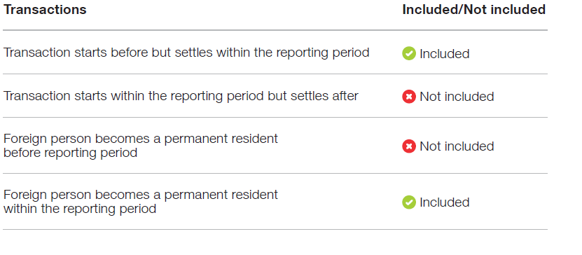

2022–23 Insights

Purchases

From 1 July 2022 to 30 June 2023 there were 5,360 residential real estate purchases with a level of foreign ownership. The total value of these purchase transactions was $4.9 billion.
Sales

The total number of residential real estate sale transactions by foreign persons for the period 1 July 2022 to 30 June 2023 was 1,119, with a total value of $1.0 billion.
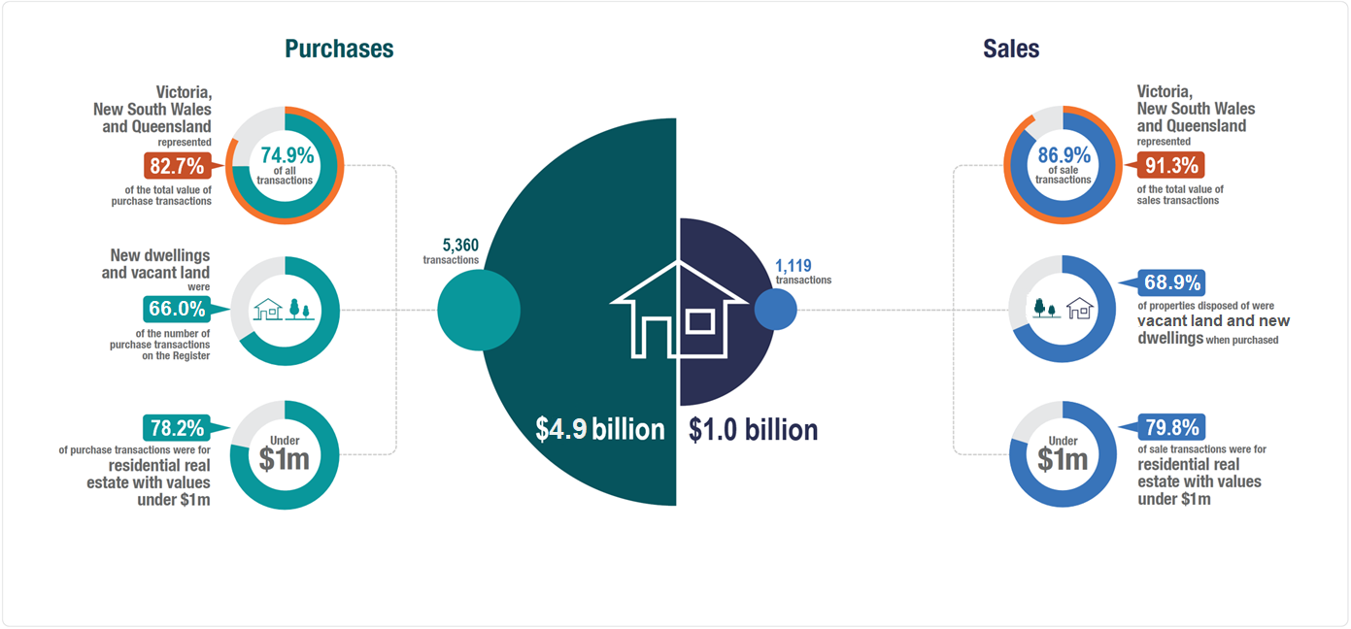
The insights show the total sale transactions during the report period (regardless of when a person initially acquired the property).
During the 2022-23 year of the 5,360 purchase transactions, 73.8 per cent of purchases occurred within 3 years of gaining foreign investment approval. This reflects the high proportion of new dwelling and vacant land property types, that can often involve long settlement periods.
The dwelling type – vacant land, new dwelling or established dwelling – reflects the type of dwelling at the time of purchase. Under Australia’s foreign investment policy,
vacant land must be constructed on within four years; and established dwellings must be either used as principal place of residence (temporary residents only) or
developed into two or more new dwellings within four years.

Purchase transactions in 2022 –23
Victoria, New South Wales and Queensland represented 74.9 per cent
of all purchase transactions and make up 82.7 per cent of the total value of purchase transactions recorded on the Register for the 2022–23 period.

- The concentration and value of transactions in Victoria, New South Wales and Queensland decreased in 2022–23 from 78.6 per cent of all purchase transactions and 86.0 per cent of the total value in 2021-22.
- New dwellings represented 49.3 per cent of purchase transactions, followed by 34.0 per cent for established dwellings and 16.7 per cent for vacant land in 2022–23. In comparison, in 2021–22, new dwellings represented 52.1 per cent of purchase transactions, followed by 31.7 per cent for established dwellings and 16.2 per cent for vacant land. The dwelling type – vacant land, new dwelling or established dwelling – reflects the type of dwelling at the time of purchase.
- Across Australia, purchase transactions increased by 26.8 per cent. The state with the greatest number of purchase transactions for all property types in 2022–23 was Victoria, the same result as in 2021-22. New South Wales had a decrease in property purchases of 1.2% per cent and all other states had an increase when compared to 2021-22.
- Residential properties with values under 1 million dollars formed the majority of residential property purchase transactions, accounting for 78.2 per cent of property transactions in 2022-23. This is an increase compared to 75.4 per cent in 2021-22.
- Of the 5,360 purchase transactions in 2022–23, 164 registrants became a permanent resident or gained Australian citizenship during the year and are included in these statistics.
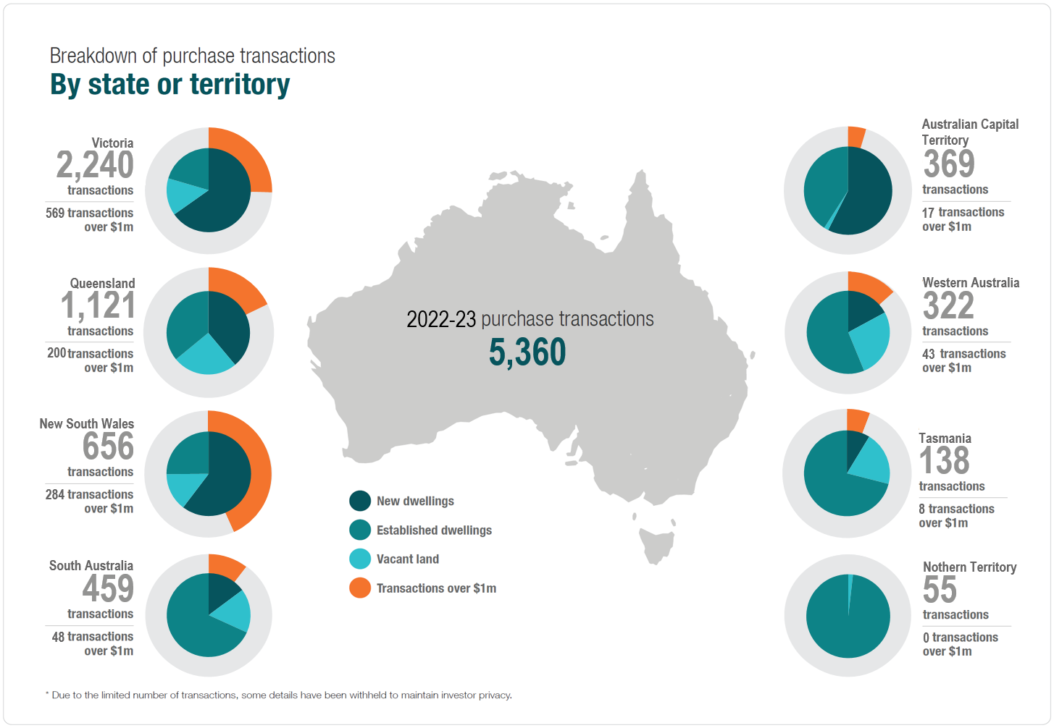

Breakdown of 2022 –23 purchase transactions by property type

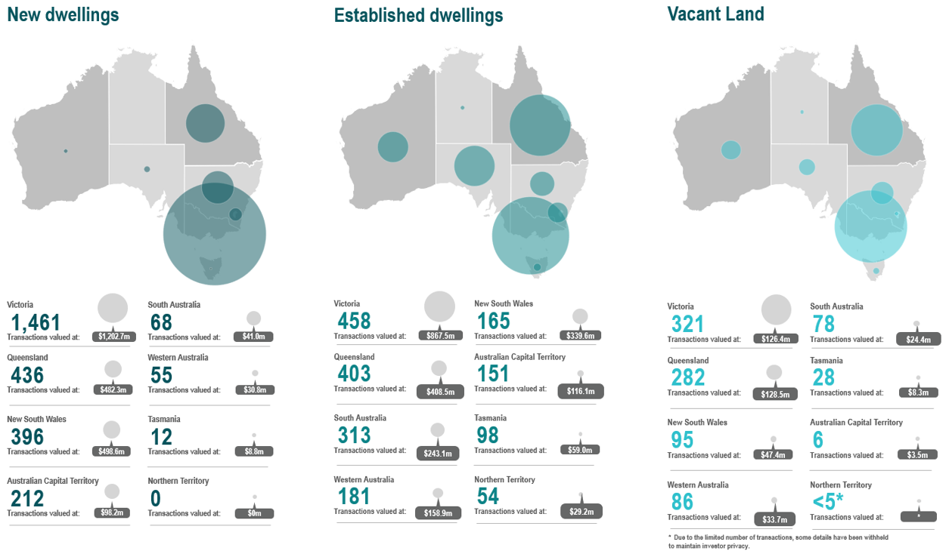

$0

Sale transactions in 2022 –23
Victoria, New South Wales and Queensland represent 86.9 per cent

of all sale transactions, making up 91.3 per cent of the value of sale transactions for the reporting period.

- In comparison, in 2021–22 Victoria, New South Wales and Queensland represented 97.0 per cent of all sale transactions and 97.8 per cent of the value.
- In 2022–23, new dwellings represented 37.4 per cent of sale transactions, followed by 31.5 per cent for vacant land and 31.1per cent for established dwellings. The property type reflects the type of property at time of purchase, e.g. new dwellings were new at the time of purchase.
- Victoria had the greatest number of sale transactions across all property types in both 2022–23 and 2021–22.
- Properties with values under 1 million dollars represented
79.8 per cent of sale transactions in 2022-23. This is a slight increase when compared to the proportion of sale transactions in 2021–22 of 76.5 per cent.
- Sale transactions numbers reflect any sale transactions settled
by foreign persons within the reporting period, regardless of when the initial purchase was contracted.
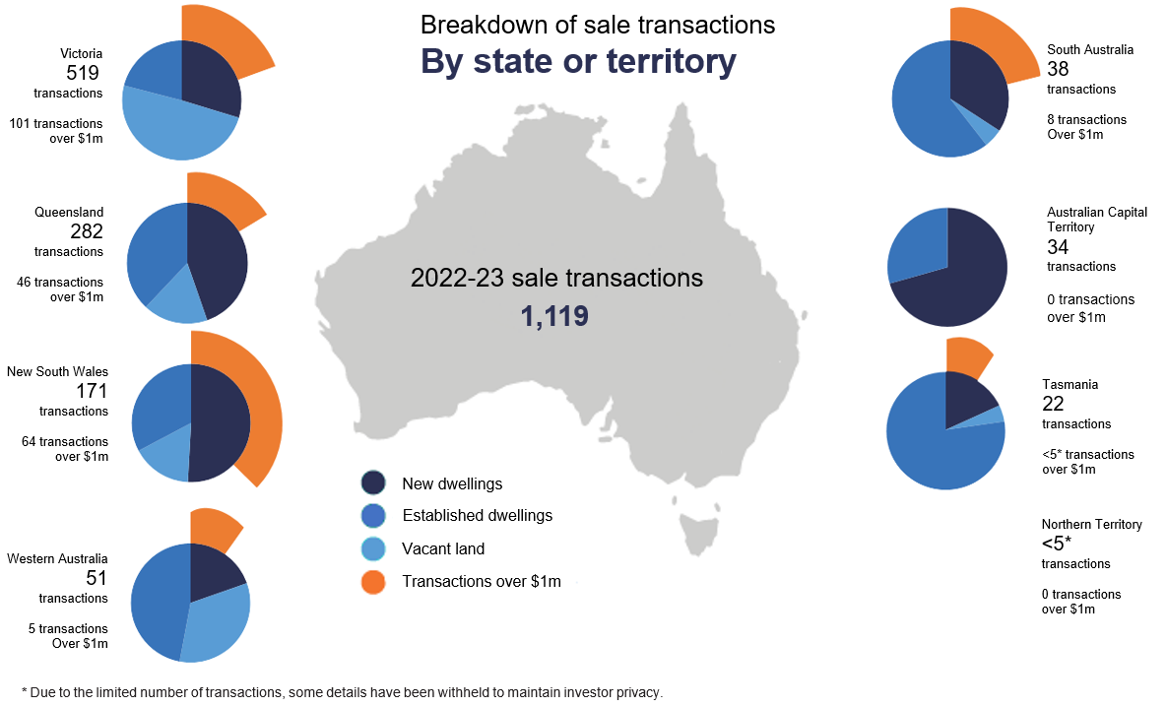

Breakdown of 2022–23 sale transactions by property type

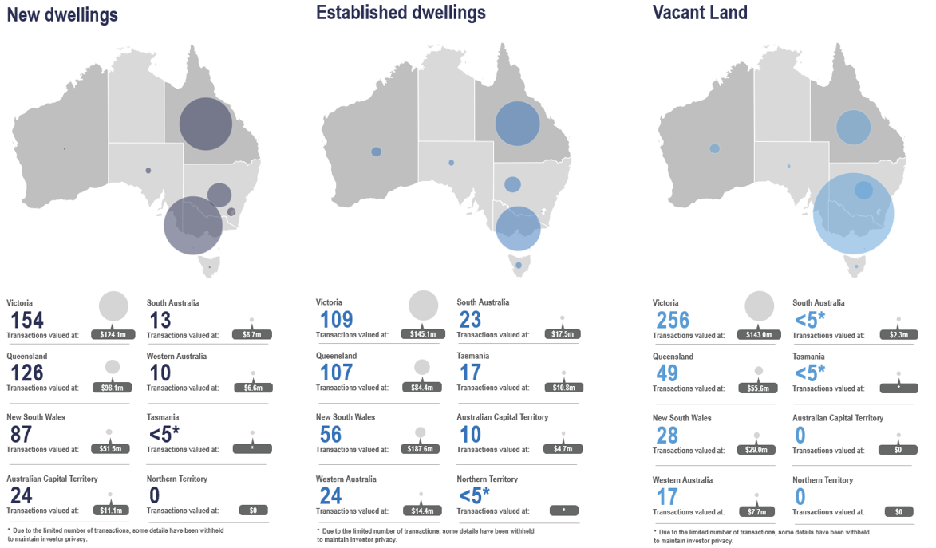

Three-year comparison of purchase transactions

The count of purchase transactions has increased to 5,360 in 2022-23 from 4,228 in 2021-22 and 5,310 in 2020-21. The value of purchase transactions has increased to $4.9b in 2022-23 from $3.9b in 2021-22 and $4.2b in 2020-21. For full trend data of purchase transactions from 2017-18 see Insights into foreign purchases and sales of residential real estate for the period 1 July 2020 to 30 June 2021.
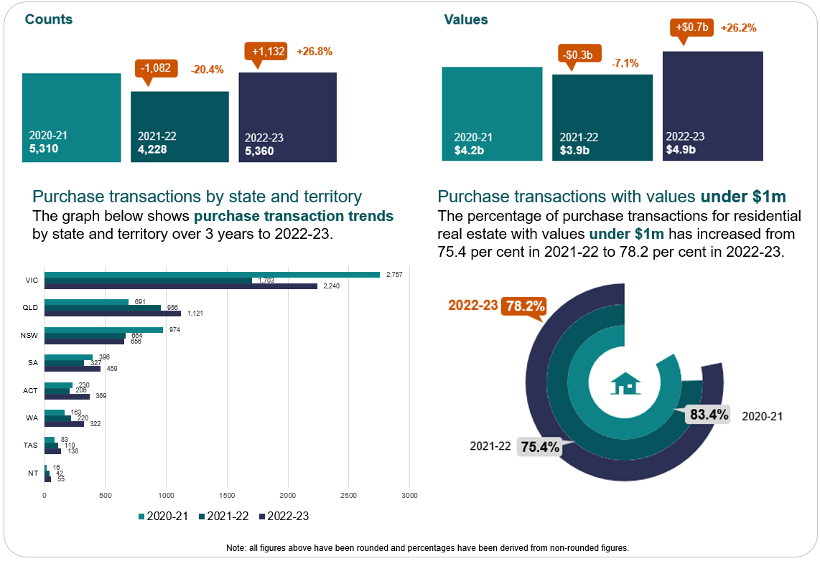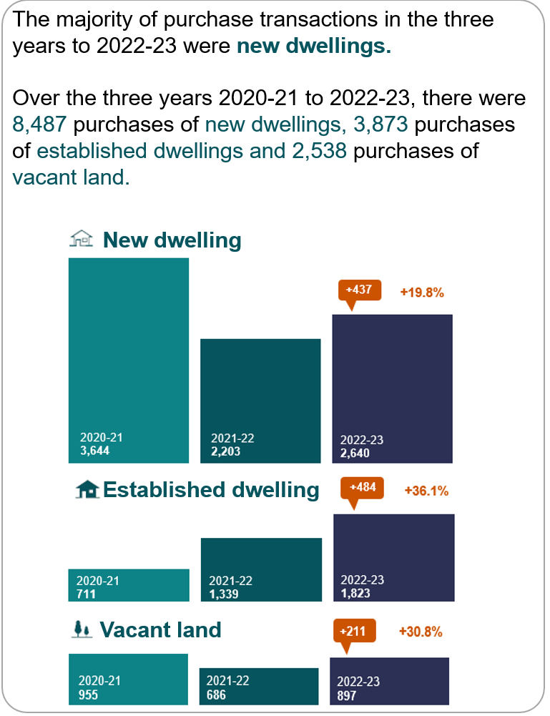

Five-year comparison of purchase transactions by state or territory by property type

Purchase transaction trends by state or territory show in the five years to 2022-23. Victoria has the greatest number of purchase transactions in each property type. The top three states showing the greatest number of purchase transactions by property type in the five years to 2022-23 are Victoria, NSW and Queensland for new dwellings, Victoria, Queensland, and NSW for vacant land and Victoria, Queensland, and South Australia for established dwellings.

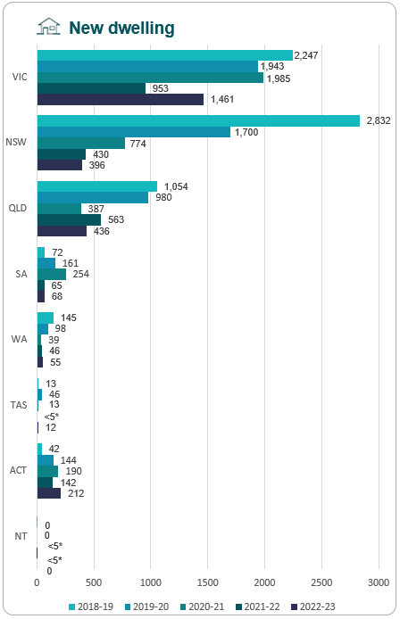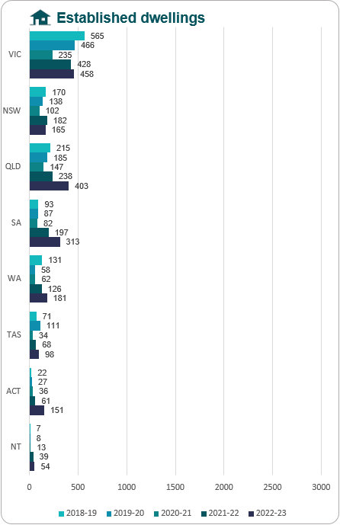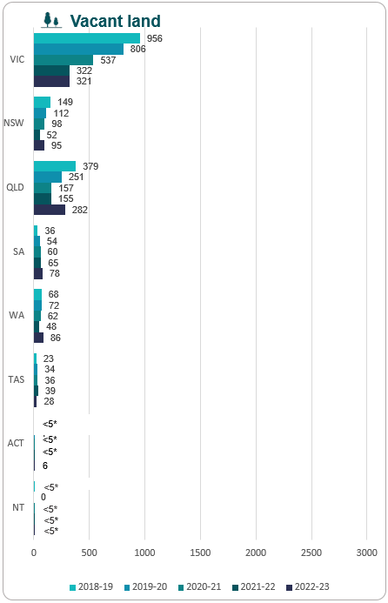

*Due to the limited number of transactions, some details have been withheld to maintain investor privacy.

Three-year comparison of sale transactions

Sale transactions have decreased in 2022-23 when compared to 2021-22 and 2020-21. There was a 52.4 per cent decrease in sale transactions in 2022-2023 when compared to 2021-22. The value of sale transactions also decreased by 53.0 per cent when compared

to 2021-22. For full trend data of sale transactions from 2017-18, see Insights into foreign purchases and sales of residential real estate for the period 1 July 2020 to 30 June 2021.

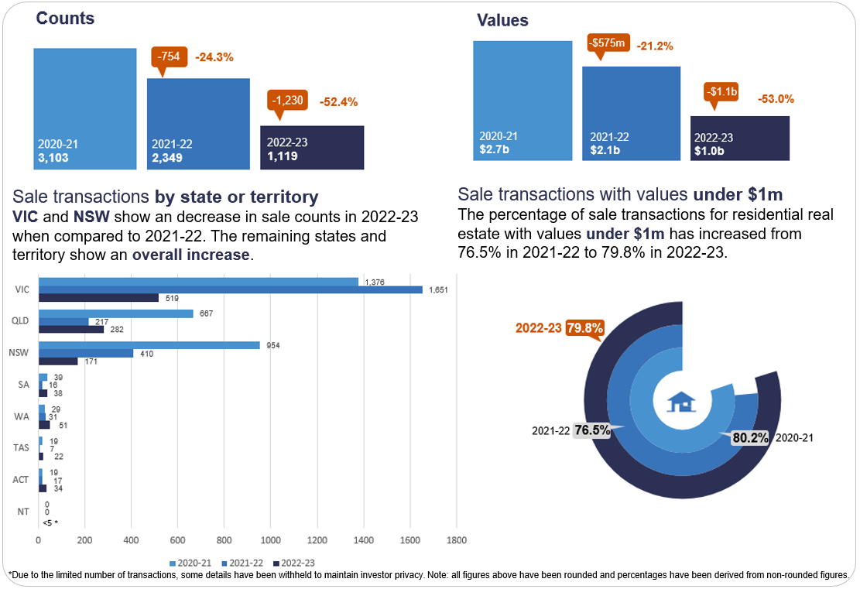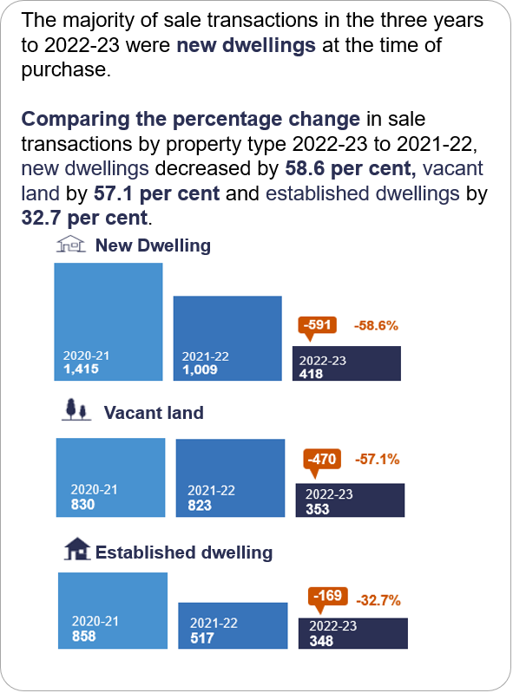

Five-year comparison of sale transactions by state or territory by property type

Sale transaction trends by state or territory show in the five years to 2022-23, Victoria has the greatest number of sale transactions in each property type. The top three states showing the greatest number of sale transactions by property type in the five years to 2022-23 are Victoria, NSW and Queensland for new dwellings, Victoria, Queensland, and NSW for vacant land and established dwellings.

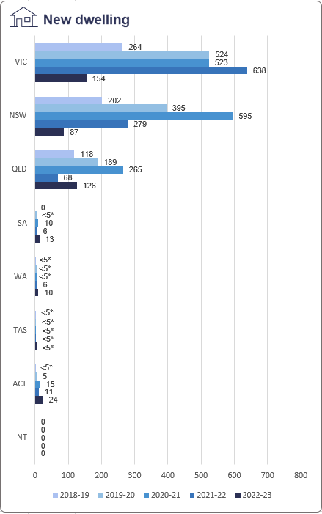 8.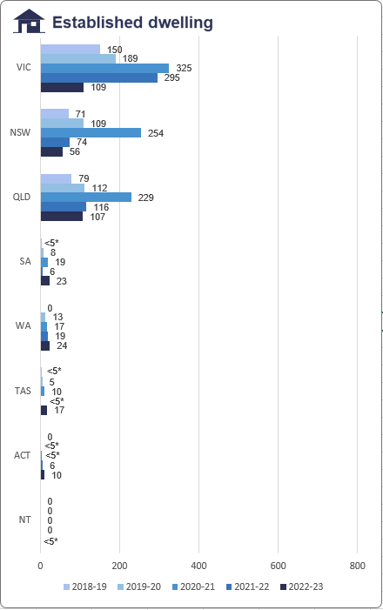 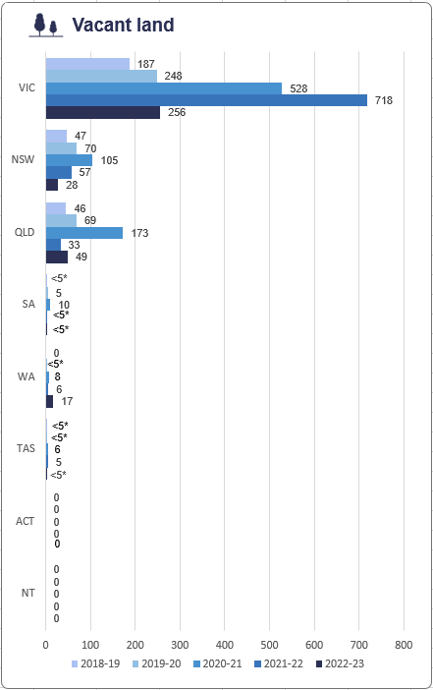
*Due to the limited number of transactions, some details have been withheld to maintain investor privacy.
*The dwelling type – vacant land, new dwelling or established dwelling – reflects the type of dwelling at the time of purchase.

