



# Register of foreign ownership of

agricultural land

Report of registrations as at 30 June 2022

OFFICIAL

EXTERNAL

# Contents

**Introduction 3**

**Summary of key findings 5**

**Findings 11**

Foreign held agricultural land by Australian states and territories 11

Agricultural land with a level of foreign ownership, by Statistical Area Level 4 (SA4) 13

Foreign and Australian share of foreign held agricultural land 15

Foreign held agricultural land by number of properties 16

Foreign held agricultural land by land use 17

Foreign held interests in freehold and leasehold land by Australian state and territory 18

Foreign held interests in freehold and leasehold land 20

**Attachment A: Background 26**

**Attachment B: Definitions 27**

**Attachment C: Land and Water registration form fields 29**

**Attachment D: Methodology 30**

**Attachment E: ABS historical data 32**

**OFFICIAL** EXTERNAL 2

# Introduction

The Register of foreign ownership of agricultural land (the Agricultural land register) was established to provide greater transparency about the level of foreign ownership of Australia’s agricultural land.

The Commissioner of Taxation reports annually to the Treasurer on the operation of the *Register of Foreign Ownership of Water or Agricultural Land Act 2015* (the Act) and is required to publish aggregate statistics of foreign ownership each year. This is the seventh report of the Agricultural land register (Agland 2022) and includes registrations made by foreign persons between 1 July 2015 and 30 June 2022.

It is mandatory for foreign persons to register their holdings in agricultural land within 30 days of a specified event occurring, including the acquisition or disposal of those holdings.

Details of specific events are outlined in Attachment A. In this report, ‘foreign held’ land is agricultural land in which a foreign person has ownership. This could be a freehold interest, or a leasehold interest or right to occupy agricultural land under a lease or licence that is likely to exceed five years. A foreign person may hold the interest alone, as a tenant in common or as a joint tenant.

The definition of ‘foreign person’ includes entities with a level of foreign ownership of at least 20%, so the Agricultural land register captures details of entities even when the majority of shareholders are Australian.

For more information on the definition of ‘foreign person’ refer to Attachment B.

Information collected during registration is detailed at Attachment C.

Consistent with Australia’s foreign investment framework, the details of investors are not made publicly available. Taxation law also restricts the release of information which could identify, or be used to identify, an individual or entity. For these reasons, and because the Act only requires aggregated statistics, information beyond what is presented in this report will not be made available.

### A quick note on methodology

The Australian Taxation Office (ATO) has undertaken additional comparative analyses using Australian Bureau of Statistics (ABS) information on agricultural land holdings in Australia to estimate the relative proportion of foreign held Australian agricultural land. This estimated proportion is referred to as the ‘level of foreign ownership’.

To calculate the estimated proportion of foreign held agricultural land, a benchmark measure of the total agricultural land area in Australia is used. The benchmark is taken from Rural Environment and Agricultural Commodities Survey (REACS) or censuses conducted by the ABS. See [7121.0 – Agricultural Commodities, Australia, 2020-21 Explanatory Notes](https://www.abs.gov.au/statistics/industry/agriculture/agricultural-commodities-australia/latest-release) for more information on the ABS 2020–21 Agricultural Census.

The Agricultural Census is conducted every five-years with REACS conducted annually in the years in between. 2020-21 is the last Agricultural Census to be conducted by the ABS.

The REACS uses a sample methodology to estimate the total agricultural land area and the estimates are subject to sampling variability.

For Agland 2022, the ABS 2020–2021 Agricultural census is used to estimate the relative proportion of foreign held Australian agricultural land. In Agland 2021 the benchmark data from the ABS 2019–2020 REACS was used.

To ensure legislative requirements are met, this report is produced as soon as practicable after 30 June each year, using the most recently available ABS REACS or Agricultural Census data at the time of publication.

Care should be taken when relying on this comparative analysis as differences in population between the Agricultural Land Register and ABS commodity surveys and censuses affect the accuracy and reliability of this analysis1.

Figures in the tables and diagrams have been rounded. Any discrepancies between totals and sums of components are due to rounding.

The statistics in this report need to be interpreted in conjunction with the information about the methodological caveats outlined in Attachment D.

The report includes an analysis of agricultural land with foreign ownership on a regional basis, using ABS Statistical Area (SA4) level standards2.

1 In particular, it should be noted that the ABS does not capture entities whose primary business activity is forestry as part of their agricultural surveys or census, whereas forestry land holdings are captured as part of the Agricultural land register.

2 The Australian statistical geography standard (ASGS) is the ABS’s geographical framework, effective from July 2021.

# Summary of key findings

The total area of agricultural land in Australia with a level of foreign ownership has decreased by 10.0% from 52.985 million hectares (ha) at 30 June 2021 to 47.709 million ha at

30 June 2022.

Using the ABS measure of total agricultural land area in Australia, the estimated proportion of agricultural land with a level of foreign ownership at 30 June 2022 is **12.3%**, compared to 14.1% in the prior year.

Figure 1 shows the area of foreign held agricultural land against the ABS measure of total Australian agricultural land to show the level of foreign ownership as at 30 June 2022.

#### Figure 1: Agricultural land with a level of foreign ownership as at 30 June 2022

The amount of agricultural land with foreign ownership and level of foreign ownership decreased in 2021-22. This decline is attributed to a large amount of land holdings reacquired by Australian owners. In addition, the proportion of land used for agricultural purposes reported by the ABS increased compared to the prior year. The increase reflects the easing of drought conditions, particularly in the Eastern States; as well as improved seasonal conditions.3

3 [ABS: Agricultural Commodities, Australia – Changes in this and forthcoming issues](https://www.abs.gov.au/statistics/industry/agriculture/agricultural-commodities-australia/latest-release)

Figure 2 shows the proportion of agricultural land with a level of foreign ownership as at

30 June for each year from 2020 to 2022.4 The level of foreign ownership of agricultural land was relatively stable in the two years prior, with a slight decrease in foreign ownership at

30 June 22.

#### Figure 2: Agricultural land with a level of foreign ownership – three year comparison

|  |  |  |  |  |  |  |  |  |  |
| --- | --- | --- | --- | --- | --- | --- | --- | --- | --- |
|  | 383.801 |  | | 377.002 |  | | 387.265 |  | |
|  |  | |  | |
|  |  | |  | |  | |
|  |  | |  | |  | |
|  |  | |  | |  | |
|  |  | |  | |  | |
|  | 13.8% | | 14.1% | | 12.3% | |
|  | 53.026 |  | 52.985 |  | 47.709 |  |

30 June 2020 30 June 2021 30 June 2022 Total Australian agricultural land (ABS) Total foreign held

million ha

4 Care should be taken when comparing percentage foreign ownership of agricultural land across years as estimates are taken from annually-updated ABS REACS or the five yearly Agricultural census. These are subject to sampling variability. For example, the 2020-2021 Agricultural Census reported a 3.0% increase in the total amount of agricultural land across Australia with the total area increasing from 377.0 million ha in 2019–20 to 387.3 million ha in 2020-21.

Figure 3 shows a 2 year comparison of foreign held agricultural land and the number of foreign held properties.

There was an overall decrease in the amount of foreign held agricultural land of 10.0% (5.276 million ha) and a 0.3% increase in the number of foreign held agricultural land properties (29) when compared to 2021.

#### Figure 3: Foreign held agricultural land and property count – two year comparison

52.985

10,284

10,313

47.709

30 June 2021 30 June 2022

Foreign held agricultural land (million ha) Properties

When comparing the type of agricultural land use to the prior year, the area of land used for crops increased by 2.4%. There was a 9.2% reduction in land used for livestock. Refer to Figure 6.

Over 85% of agricultural land with foreign ownership is used for livestock

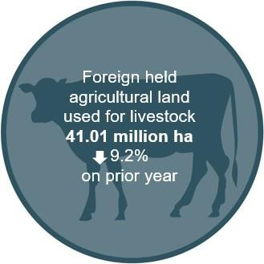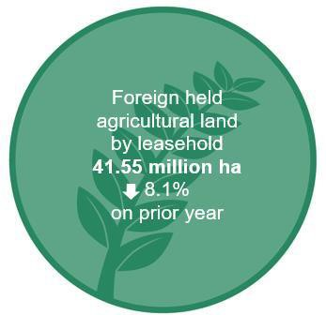Around 82% of agricultural land with foreign ownership is held on a leasehold basis

When the total foreign held freehold and leasehold interests are aggregated, China has the largest holding of total Australian agricultural land of 2.0%. This is followed by the United Kingdom with 1.9%, Canada with 0.7%, the United States of America with 0.6% and Netherlands with 0.6%. Refer to Table 5.

Generally, the changes in agricultural land interests by country of ownership compared to Agland 2021 can be attributed to:

* new registrations of acquisitions of agricultural land that have settled since the last report
* agricultural land that has been sold to Australian entities and has been removed from the register
* agricultural land that has been sold to other foreign entities with a different foreign country of ownership
* foreign entity restructures which have resulted in a change of the foreign entity’s status as a foreign person.

There was a change in the amount of foreign held agricultural land in each of the states and territories as at 30 June 2022 when compared to the prior year. The level of foreign held agricultural land decreased in all states and territories except for Northern Territory, which saw a small increase.

Figure 4 shows the net change of foreign held agricultural land by state or territory. Refer to Table 2 for further information.

**Figure 4: Foreign held agricultural land by state or territory – net change compared to prior year**

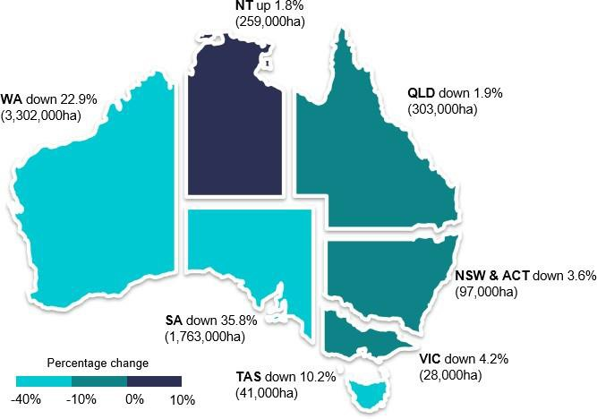

# Findings

## Foreign held agricultural land by Australian states and territories

#### Table 1: Foreign held agricultural land by state or territory as at 30 June 2022

|  |  |  |  |  |  |
| --- | --- | --- | --- | --- | --- |
| **Foreign held agricultural land**  **(‘000 ha)** | | | **Australian agricultural land (‘000 ha)** | | **Foreign**  **held (%)** |
| **State or territory** | **30 June 2020** | **30 June 2021** | **30 June 2022** | **2020-2021**  **Ag Census** | **30 June 2022** |
| NSW/ACT | 2,660 | 2,674 | 2,577 | 53,844 | **4.8** |
| VIC | 639 | 669 | 641 | 11,391 | **5.6** |
| QLD | 15,724 | 15,648 | 15,345 | 134,842 | **11.4** |
| WA | 13,954 | 14,394 | 11,092 | 86,441 | **12.8** |
| SA | 4,949 | 4,925 | 3,162 | 46,181 | **6.8** |
| TAS | 382 | 401 | 360 | 1,503 | **23.9** |
| NT | 14,718 | 14,274 | 14,533 | 53,063 | **27.4** |
| **Total** | **53,026** | **52,985** | **47,709** | **387,265** | **12.3** |

**Notes:**

* The area of agricultural land with a level of foreign ownership by Australian states and territories is compared to the latest benchmark information, by states and territories from the ABS Agricultural Census to identify the estimated proportion of agricultural land that has a level of foreign ownership.
* The ‘foreign held per cent’ is the ratio of agricultural land with a level of foreign ownership to the total of Australian agricultural land for each state or territory.
* Differences between the Agricultural land register and ABS commodity surveys and censuses affect the accuracy and reliability of the above proportions. For example, the ABS total agricultural land figure does not include agricultural land held by entities whose primary business activity is forestry. In regions such as Tasmania and Victoria that have a large proportion of forestry the proportion of agricultural land that is foreign owned is therefore likely overstated.
* See Table 4 for further details on land usage by state or territory.
* Information on historical agricultural land totals (from the ABS) is at Attachment E.

Table 2 compares the amount of foreign held land (on a state or territory basis) at 30 June 2022 with the previous two years. The change percentage represents the change in the amount of foreign held land at 30 June 2022 compared to 30 June 2021 in each state or territory.

#### Table 2: Foreign held agricultural land by state or territory – Land size comparison

|  |  |  |  |  |
| --- | --- | --- | --- | --- |
| **State or territory** | **30 June 2020**  **(‘000 ha)** | **30 June 2021**  **(‘000 ha)** | **30 June 2022**  **(‘000 ha)** | **Change**  **(%)** |
| NSW/ACT | 2,660 | 2,674 | 2,577 | -3.6 |
| VIC | 639 | 669 | 641 | -4.2 |
| QLD | 15,724 | 15,648 | 15,345 | -1.9 |
| WA | 13,954 | 14,394 | 11,092 | -22.9 |
| SA | 4,949 | 4,925 | 3,162 | -35.8 |
| TAS | 382 | 401 | 360 | -10.2 |
| NT | 14,718 | 14,274 | 14,533 | 1.8 |
| **Total** | **53,026** | **52,985** | **47,709** | **-10.0** |

**Notes:**

* It is not possible to reconcile the percentage changes reflected in Table 2 against annual movements in the estimate of the percentage of total agricultural land held by foreign persons, due to annual fluctuations in ABS total agricultural land estimates.

## Agricultural land with a level of foreign ownership, by Statistical Area Level 4 (SA4)

Chart 1 shows the proportion of agricultural land with a level of foreign ownership for each SA4 regional area as at 30 June 2022.

#### Chart 1: Proportion of agricultural land with a level of foreign ownership, by SA4

**Notes:**

* The proportion of agricultural land with a level of foreign ownership for each SA4 regional area is calculated by dividing the total amount of foreign held agricultural land in each region by the total amount of agricultural land in each region. The SA4 regional areas are based on postcodes geographically coded to each statistical area.
* Statistical Areas Level 4 (SA4) are geographical areas built from whole Statistical Areas Level 3 (SA3s). SA4 regions are the largest sub-State regions in the Main Structure of the Australian Statistical Geography Standard (ASGS). Whole SA4s aggregate to Greater Capital City Statistical Areas (GCCSA) and State and Territory. There are 108 SA4 regions covering the whole of Australia without gaps or overlaps.5

5 [ABS – statistical areas](https://www.abs.gov.au/ausstats/abs%40.nsf/Lookup/by%20Subject/1270.0.55.001~July%202016~Main%20Features~Statistical%20Area%20Level%204%20(SA4)~10016)

* The total amount of foreign held agricultural land in each region uses data collected by the ATO to

30 June 2022. As the ATO only collects data on foreign holdings, ABS data on total land holdings is used to estimate the proportion of land with a foreign ownership interest in each region. The ABS 2020–21 Agricultural Census and the ABS SA4 standards6 was used for this.

* Differences between the Agricultural land register and ABS commodity surveys and censuses affect the accuracy and reliability of this analysis. For example, the ABS total agricultural land figure does not include agricultural land held by entities whose primary business activity is forestry. In regions such as Tasmania and Victoria that have a large proportion of forestry the proportion of agricultural land that is foreign owned is therefore likely overstated.
* This information is for illustrative purposes only and care should be taken when using this information for any other purpose.

6 The Australian statistical geography standard (ASGS) is the ABS's geographical framework, effective from July 2021.

## Foreign and Australian share of foreign held agricultural land

Figure 5 shows the foreign and Australian share of foreign held agricultural land as at

30 June for each year from 2020 to 2022. The register records land held by foreign persons that have a foreign ownership share of 20% or more. This means there may also be a significant portion of Australian ownership in those same parcels of land.

#### Figure 5: Foreign and Australian share of foreign held agricultural land

60

50

11.337

13.589

13.59

36.372

39.396

39.436

40

million ha

30

20

10

0

30 June 2020

30 June 2021

30 June 2022

Australian share of foreign held land Foreign share of foreign held land

**Note:**

As at 30 June 2022, of the 47.709 million ha of foreign held Australian agricultural land, 23.8% (11.337 million ha) is indirectly held by Australian investors who have shares in entities considered foreign persons.

## Foreign held agricultural land by number of properties

Table 3 shows the number of foreign held properties on the Agricultural land register by state and territory as at 30 June for each year from 2020 to 2022.

#### Table 3: Foreign held agricultural land – Number of properties held comparison over three years

|  |  |  |  |
| --- | --- | --- | --- |
| **State or territory** | **30 June 2020 (No. of properties)** | **30 June 2021 (No. of properties)** | **30 June 2022 (No. of properties)** |
| NSW and ACT | 2,450 | 2,580 | 2,449 |
| VIC | 2,014 | 2,187 | 2,218 |
| QLD | 1,620 | 1,693 | 1,711 |
| WA | 1,449 | 1,564 | 1,639 |
| SA | 741 | 815 | 1,037 |
| TAS | 1,529 | 1,344 | 1,151 |
| NT | 94 | 101 | 108 |
| **Total** | **9,897** | **10,284** | **10,313** |

**Note:**

* In this table the figures for “No. of properties” measures property titles. Multiple (sometimes hundreds) of titles can transfer between two parties in one acquisition and, thus, the number of properties may not be an accurate of the amount of land changing hands. For example, while there was a 27.2% net increase (223) in the number of foreign held properties in South Australia as at 30 June 2022, the overall land size decreased by around 35.8% (1.763 million ha) as detailed in Table 2.

## Foreign held agricultural land by land use

Table 4 illustrates land use by state and territory across categories collected in the Agricultural land register as at 30 June 2022.

#### Table 4: Foreign held agricultural land by land use as at 30 June 2022

|  |  |  |  |  |  |  |  |  |
| --- | --- | --- | --- | --- | --- | --- | --- | --- |
| **State or territory** | **Crops**  **(‘000 ha)** | **Livestock**  **(‘000 ha)** | **Intensive Horticulture**  **(‘000 ha)** | **Other Farming**  **(‘000 ha)** | **Forestry**  **(‘000 ha)** | **Non- farming**  **(‘000 ha)** | **Unreported**  **(‘000 ha)** | **Total** |
| NSW and ACT | 675 | 1,549 | 82 | 46 | 84 | 66 | 75 | **2,577** |
| VIC | 97 | 68 | 7 | 16 | 420 | 18 | 15 | **641** |
| QLD | 502 | 13,382 | 87 | 55 | 325 | 190 | 804 | **15,345** |
| WA | 771 | 9,290 | 10 | 19 | 186 | 411 | 404 | **11,092** |
| SA | 30 | 2,922 | 8 | 11 | 155 | 32 | 3 | **3,162** |
| TAS | 7 | 59 | 3 | 4 | 280 | 6 | 1 | **360** |
| NT | 4 | 13,744 | 0 | 0 | 13 | 18 | 753 | **14,533** |
| **Total** | **2,085** | **41,014** | **198** | **150** | **1,4647** | **742** | **2,056** | **47,709** |

**Notes:**

* The registration form includes land use categories of crop, livestock, intensive horticulture, forestry, other farming, non-farming. Where registrants did not report the land use, this is shown in the ‘Unreported’ column.
* The non-farming category is an undefined term and requires registrants to determine the land use. Examples where this has been selected include land zoned for mining or used as a mining buffer.

7 The ABS does not capture entities whose primary business activity is forestry as part of their agricultural surveys or census, however forestry land holdings are captured as part of the Agricultural land register.

Figure 6 shows foreign held agricultural land by land use and compares the percentage change in foreign held agricultural land by land use as at 30 June 2022 to foreign held agricultural land as at 30 June 2021.

#### Figure 6: Foreign held agricultural land by land use – comparison

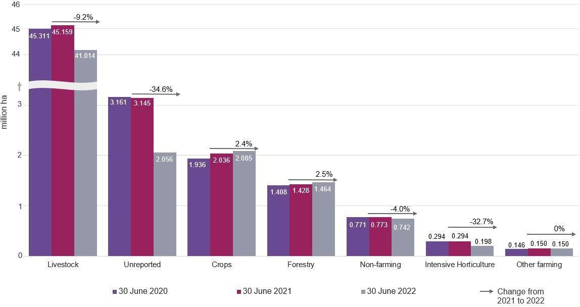

**Notes:**

* The registration form includes land use categories of crop, livestock, intensive horticulture, forestry, other farming, non-farming. Where registrants did not report the land use, this is shown in the ‘Unreported’ column.
* The non-farming category is an undefined term and requires registrants to determine the land use. Examples where this has been selected include land zoned for mining or used as a mining buffer.

## Foreign held interests in freehold and leasehold land by Australian state and territory

Figure 7 shows the ratio of freehold and leasehold land to the total foreign held land by state and territory reported on the register as at 30 June 2022. The aggregate freehold interest is 8.988 million ha, and aggregate leasehold interest is 41.546 million ha.

#### Figure 7: Foreign held interests in freehold and leasehold land by state and territory as at 30 June 2022 (million ha)

QLD

12.035

4.512

10.976

1.14

.

7

.

1.074

2.064

.127

.546

.051

.309

161

3.005

254

14.279

WA

NT

SA

NSW/ACT

VIC

TAS

million ha

Freehold Leasehold

**Notes:**

* In some instances, the same property has been separately registered by a foreign person with a freehold interest in the land and by another foreign person with a leasehold interest in the land, as required under the Act. Land size information from both registrations has been included in this table.
* As a result, the total of foreign held leasehold and freehold interests land in this table (50.534 million ha) is greater than the total amount of land held by foreign persons (47.709 million ha) as illustrated in Tables 1 to 4 and Figures 1 to 6.

## Foreign held interests in freehold and leasehold land by country

Table 5 shows the foreign share of the foreign held freehold and leasehold land by the

top 10 countries as at 30 June 2022. This excludes the Australian share of the total foreign held freehold and leasehold land.

Notably:

* + The United States of America decreased it’s overall interest.
  + Canada was the only country in the top 10 whose overall interests increased.
  + China’s overall interest was lower due to the sale of large perpetual leasehold and freehold interests.
  + Hong Kong’s overall interest decreased due to the sale of multiple properties.

#### Table 5: Foreign held freehold and leasehold agricultural land - Top 10 countries

|  |  |  |  |  |
| --- | --- | --- | --- | --- |
| **Country** | **Freehold**  **(‘000 ha)** | **Leasehold**  **(‘000 ha)** | **Total foreign held**  **(‘000 ha)** | **Agricultural land with a level of foreign ownership (%)** |
| China | 750 | 7,036 | 7,786 | **2.0** |
| United Kingdom | 781 | 6,514 | 7,295 | **1.9** |
| Canada | 634 | 2,252 | 2,886 | **0.7** |
| Netherlands | 1,453 | 950 | 2,403 | **0.6** |
| United States of America | 1,156 | 1,100 | 2,256 | **0.6** |
| Bahamas | 0 | 2,201 | 2,201 | **0.6** |
| Germany | 197 | 1,937 | 2,134 | **0.6** |
| Switzerland | 236 | 1,877 | 2,113 | **0.5** |
| South Africa | 102 | 1,761 | 1,863 | **0.5** |
| Hong Kong | 277 | 1,274 | 1,436 | **0.4** |

**Notes:**

* To avoid identifying individuals and entities, only the top 10 countries are shown.
* In some instances, the same property has been separately registered by a foreign person with a freehold interest in the land and by a foreign person with a leasehold interest in the land, as required under the Act. Land size information from both registrations has been included in this table.
* The level of foreign ownership in agricultural land is derived by calculating total foreign held agricultural land as a proportion of the 2020–21 Agricultural Census total of 387.265 million ha.
* The changes in country ranking are attributed to sales and purchases by respective countries. Further information for current and prior year holdings for the top 10 countries for freehold and leasehold respectively are detailed in Table 6 and Table 7.

Figure 8 shows the foreign share and Australian share of foreign held freehold agricultural land as at 30 June for each year from 2020 to 2022.

#### Figure 8: Foreign held freehold agricultural land – Foreign and Australian share of foreign held land

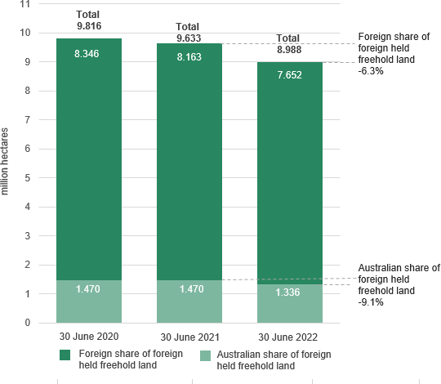

**Notes:**

* As at 30 June 2022, of the 8.988 million ha of freehold land held by foreign persons:
* the Australian share was 1.336 million ha with a 9.1% decrease on the prior year.
* the foreign share was 7.652 million ha with a 6.3% decrease on the prior year.

Table 6 shows the top 9 countries holding freehold land by size of agricultural land as at 30 June 2022. The top 9 country ranking as at 30 June 2022 does not reflect ranking for

prior year. Prior year figures are included to enable a comparison of the top 9 countries over time.

#### Table 6: Foreign held freehold agricultural land by foreign share – Top 9 countries

|  |  |  |  |
| --- | --- | --- | --- |
| **Foreign share of foreign held - freehold land**  **(‘000 ha)** | | | |
| **Country** | **30-Jun-20** | **30-Jun-21** | **30-Jun-22** |
| Netherlands | 1,648 | 1,661 | 1,453 |
| United States of America | 1,310 | 1,371 | 1,156 |
| United Kingdom | 882 | 886 | 781 |
| China | 824 | 830 | 750 |
| Canada | 907 | 564 | 634 |
| Saudi Arabia | 498 | 500 | 500 |
| Denmark | 327 | 325 | 264 |
| Switzerland | 257 | 297 | 236 |
| Germany | 201 | 207 | 197 |

**Notes:**

* In this table, the freehold land by size for the top 9 countries only shows the foreign share of the foreign held freehold land and excludes the Australian share of the total foreign held freehold land.
* To avoid identification of individuals and entities, only top 10 countries are shown.

Figure 9 shows the foreign and Australian share of foreign held agricultural leasehold land.

#### Figure 9: Foreign held leasehold agricultural land – Foreign and Australian share of foreign held land (million ha)

|  |  |  |  |  |  |  |
| --- | --- | --- | --- | --- | --- | --- |
|  | 32.705 |  | 32.906 |  | | |
|  | 31.327 |  |
|  |  |  |  |
|  |  |  |  |
|  |  |  |  |
|  |  |  |  |
|  |  |  |  |
|  |  |  |  |
| 12.288 | 12.32 |
|  |  |  | 10.219 |  |
|  |  |  |  |

30 June 2020 30 June 2021 30 June 2022 Australian share of foreign held leasehold land Foreign share of foreign held leasehold land

**Notes:**

* At 30 June 2022, of the 41.546 million ha of foreign held leasehold land:
* the Australian share was 10.219 million ha with a 17.1% decrease on the prior year, and
* the foreign country share was 31.327 million ha with a 4.8% decrease on the prior year.

Table 7 shows the top 10 nationalities holding leasehold land by size of agricultural land as at 30 June 2022. The top 10 country ranking as at 30 June 2022 does not reflect ranking for prior year. Prior year figures are included to enable a comparison of the top 10 countries over time.

#### Table 7: Foreign held leasehold agricultural land by foreign share – Top 10 countries

|  |  |  |  |
| --- | --- | --- | --- |
| **Foreign share of foreign held land - Leasehold**  **(‘000 ha)** | | | |
| **Country** | **30 June 2020** | **30 June 2021** | **30 June 2022** |
| China | 8,374 | 7,669 | 7,036 |
| United Kingdom | 7,284 | 7,364 | 6,514 |
| Canada | 1,703 | 1,887 | 2,252 |
| Bahamas | 2,201 | 2,201 | 2,201 |
| Germany | 1,933 | 1,937 | 1,937 |
| Switzerland | 1,822 | 1,852 | 1,877 |
| South Africa | 1,691 | 1,761 | 1,761 |
| Hong Kong | 1,219 | 1,502 | 1,274 |
| United States of America | 1,442 | 1,555 | 1,100 |
| Netherlands | 1,153 | 1,156 | 950 |

**Notes:**

* The leasehold land by size for the top 10 countries only shows the portion of the foreign held land owned by foreign countries and excludes any Australian share in the foreign held entity.
* To avoid identification of individuals and entities, only the top 10 countries are shown.

**Background information on obtaining source country information**

The annual report includes information on the level of ownership by source country. For the purpose of preparing the statistical report, we attribute a source country to each registration. This is done to enhance transparency at an aggregated level consistent with the policy objective for the Agricultural land register.

As part of the registration information, owners who are individuals or partnerships are required to provide their country of nationality. Companies are required to provide their country of incorporation.

Where the registered owner is an individual, the nationality of the person reported in their registration is treated as the source country.

Where the registered owner is a company or trust, it is the nationality of the person/s who appear to control the entity that is used to attribute the source country rather than the country of incorporation. Where the person who controls the entity is identified as an Australian citizen who is not ordinarily resident in Australia (and hence a foreign person), the source country is attributed to the country they are ordinarily resident in.

Where shares or interests are widely held for companies or trusts, the interest in agricultural land held is attributed to a source country based on the location of the directors or the country where the entity (or trustee) is headquartered or publicly listed depending on information available.

The country of control is assessed using data resources within the ATO and other agencies such as Department of Immigration and Border Protection and Australian Securities and Investment Commission.

The attribution of a source country to foreign held agricultural land continues to evolve as new information comes to light.

# Attachment A: Background

The Agricultural land register was established on 1 July 2015 and is administered by the ATO. The Act requires foreign persons with an interest in agricultural land to register that interest on the Agricultural land register, regardless of the value of the land or the requirement to have FIRB approval. This is referred to in this report as foreign ownership of agricultural land.

Ultimately the obligation to register correctly lies with the foreign person and penalties exist under the *Taxation Administration Act 1953* where a person fails to register correctly.

Section 16 of the Act allows the Commissioner to correct or update information on the Agricultural land register.

Investors are required to notify the ATO within 30 days of a specified event occurring. These specified events include:

* + a foreign person starts to hold agricultural land
  + a foreign person ceases to hold agricultural land
  + an investor becomes a foreign person while holding agricultural land
  + an investor ceases to be a foreign person while holding agricultural land
  + a foreign person holds land that becomes agricultural land
  + a foreign person holds land that ceases to be agricultural land.

An interest in agricultural land includes a freehold interest or the right to occupy land under a lease (including a sublease or licence) where the term of the lease or licence (including any extension or renewal) is reasonably likely to exceed five years.

A stocktake was conducted between 1 July 2015 and 29 February 2016 to enable existing foreign person landholders to register their land. During this time, the ATO used data matching to identify and contact investors who may have met the definition of foreign person and who held Australian land that may have met the definition of agricultural land.

# Attachment B: Definitions

This attachment provides information on the definitions of ‘foreign person’ and ‘agricultural land’ as detailed in the Act. Further information on the definitions can be found in the guidance notes on the Foreign investment in Australia website at [foreigninvestment.gov.au](http://www.firb.gov.au/).

### Definition of a foreign person

The term ‘foreign person’ is defined in section 4 of the Act. It states that the term has the same meaning as ‘foreign person’ as defined in section 4 of the *Foreign Acquisitions and Takeovers Act 1975*.

In general, a ‘foreign person’ is:

* + an individual not ordinarily resident in Australia8
  + a foreign government or foreign government investor
  + a corporation, trustee of a trust or general partner of a limited partnership where an individual not ordinarily resident in Australia, a foreign corporation or a foreign government holds a substantial interest of at least 20%
  + a corporation, trustee of a trust or general partner of a limited partnership in which two or more foreign persons hold an aggregate substantial interest of at least 40%.

### Definition of agricultural land

‘Agricultural land’ is defined in section 4 of the Act as land in Australia that is used, or that could reasonably be used, for a primary production business.

Section 5 of the Act provides that the rules may specify land that will not be considered agricultural land for the purposes of the Agricultural land register. The *Register of Foreign Ownership of Water or Agricultural Land Rules 2017* provides that the following land will not be considered agricultural land for the purposes of the Act9:

* + Land that is not currently being wholly or predominantly used at that time for a primary production business and:
    - zoning approval is required from government before the land could be used for primary production
    - the land is currently used, or proposed to be used for mining or activities ancillary to mining
    - the land is used for environmental protection or conservation under a law of the Commonwealth, a state or a territory or a legally binding agreement
    - the land is located within an area that has been approved by a government authority as an industrial estate

8 As defined in section 5 of the *Foreign Acquisitions and Takeovers Act 1975*.

9 Land that is not agricultural land for the purposes of the *Register of Foreign Ownership of Water or Agricultural Land Act 2015*

is outlined in section 44 of the *Foreign Acquisitions and Takeovers Regulation 2015.*

* + - the size of the land is under one hectare
    - the land has been approved by a government authority for use as a tourist facility, an outdoor education establishment or an outdoor recreation facility that is open to the public
    - an application has been made to re-zone the land to not allow the land to be used for a primary production business, or approval has been sought to use the land for mining activities
    - the land is used for wind or solar power station(s), including when an approval is in place to allow the wind or solar farm to be established or operated on the land, or the land was acquired solely for the purpose of meeting a requirement of government approval for the solar or wind farm.
  + Land where the only primary production business the land could reasonably be used for is a primary production business relating to submerged plants and animals.

# Attachment C: Land and Water registration form fields

Each registrant must complete the following mandatory fields:

### Contact details

* + Name
  + Position
  + Address
  + Mobile/cell number
  + Contact email

### Reason for registration

* + Acquisition of agricultural land
  + Cease to hold agricultural land
  + Change in status to or from a foreign person
  + Change in status to or from agricultural land

### Entity and ownership details

* + Name
  + Country of incorporation (where registrant is a trust or company)
  + Reason why the company or trust is a foreign person
  + Address
  + Date of birth
  + Nationality (where registrant is an individual or where country of incorporation is entered as Australia)
  + Address
  + Mobile/cell number
  + Contact email

### Land title details

* + Property address
  + Title information
  + Land area
  + Land use categories include crop, livestock, Intensive horticulture, forestry, Other farming, non farming
  + Land value
  + Title holding type (leasehold or freehold)
  + Date of event
  + Percentage interest in the land

# Attachment D: Methodology

This is an overview of the main methodological caveats that apply to the data in this report.

* + Data was extracted from the Agricultural land register database for properties settled as at 30 June 2022.
  + Some registrations have been corrected or updated in accordance with section 16 of the Act when it has been determined via data matching or manual data collection that the registrant has provided incorrect information. The validation of new and existing registrations is an ongoing exercise, with information reconciled against third party data sources and manual data collection.
  + Registrants are required to enter the area of their land holding in metres squared (m2) which is then converted to ha for reporting purposes. The ATO has converted into ha any land holdings reported in a different unit of measurement.
  + Entities and trusts were required to report their country of incorporation and the nationality of the owner. However, this is not necessarily a reflection of the foreign source country of the investor. Source country information has been obtained using information provided by registrants, ATO data sources and manual data collection.10
  + Properties are given a unique identifier in the form of a composite of the property name, address, suburb and state or territory. Counts of properties were based on instances of unique identifiers.
  + Properties were assigned geographic coordinates using a geocoding algorithm. Each property was assigned a Statistical Area (Level 4) based on its geographic coordinates, (shown in Chart 1).
  + In some instances, the same property has been registered twice - by a foreign person with a freehold interest in the land and by another foreign person with a leasehold interest in the land, as required under the Act. Information in Tables 1 to 4 and Figures 1 - 6 does not include leasehold registrations where a property has been already been registered as freehold. However, in Figure 7 and Table 5, the land size information from both freehold and leasehold registrations has been included by state and territory and the top 10 countries respectively. Figure 8 and Figure 9 and Table 6 and Table 7 separately show the size of foreign held agricultural land by freehold and leasehold respectively.
  + The definition of agricultural land under the *Foreign Acquisitions and Takeovers Act 1975* includes ‘land in Australia that is used, or that could reasonably be used, for primary production purposes’. Due to the broad nature of this definition it is possible that the Agricultural land register includes land that is not captured as part of the ABS Agricultural Census or ABS REACS. This may have the effect of overstating the total proportion of Australian agricultural land that is foreign held. Importantly, entities whose primary business is forestry are not captured by ABS agricultural data that has been used for comparative purposes in this report. As at 30 June 2022, land use attributed to

10 In some cases, the nationality or country of incorporation of a nominal investor may have been identified, rather than the nationality or country of incorporation of the ultimate beneficial owner.

forestry on the Register was 1.208 million ha, representing 0.3% of the 2020-21 agricultural census.

* + The Act requires foreign persons to notify of certain changes to their holdings. The movement in country rankings and holding by country may be in part be attributed to instances where a registration is updated following, for example, an internal company reorganisation, where the same entity owns the land but there has been a change in the country of control.

# Attachment E: ABS historical data

#### Table 8: Total area of Australian agricultural land by state or territory – ABS agricultural land

|  |  |  |  |
| --- | --- | --- | --- |
| **State/Territory** | **2019-20**  **REACS**  **(‘000 ha)** | **2020-21**  **Agricultural census**  **(‘000 ha)** | **Change**  **%** |
| NSW/ACT | 51,303 | 53,844 | 5.0 |
| VIC | 11,261 | 11,391 | 1.2 |
| QLD | 128,702 | 134,842 | 4.8 |
| WA | 84,965 | 86,441 | 1.7 |
| SA | 45,351 | 46,181 | 1.8 |
| TAS | 1,570 | 1,503 | -4.3 |
| NT | 53,850 | 53,063 | -1.5 |
| **Total** | **377,002** | **387,265** | **2.7** |

**Notes:**

* A comparison of total area of agricultural land split by state and territory over the last two years illustrates movement in all agricultural land in Australia using ABS data.
* The movement in agricultural land between each year is indicated as ‘change %’ for each state and territory.
* The Agricultural Census is conducted every five-years with REACS conducted annually in the years in between. 2020-21 is the last Agricultural Census to be conducted by the ABS.



**ato.gov.au**