Guidance Note 1

Overview: Australia’s Foreign Investment Framework

This guidance note provides foreign investors with an overview of the rules that underpin Australia’s foreign investment framework, and how those rules are applied. In doing so, it operates as a high-level guide to the other guidance notes available on the Foreign Investment website. In particular, it introduces foreign investors to:
- when they need to submit an application;
- when they are not required to submit an application, but may consider doing so;
- the types of conditions that are typically applied to approvals for certain types of investment; and
- how approved investors are required to comply with such conditions.

Looking for more?
A: Submitting an application to the Treasurer 3
B: Choosing the correct type of application 7
C: Submitting the application 8
Further information 10

A: Submitting an application to the Treasurer
The following flow chart is a guide to deciding whether a foreign investment application should be made to the Treasurer. Investors should note that many of the terms within the chart (e.g. ’foreign person’ or ‘notifiable action’) are legislative terms defined within the Foreign Acquisitions and Takeovers Act 1975 (the Act). The remainder of this guidance note provides investors with the detail needed to utilise this flowchart, decide whether an application is appropriate, and generally navigate Australia’s foreign investment framework.
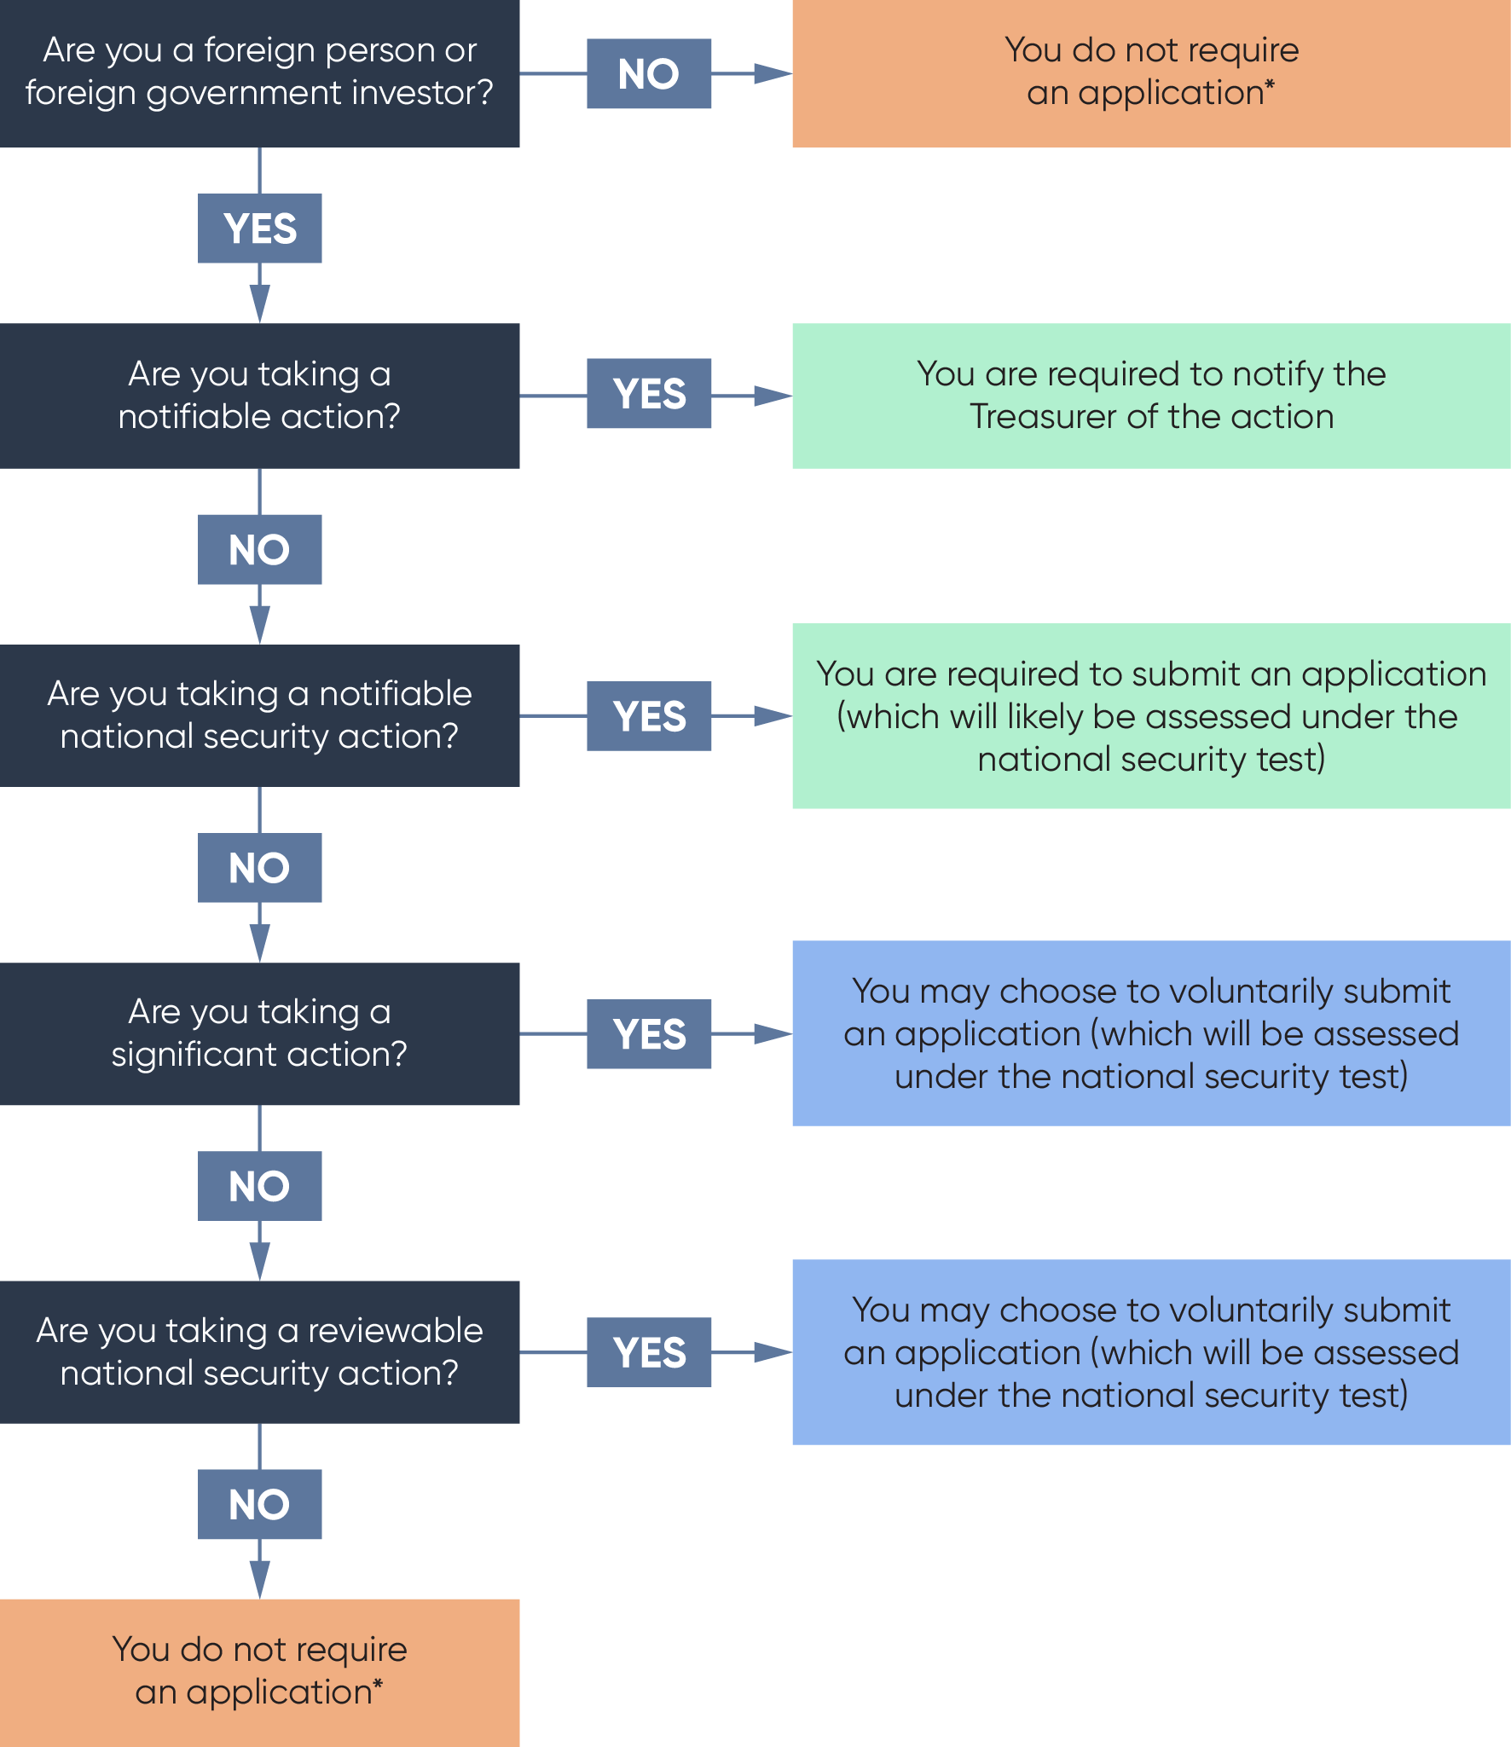
* Under rare circumstances, significant actions or reviewable national security actions may occur as a result of an action taken by a person who is not a foreign person or foreign government investor. In these circumstances, the person taking the action should assess whether an application is appropriate.

When an application must be submitted
Under the Act, a foreign person must submit an application to the Treasurer before taking certain transactions known as ‘notifiable actions’ or ‘notifiable national security actions’. In deciding whether an application is needed, a first step is to assess whether a notifiable action or notifiable national security action is proposed to be taken. The below three tables may assist investors as a guide to assessing whether a notifiable action is being taken.
The first step is to determine whether the foreign person is taking a notifiable action. Generally, a foreign person will likely need to submit an application for a notifiable action if each of the following four criteria are satisfied:
Generally, a foreign person will need to submit an application if: | Issues to consider  (non-exhaustive list)
1. They are a foreign person under the Act.  This includes foreign government investors | Who is a foreign person under the Act?  What if the company is Australian but there is some ‘upstream’ foreign ownership?
2. They are proposing to acquire:  - an interest in Australian land or an Australian land entity (including mining and production tenements);  - a direct interest (usually 10 per cent or more) in an Australian entity or Australian business that is an agribusiness;  - a substantial interest (usually 20 per cent or more) in an Australian entity; or  - at least 5 per cent in an Australian media business. | What is Australian land, and what type of land is being acquired?  What is an agribusiness?  What is a direct interest?  What is a substantial interest?  For investments in securities, assets, trusts or unincorporated limited partnership, are tracing rules relevant?  What is a land entity?  What is a media business?  Are two or more people associates under the Act?
3. The relevant monetary threshold test is met. | Where do I find the relevant monetary threshold?  How is consideration calculated?
4. None of the relevant exemptions apply. | What are the relevant exemptions?

If they do not satisfy the requirements above, a foreign government investor will likely need to submit an application for a notifiable action if each of the following three criteria are satisfied:
Generally, a foreign government investor will need to submit an application if: | Issues to consider (non-exhaustive list)
1. They are a foreign government investor under the Act. | What defines a foreign government investor?
2. They are proposing to:  - acquire a direct interest (usually 10 per cent or more) in an Australian entity or business;  - start an Australian business;  - acquire an interest in a tenement; or  - acquire at least 10 per cent of a mining, production or exploration entity. | What is a direct interest?  For investments in securities, assets, trusts or unincorporated limited partnership, are tracing rules relevant?
3. None of the relevant exemptions apply. | What are the relevant exemptions?
Even if they are not taking a notifiable action, a foreign person will still need to submit an application if they are taking a notifiable national security action – in which case they will likely be assessed under the narrower national security test (see the National Security Guidance Note). Generally, a foreign person will likely need to submit an application for a notifiable national security action if each of the following three criteria are satisfied:
Generally, a foreign person will need to submit an application if: | Issues to consider (non-exhaustive list)
1. They are a foreign person under the Act. | Who is a foreign person under the Act?  What if the company is Australian but there is some ‘upstream’ foreign ownership, how do the Acts tracing rules work?
2. They are proposing to:  - acquire a direct interest (usually 10 per cent or more) in a national security business or an entity that carries on a national security business;  - start a national security business;  - acquire an interest in national security land; or  - acquire an interest in an exploration tenement in respect of national security land. | What is a direct interest?  What is a national security business?  What is national security land?
3. None of the relevant exemptions apply. | What are the relevant exemptions?
In general, if an investor is unsure whether their proposed transaction is a notifiable action or notifiable national security action, they should seek professional legal advice. If an investor submits an application and the Treasurer considers that the foreign investor did not need to notify – and the investor does not wish to submit a voluntary application (see below) – the foreign investor will receive a refund of the fee. However, if the foreign investor does not submit an application for a planned transaction that does require notification to the Treasurer, penalties may apply. In this instance, the foreign investor will bear the risk of a prohibition or disposal order.
Applicants should also note that it is an offence under the Act for a foreign person to take a notifiable or notifiable national security action before submitting an application to the Treasurer. Applicants should also note that generally actions are deemed to be taken when the relevant agreement is entered into and the relevant action under that agreement becomes binding (which may be on satisfaction of conditions). For this reason, it is common where an agreement is entered into where the taking of the action is made conditional on Treasurer approval, the action is not taken until approval is granted. For further information, see the Key Concepts Guidance Note.
This section has covered the scenarios in which foreign investors are legally obligated to submit an application to the Treasurer. The next section provides guidance on when investors may wish to submit an application, even if they’re not legally obligated to do so.

Other reasons to submit an application
Under the Act, the Treasurer has a range of powers to ensure that foreign investment transactions are not contrary to Australia’s national interest. Many of these powers extend to actions beyond the notifiable actions and notifiable national security actions discussed above. One of these powers is the ability for the Treasurer to ‘call in’ an application for review, if the Treasurer considers that the action may pose a national security concern. Under the Act, the Treasurer cannot call in a transaction for review if the action has been notified to the Treasurer, or if a person was given a no objection notification or exemption certificate in relation to the action. Therefore to avoid an action being called in for review, foreign investors may wish to voluntarily notify the action to the Treasurer.
In conjunction with the ‘call in’ power, the Treasurer possesses many powers relating to what the Act calls ‘significant actions’. For instance, where a significant action has been taken, or is proposed to be taken, the Treasurer has the power to approve the action, prohibit the action, impose conditions on the action, or require the action to be undone. The vast majority of significant actions are also notifiable actions and therefore an application is required. Despite this, situations may arise where a significant action but not a notifiable action is proposed to be taken. In these situations, investors may choose to submit an application, whilst noting that submitting an application is not mandatory. A foreign investor may choose to take this path as many of the Treasurer’s powers are limited once approval has been given. The below table summarises this information and provides resources that may aid in assessing whether an application is appropriate:

A foreign person may wish to submit an application if: | Issues to consider (non-exhaustive list)
1. While their proposed investment does not require approval, the investor believes it is a reviewable national security action that may be called-in on national security grounds – and wishes to avoid that uncertainty. | What is the Treasurer’s call in power and how does it work?
2. While their proposed investment does not require approval, the investor believes the actions are still significant actions that the Treasurer has powers over – and seeks approval to limit these powers. | What defines a significant action?  What defines change in control?  What are the relevant exemptions?
When submitting an application that is not mandatory, investors should note that approval prevents use of all powers available under the Act, except the last resort power. The last resort power allows the Treasurer to review a prior approval where a national security risk arises in relation to an action. However, this power is subject to strict safeguards, meaning it can only be used in exceptional circumstances.

B: Choosing the correct type of application

No objection notifications and exemption certificates
Under the Act, applicants can submit an application for a ‘no objection notification’ (NON) or an ’exemption certificate’ (EC).
The vast majority of applications will be for a NON. A NON is a letter from the Treasurer that gives approval to the applicant to take the relevant action(s) within a given time period (usually 12 months) and which may impose conditions. It is the appropriate application type when there is only one action that is a significant action, notifiable national security action or a reviewable national security action or set of such actions being proposed to be taken at a particular time.
When an investor is planning a program of investments, they must assess whether a separate application (and thus NON for each transaction) is more appropriate than an EC covering all agreements. An EC exempts applicants from having to obtain approval for future actions that fall within the scope of the EC. ECs are intended to reduce regulatory burden for foreign persons. Rather than having to notify before each separate acquisition, an EC allows a foreign person to apply once prior to making any acquisitions and seek preapproval for multiple acquisitions.
Applicants should note the respective fee structures for NONs and ECs, as well as the fact that on average, ECs take a longer time to process.
If an application for an EC is not granted, the investor may still then apply for individual approval for each proposed investment.

Variations
The Act allows foreign persons to apply for variations to NONs, ECs, and to conditions that are imposed on NONs and ECs. The Treasurer may vary the content of a NON or EC if the Treasurer is satisfied that it is not contrary to the national interest (or national security, as the case requires), but cannot do so in a manner that disadvantages the applicant. Variations will be assessed on a case by case basis with the Treasurer paying particular attention to:
- the nature of the variation;
- the control the applicant had over the circumstances;
- the implication on fees;
- the applicant’s previous compliance history;
- the applicant’s previous conduct with the Treasury and the Australian Taxation Office (the ATO); and
- the change to the overall circumstances, since approval was given.
For more information on variations and whether a variation or new application is appropriate, see the Key Concepts Guidance Note.

C: Submitting the application
Foreign persons should lodge an application in advance of any transaction, or otherwise make the taking of the action conditional on foreign investment approval in any sale and purchase agreement. The foreign person must not take the action until they have received foreign investment approval.
The Government encourages potential investors to engage with the Treasury (or the ATO) for investments related to residential land) prior to lodging applications on significant proposals to allow timely consideration of the proposal. The Government will treat proposals in-confidence.
Applications are submitted electronically on the Foreign Investment website, and are supported by further guidance (see, for example, the foreign investment application checklist). If all the actions an investor proposes to take relate to residential land, the application should be submitted on the ATO website.

Fees
A fee is payable for all foreign investment applications. Fees are payable at the time of application.
The timeframe for making a decision will not start until the correct fee has been paid. For retrospective applications, fees are payable if the Treasurer makes an order or gives a no objection notification in relation to an action. If so, fees are payable within 30 days after the order or notification is given. Fees are contingent on the type of action being taken and the consideration value for the action. For further information on fees, please see the Fees Guidance Note.

Decision timeframes
Under the Act, the Treasurer has 30 days to consider an application and make a decision.
The timeframe for making a decision will not start until the correct fee has been paid in full.
In certain circumstances, the Treasurer may extend this period by up to a further 90 days by providing written notice to the applicant, and another 90 days by publishing an interim order.
In addition, investors can voluntarily extend the period by providing written consent.
Applicants will be informed of the Treasurer’s decision within 10 days of it being made. That decision will either raise no objections allowing the proposal to proceed; raise no objections but impose conditions which will need to be met; or make orders prohibiting the proposal.
More information on decision timeframes is available in the Key Concepts Guidance Note.

Confidentiality and privacy
The Government may share an investor’s application with Commonwealth, state and territory government departments and agencies for consultation purposes under the Act. The Government respects any ‘commercial-in-confidence’ information it receives and ensures that appropriate security is provided.
The Government also respects the privacy of personal information provided by applicants, as per the requirements of the Privacy Act 1988 and the Freedom of Information Act 1982.The Government is also subject to confidentiality requirements under the Act.

Conditions
If a foreign investment application is approved, it may be approved subject to certain conditions. The Treasurer can impose any condition on an investment that the Treasurer considers is necessary to protect Australia’s national interest (or national security, as the case requires). If the Treasurer is considering imposing conditions on an acquisition, applicants will have a chance to comment on any of the proposed conditions. For more information on conditions, please see the Protecting the National Interest – Principles for Developing Conditions Guidance Note and the Tax Conditions Guidance Note.

Compliance
Maintaining strong compliance with Australia’s foreign investment legislation is a priority for the Australian Government, to ensure that foreign investment is not contrary to the national interest (or national security, as the case requires). Significant penalties (including infringement notices, civil and criminal penalties) may apply for breaches of the foreign investment law.
Foreign persons who think they may have breached the law are strongly encouraged to self-disclose such breaches. Lower penalties may apply if a breach is self-reported. Foreign persons who have breached the law by taking a notifiable action or a notifiable national security action without prior foreign investment approval may apply for retrospective approval of that acquisition.
Any person who has information about a suspected breach of Australia’s foreign investment laws can make a report to the ATO or Treasury. Such reports can be made anonymously.
Where a foreign person receives approval that is subject to conditions, it is common that these conditions will also require reporting on compliance. A foreign investor’s specific compliance reporting obligations are set out in the relevant NON or EC issued to them. For more information on reporting requirements, please see the Compliance Reporting Requirements Including Independent Audit Reporting Conditions Guidance Note.
Foreign persons must give notice of certain actions relating to Australian land, water, entities, businesses and other assets to the Registrar of the Register of Foreign Ownership of Australian Assets. For more information, see the Register of Foreign Ownership of Australian Assets Guidance Note.

Further information
Further information is available on the Foreign Investment website by contacting 1800 050 377 from Australia or +61 2 6216 1111 from overseas.
Important notice: This Guidance Note provides a summary of the relevant law. As this Note tries to avoid legal language wherever possible it may include some generalisations about the law. Some provisions of the law referred to have exceptions or important qualifications, not all of which may be described here. The Commonwealth does not guarantee the accuracy, currency or completeness of any information contained in this document and will not accept responsibility for any loss caused by reliance on it. Your particular circumstances must be taken into account when determining how the law applies to you. This Guidance Note is therefore not a substitute for obtaining your own legal advice.

